**NDS Safer and Stronger Project**

July 2020 – June 2022

**Reflections Report**

‘I want to personally thank the team at NDS for your support and responsiveness to us through the challenges of COVID and the many policy changes we have had to navigate.

You have played an important role in assisting the disability sector and we sincerely value the relationship we have with NDS.

The past few years have been challenging for the entire community, and our customers across the sector have been particularly affected, so your support means a lot to us.’

Regional Provider, 30 May 2022

**Contents**

Foreword 4

Executive Summary 7

NDS Safer and Stronger made a positive impact throughout the pandemic: 8

Sector engagement at a glance 8

COVID-19 detected in Australia 10

Early NDS Response 10

Safer and Stronger established 10

Overview of Safer and Stronger Project 11

Meeting the challenges 12

Case Study**:** Influence and advocacy 12

Engaging with the Disability Sector 13

Engagement Challenges 14

Communications goes online 14

Case Study: Adapting to online 15

Project Highlights 16

Victorian COVID-19 Hub 16

Infection Prevention and Control 17

COVID-19 Vaccination rollout 18

Focus on CALD communities: 18

Business Continuity 19

Workforce 20

Case Study: Vaccine hesitancy 21

What we have learnt 22

Business continuity 22

Infection Prevention and Control 22

Workforce 23

CALD Communities 23

Safer, Stronger and Smarter 24

Listening to the sector 25

Workforce shortages 25

Business Viability 26

Heightened anxiety and stress 26

Impact of Omicron 27

Conclusions 28

NDS Resources 29

Victorian COVID-19 Hub 29

Outbreak Management 29

COVID-19 Vaccinations  29

Business Continuity 29

Infection and prevention control 30

Workforce 30

# Foreword

By Sarah Fordyce

The COVID-19 pandemic has been a challenge for us all, but particularly so for Victorian disability services who have managed multiple extended lockdowns and restrictions. It is a credit to people with disabilities, service providers, government, and broader community in Victoria that we did not experience the grim outcomes experienced in some jurisdictions. This is a result of proactive measures, immense efforts by people with disability, workers and sector leaders, and widespread collaboration across the sector. This coordination and collaboration have contributed to an effective response to the pandemic.

NDS in Victoria has supported this response, largely through our Safer and Stronger project. This two-year long project was funded by the Victorian government from July 2020 to June 2022. The project has concluded but has left a significant legacy of achievements.

The Safer and Stronger project led to increased collaboration among providers, an engagement infrastructure with multiple online provider networks run by NDS, a suite of practical resources, and increased knowledge and expertise relating to infection prevention and control and business continuity planning and implementation.

We are proud of this work, and believe it is important to capture these lessons and achievements and acknowledge the engagement and contribution of so many Victorian disability services in this sector-wide response to the pandemic. This report documents this knowledge and information sharing.

None of us could ever have foreseen the trajectory of the COVID-19 virus, the impact on all our lives and the seemingly unending nature of the pandemic. The disability sector demonstrated its capacity to meet the multiple challenges thrown up by the pandemic – lockdowns, outbreaks, emergency management, infection control, stay-at-home orders, changing rules, vaccine mandates, workforce shortages, threats to economic viability, impacts on the mental health and wellbeing of staff and clients, and workforce shortages – to name just a few.

People at all levels within organisations stepped up, willingly sharing resources, and supporting each other to navigate outbreaks and lockdowns. The sector readily adapted to new technologies, and new collaborative networks were built through online sector meetings, communities of practice and webinars. NDS prioritised the delivery of timely information and resources, and the bringing together of people to share knowledge sector and strategies.

I acknowledge the input and support of the many high-level state and federal government representatives who willingly provided updates at our webinars and engaged collaboratively with the sector to tackle the challenges posed by the pandemic.

I want to thank the many people who work in the sector that logged onto 1,261 NDS Zoom presentations over the two years of the project to ensure they had the latest information to help them support clients, workers, and families.

The new online network that NDS built throughout 2020 and 2021 increased our reach and influence. Critical to NDS’s work throughout the pandemic has been our advocacy, ensuring that the voice of disability service providers was heard at both state government and national levels.

We have liaised closely with both the Victorian Department of Families, Fairness and Housing (DFFH) and Department of Health (DoH), highlighting the need for clear and timely disability-specific guidance on restrictions and the dire workforce shortages, and promoting the needs of our sector in relation to vaccines and the vaccine rollout.

We have lobbied on behalf of providers with the NDIA, at both state and federal levels, with the Federal Minister, and with relevant Commonwealth departments.

NDS has sought to uncover the impact of COVID-19 on the disability sector and share the results with policymakers. Some of the more influential studies that we commissioned included the [report by Purpose at Work](https://www.nds.org.au/workforce-hub) on how lockdowns exacerbated existing workforce issues, Josie Prioletti’s report on the experiences of CALD disability workers, participants, and their families during 2020 and Graeme Kelly’s review of how the disability sector addressed the pandemic in 2020. Their findings are included later in this report.

I would also like to acknowledge the committed and high performing Safer and Stronger team who have supported the sector during these extraordinarily difficult years.

The Victorian Government funding enabled NDS to bring together the skills and experience, which together with the right values-fit, meant providers looked to NDS to provide the leadership and advocacy required to focus attention on the disability sector and its specific and critical needs during the pandemic.

**Case Study**

Providers support each other

Leaders from larger provider organisations stepped forward from the start of the pandemic, working with NDS and government to respond to new challenges and assist fellow providers.

There was evidence of this in Shepparton during the COVID-19 outbreak in August 2021.

NDS, in partnership with Boosting the Local Care Workforce (BLCW) Program, collaborated with providers impacted by the outbreak, using lessons we learned the previous year to identify issues, assist providers, and facilitate sharing of information.

It was gratifying to see a major provider from outside the region offering staff and resources. This experience gives us lessons for a model for how regional areas can respond to future outbreaks and other emergencies.

# Executive Summary

The onset of the COVID-19 pandemic quickly shone a light on the challenges facing the community services sector when protecting society’s more vulnerable people in a pandemic. The early outbreaks and deaths in aged care brought this home, and the focus of governments turned to that sector.

NDS undertook strong advocacy both at the national and state levels in the early days of the pandemic, arguing for a discrete focus on the particular needs of people with disability and the organisations which support them. It was important to ensure that disability was not treated as a ‘poor cousin,’ with provision of supports well behind the aged care sector.

The Victorian government recognised the needs of the sector, funding NDS to support the sector’s response to COVID-19 from July 2020.

Safer and Stronger was funded to work with providers on key priority areas:

* Business Continuity
* Infection Prevention and Control

The project provided practical information, guidance, support, and active intervention to all Victorian providers to enable services to respond to COVID-19 and emerge as stronger organisations delivering high-quality services to people with disability.

The project was established to:

* Keep the sector up to date with knowledge and government advice
* Provide disability sector intelligence to the government
* Build Infection Prevention and Control (IPC) capacity in services
* Capture, curate and disseminate examples of best practice to the sector
* Identify and support high risk cohorts
* Ensure business continuity issues are understood and addressed.

As the pandemic continued, the project adapted to meet the emerging needs of the sector, including a focus on:

* Mental health and wellbeing
* Workforce shortages

Safer and Stronger, originally funded to 30 June 2021, was extended through to 30 June 2022. This ensured continued support for the sector through the evolution of the coronavirus, repeated outbreaks, the extension of the State of Emergency and Public Health Order restrictions and associated ongoing challenges.

## NDS Safer and Stronger made a positive impact throughout the pandemic:

* The project had extensive reach into the disability sector and successfully assisted providers in their infection control and COVID-19 management practices (Safer). It also assisted in addressing provider viability challenges (Stronger).
* NDS effectively distilled complex government information and fostered understanding amongst providers to make changes and improvements to their practices in a timely way.
* High level advice was provided directly to disability providers both in one-on-one situations and in Community of Practice and webinar settings.
* Deep intelligence of what was happening “on the ground” for providers was provided to DFFH and the DoH.

## 

## Sector engagement at a glance

The following activities were undertaken during the Safer and Stronger Project period between July 2020 and June 2022.

28,084 video views & podcast listens
6,368 NDS website COVID-19 Toolkit hits
201 Online webinars and Community of Practice meetings
15,353 people attended online meetings
107,217 Vic COVID-19 news update views

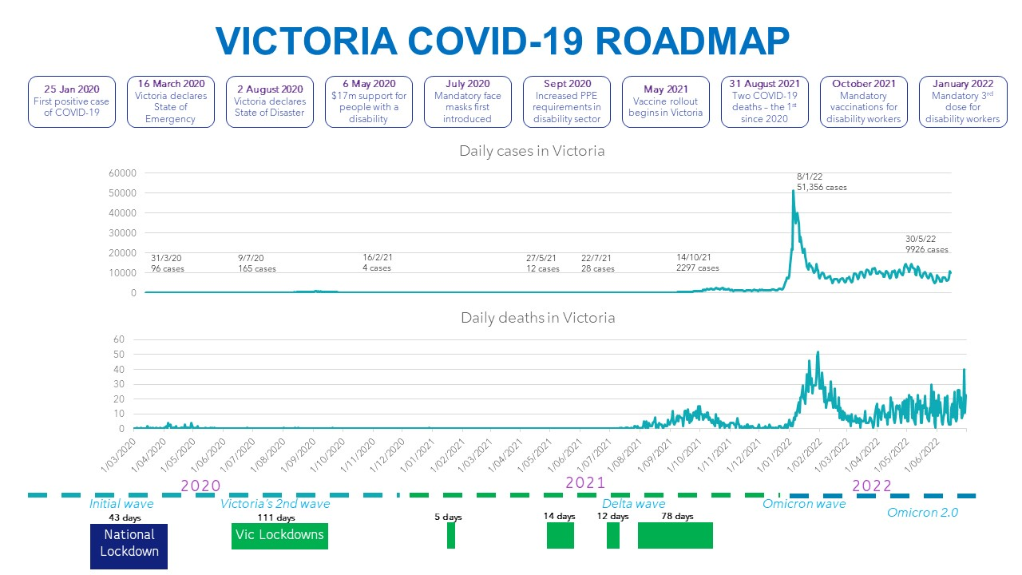

This diagram is based on data presented by Orima Research at an NDS presentation: Optimising your recovery from the pandemic

## COVID-19 detected in Australia

The first case of COVID-19 in Australia was reported in Victoria on 25 January 2020; a passenger who had flown in from Wuhan in China, the epicentre of the virus. On 26 March 2020, Victoria’s first three deaths related to coronavirus (COVID-19) were reported. The state’s total number of cases had already reached 520.

In March 2020, responses to the pandemic hit overdrive. The Victorian Government released its COVID-19 Pandemic Plan for the Victorian health sector, activated the State Control Centre, cancelled the Grand Prix, and declared a four-week State of Emergency to ‘flatten the curve’. Non-essential gatherings of over 500 people were banned.

## Early NDS Response

NDS in Victoria recognised that COVID-19 presented serious challenges for disability service providers, both in responding to the immediate impact of infection scenarios as well as reorienting their business models to address uncertainty and disruption in the medium and longer term.

This was particularly acute for smaller organisations that may not have had the resources for implementing multiple service changes and reorienting their business models.

NDS quickly responded to the emergency, recognising the potential risk for disability settings, and the imperative for accurate advice and practical support to keep people safe.

In the early months of the pandemic, NDS began working closely with the Victorian Department of Health and Human Services (DHHS). Drawing on this relationship, we ran joint webinars to keep disability services abreast of developments, issued timely news updates on key directions and advice, and provided advice to assist individual providers to navigate the government directives and multiple challenges of the pandemic.

## Safer and Stronger established

In June 2020, in recognition of the major impact of COVID-19 on disability services, DHHS funded NDS to provide tools, training and resources aimed at assisting providers to plan and prepare for their business continuity, and to adapt their practices to ensure appropriate infection controls were put in place.

The needs of smaller organisations operating in potentially thin markets (such as rural and regional providers, or culturally specific providers) were highlighted.

## Overview of Safer and Stronger Project

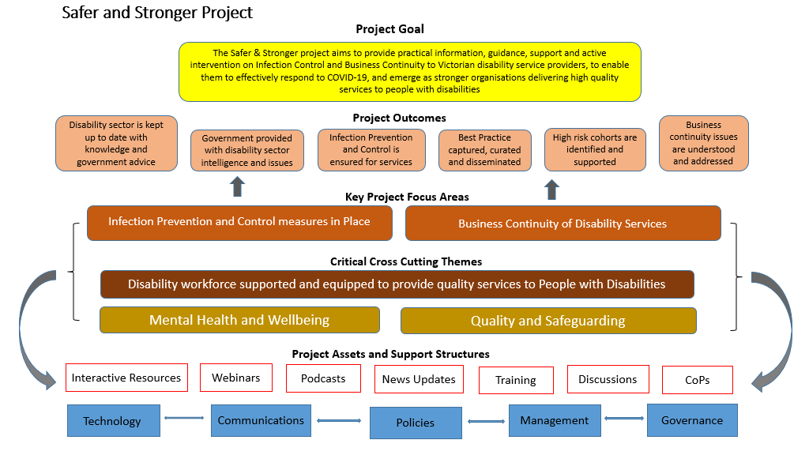

## 

## Meeting the challenges

|  |  |
| --- | --- |
| **Challenge** | **Response** |
| Delivering useful, practical, applicable information to support the sector in a complex, rapidly changing environment. | Safer and Stronger demonstrated key characteristics to support the sector:  Flexibility  Innovation  Responsiveness  Adaptability  Collaboration |
| Developing new tools and resources for dealing with a pandemic, specific to the disability sector, | * Larger providers shared the tools and resources they had developed, allowing NDS to adapt for use across the sector. * NDS responded to provider requests to develop and adapt useful and practical resources. |

A key trait of the Safer and Stronger project was its iterative and flexible nature which enabled NDS to adapt and respond to emerging and changing needs over the two-year project timeline. The initial broad framing of the project by both DHHS and NDS supported this approach.

## Case Study: Influence and advocacy

Throughout the pandemic, NDS Victoria advocated strongly for the needs of disability services within our engagement with the Victorian government. This was critical in ensuring that Victorian government directives and written advice took account of the nuances of the sector and recognised the differing disability settings and circumstances.

Examples included advocating for:

* clear advice for providers who operate along state borders during border closures
* directions for residential disability services being differentiated from those for aged care in isolation and lockdown scenarios
* a “traffic light” model of restrictions which provided greater certainty for the sector around implementation of restrictions in future lockdowns
* access to Commonwealth data regarding the vaccination status of cohorts of people with disabilities. This was critical to inform our targeted vaccine initiatives.
* the need for non-digital check-in options for population groups that are unable to use the digital QR codes.

# Engaging with the Disability Sector

Engagement with Victorian disability services underpinned the Safer and Stronger project. This included, but was not limited to, engagement with NDS member organisations.

The engagement infrastructure for the Safer and Stronger project was built around three broad tiers of communication and engagement:

* Disability sector wide general advice and information, provided using a range of mediums including webinars, newsletters and updates
* Specific information and training to support people working in a range of specific disability settings, including targeted communities of practice
* Provision of individual tailored advice to disability services, often in response to queries, and via phone or email.

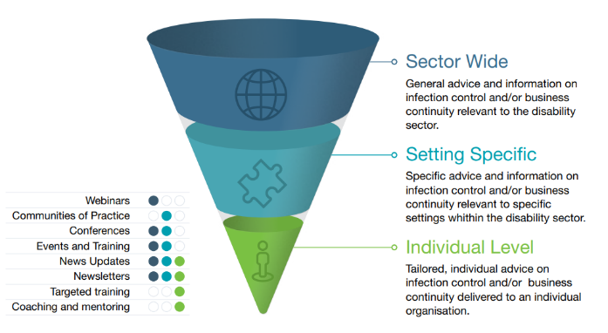

The NDS Safer and Stronger team adopted online communication tools to communicate with the sector early in the pandemic. Meetings and Communities of Practice previously held in-person were quickly replaced by online forums, as both NDS and the sector quickly learnt new skills and transitioned to online communication.

## Engagement Challenges

|  |  |
| --- | --- |
| **Challenge** | **Response** |
| NDS, government and the sector moving to online communications and engagement, i.e., technical expertise, working from home, IT infrastructure, unreliable internet. | NDS quickly adopted Zoom to connect with and inform the sector. State and Commonwealth experts delivered updates via regular NDS Zoom webinars. The sector also quickly adopted online communications, with more than 1,000 attendees at some of the early sessions. |
| Providers receiving accurate key updates, such as new public health orders in real time. | NDS established direct contact with DFFH / DoH for clarification through strengthened relationships.  Informed providers if more information was to come  Used direct communication methods e.g., email for critical information |

## Communications goes online

Delivering webinars, meetings and information sessions online had a number of positive outcomes.

* Increased direct engagement with regional and rural service providers
* Higher attendance at events, facilitating greater access to key information for providers
* Development of IT communications skills and familiarity for both NDS and the sector
* Bringing together key federal, state government and NDIA personnel to present on sector-specific issues
* Increased organisational capacity through greater interaction and sharing at well-attended meetings
* Strengthened networks with more NDS and government staff able to meet on the online platforms.
* Due to such benefits, online engagement has now been incorporated into standard NDS activities.

“Thank you to the team at NDS for your support and responsiveness to us through the challenges of COVID-19. You have played an important role in assisting the disability sector and we sincerely value the relationship we have with NDS.”

## Case Study: Adapting to online

NDS embraced online communications technology from the start of the pandemic. The high level of engagement at communities of practice, webinars, meetings, and forums resulted in governments and decision makers prioritising NDS to deliver information about COVID-19 that was clear, timely, accurate and meeting the needs of the disability sector.

NDS was quick to respond to emerging pandemic issues, which were impacting the disability sector. Safer and Stronger established regular online networks as they were needed, to ensure providers were informed and supported. These included:

* COVID Prevention, Vaccines and Outbreak Management Community of Practice
* Living with COVID-19: Information sharing and collaboration series
* DHHS Fortnightly Webinars.

Collaboration was a key characteristic of Safer and Stronger. Many organisations worked closely with NDS to provide expertise, knowledge, and support through the NDS online community. These included:

* Opening to COVID Normal in Victoria: Scoping the issues for disability services
* [Strengthening Senior Leader Resilience and Wellbeing](https://www.nds.org.au/index.php/resources/strengthening-senior-leader-resilience-and-wellbeing)
* Vaccination webinar for disability sector unions and workers, presented by Professor Ben Cowie.

This is a photo of a zoom webinar with 4 speakers. They are Graeme West from NDS, Toby Halls, who is an industrial relations expert, Anna Pannuzzo from Workplace Plus and Yumi Stamet from Purpose at Work

# Project Highlights

The following are Safer and Stronger project highlights from July 2020 – June 2022.

## Victorian COVID-19 Hub

Safer and Stronger created the Victorian COVID-19 Hub on the NDS website. This Hub was a critical source of key intelligence throughout the pandemic, with 4000 people visiting the landing page, or an average of seven people per day over the project’s two years.

As an open access platform, all Victorian providers have had access to an impressive suite of products, developed by Safer and Stronger; many in collaboration with sector, industry, and government partners.

* The [COVID-19 Toolkit](https://www.nds.org.au/index.php/covid-19-hub/victorian-covid-19-response/covid-toolkit) became a central access point for information and resources on Business Continuity, Infection Prevention and Control and Mental Health and Wellbeing. The Toolkit centralised internal and external resources for the sector, foresaw the mental health and wellbeing impacts on the workforce and was viewed 6,368 times over the two-year period.
* NDS member SCOPE Australia generously made its guidance document which outlined how to respond in the first 24 hours of an outbreak available to NDS to adapt and make available to service providers. This document has been updated and reproduced for all the other state and territories. [First 24 hours guide (Victoria): Responding to a positive COVID-19 diagnosis [doc]](https://www.nds.org.au/images/resources/covid/VIC_COVID-19_First-24-hours_Response_Feb22.docx)
* The [Snap Lockdown Guide](https://www.nds.org.au/covid-19-hub/victorian-covid-19-response/snap-lockdown-checklist) developed by Safer and Stronger was viewed 2,000 times. The guide was a checklist to assist providers to prepare for sudden lockdowns.
* A [Rapid Antigen Test resource](https://www.nds.org.au/index.php/covid-19-hub/victorian-covid-19-response/covid-toolkit#PPE) including links to supply guidelines, implementation, and a worker reporting tool was adapted from a resource developed and shared by Melba Support Services.

Infection Prevention and Control

Throughout the Safer and Stronger project, there has been an emphasis on building the capability of disability services to effectively implement strengthened infection prevention and control measures.

|  |  |
| --- | --- |
| **Product** | **Total** |
| Webinars, forums and meetings | 5,581 people |
| Videos and Podcasts | 7,466 views / listens |
| News Updates | 47,804 hits |
| Training | 272 attendees |

NDS produced IPC resources:

* [A Victorian First 24 hours document](https://www.nds.org.au/images/resources/covid/VIC_COVID-19_First-24-hours_Response_Feb22.docx) which outlines steps for providers to take in response to a positive COVID-19 diagnosis.
* A [Rapid Antigen Test resource](https://www.nds.org.au/index.php/covid-19-hub/victorian-covid-19-response/covid-toolkit#PPE) which was adapted from a resource developed and shared by Melba Support Services, includes links to supply guidelines, implementation, and a worker reporting tool.
* A [PPE outbreak supply calculator](https://www.nds.org.au/covid-19-hub/victorian-covid-19-response/covid-toolkit#infection_prevention_control) which assists providers to determine PPE requirements, and includes links to TGA-approved resources and when to apply different levels.
* A National “Preparing for Winter” webinar, including speakers from Federal DSS and DoH, NDIS Quality and Safeguards Commission, Life Without Barriers and NDIA
* Promotion of the Victorian Department of Health Disability Liaison Officer Program, to facilitate the uptake of vaccinations for people with disabilities.
* [Four short videos](https://www.nds.org.au/index.php/covid-19-hub/victorian-covid-19-response/covid-toolkit#infection_prevention_control) in collaboration with Health Education Collective, demonstrating the correct use of face masks, including disposal and washing of cloth masks.
* [Podcasts](https://www.nds.org.au/resources/nds-ndis-sector-development-podcast) and video with a sector worker and two people with lived experience sharing why it was important for them to receive a COVID vaccination.

## COVID-19 Vaccination rollout

|  |  |
| --- | --- |
| **Product** | **Total** |
| Webinars, forums and meetings | 1,138 people |
| Videos and Podcasts | 7,485 views / listens |
| News Updates | 23,009 hits |
| Vaccine Rollout Webpage | 5,267 webpage hits |

NDS Safer and Stronger took a lead in promoting COVID-19 vaccination and overcoming hesitancy in the disability sector. Some of the highlights were:

* The [COVID-19 Vaccine rollout for the Disability Sector](https://www.nds.org.au/item/covid-19-vaccine-rollout-for-the-disability-sector) FAQs and vaccine webpage
* The AMAZE, Vic DoH, and NDS Safer and Stronger social scripts for adults and children with autism or anxiety regarding their COVID-19 vaccinations that have been downloaded more than 6,500 times (Source: AMAZE)
* Our Disability Vaccine Collaborative fortnightly meetings in 2022, which supported funded organisations targeting unvaccinated people with disabilities (funded by DoH)
* The NDS-DoH Disability Sector Engagement Work Group and Planning meetings, which provided valuable insights and support for the vaccination rollout
* Our Living with COVID-19 fortnightly webinars
* Two videos produced by NDS - ["COVID Vaccine - Getting it done in disability"](https://www.nds.org.au/covid-19-hub/covid19-vaccine)

## Focus on CALD communities:

* NDS partnered with DFFH, DoH Infection Prevention Control Response (IPCAR) team and Ethnic Communities' Council of Victoria (ECCV) to deliver IPC webinars for CALD workers
* 12 languages versions of the AMAZE - NDS social scripts, with links from state and federal health websites, were created
* NDS attended the ECCV Statewide Disability Network, providing updates on COVID requirements, updates, and vaccination information
* Workshops were delivered on communication in an inclusive and effective manner with CALD groups. NDS will support delivery of refresher infection control training with ECCV, VicHealth, IPCAR and CALD workers.

## Business Continuity

The Safer and Stronger project recognised that disability services needed to focus on business continuity, both in terms of short-term continuity of service for people with disability, and in relation to longer term business viability. Throughout the project, a broad ranging array of initiatives have contributed to this stream of work.

|  |  |
| --- | --- |
| **Product** | **Total** |
| Webinars, forums and meetings | 7,010 people |
| Videos and Podcasts | 9,739 views / listens |
| News Updates | 12,239 hits |

* NDS supported boards and senior leaders with forums around optimising organisational performance. Topics covered included strategy setting (with a guest speaker from Pitcher Partners), customer centricity, risk management, Orima research on the experience of the disability sector during COVID, quality and safeguards and clinical governance and risk management. Sessions were recorded and profiled on the NDS website.
* NDS responded to provider business continuity issues, providing support for approx. 12-15 queries per month throughout the project
* Business continuity resources developed, loaded to the NDS Website, and promoted to address COVID-19 challenges included
  + Business continuity planning 101
  + Risk management focus areas in business continuity planning
  + Business strategy development to address economic viability challenges
  + IT transformation to improve connectedness and improve processes
  + Customer experience with CX Fundamentals - don’t forget the customer
  + Frontline worker emergency communications
  + Lifting clinical governance
  + Taking action to improve governance learning from the Disability Royal Commission findings
  + Understanding customer and work needs through research results.

## Workforce

During the course of the Safer and Stronger project, the focus on the disability workforce increased, with recognition of challenges associated with recruitment, retention, mental health and wellbeing and skills and capability building.

|  |  |
| --- | --- |
| **Product** | **Total** |
| Webinars, forums and meetings | 1,313 people |
| Videos and Podcasts | 1,209 views / listens |
| News Updates | 8,890 hits |

* 7 [videos and resource booklets](https://www.nds.org.au/resources/creating-an-enabling-workplaces-video-series) developed and available on the [NDS Workforce Hub](https://www.nds.org.au/resources/creating-an-enabling-workplaces-video-series)
* Workforce webinars attracted large audiences and were rated very valuable by attendees
* A workshop focused on strategies for retaining Allied Health workers was delivered
* Resources were devoted to monitoring NDIS Worker Screening Check application delays and assisting fast tracking of applications where required
* A webinar was delivered on etaining employees in the disability sector
* NDS facilitated Purpose@Work workshops on building an enabling environment for workers
* [Workforce supports for the disability sector in response to Covid-19](https://www.nds.org.au/images/workforce/workforce-project/NDS-COVID-19-Workforce-Paper_final-V-Public.pdf) were provided
* [SACS webinars,](https://sacsconsult.com.au/resources/nds-members/) such as Candidate Attraction and Evaluation, were delivered

## Case Study: Vaccine hesitancy

Vaccine hesitancy among disability workers presented real concerns around the sector’s capacity to protect and support people with disability during an outbreak and protect the health of the workforce. NDS initiated and collaborated on innovative and far-reaching communications and engagement tools to address vaccine hesitancy and promote vaccinations in the sector.

The resources and events NDS produced included:

* Partnerships to deliver online training to build confidence in COVID-19 vaccines and address vaccine hesitancy in the workforce. NDS ran 15 COVID Prevention, Vaccines and Outbreak Management CoPs.
  + **1200 people attended the vaccine CoPs**
* Collaboration with providers, unions, and Government to produce two videos; ‘COVID Vaccine – getting it done in disability’. The first talking to people about the first vaccination and then a follow up about the second vaccination.
  + **3330 viewing of these vaccine videos**
* Collaboration with DFFH to produce four podcasts and a video with four of Victoria’s Vaccine Champions
  + **4400 times podcasts and video were played**
* NDS produced disability-specific Vaccine FAQs to bring the latest key changes to providers as they are announced.
  + **9000 views of the vaccine rollout webpage**
* NDS and AMAZE produced 12 Social Scripts for children, teens, and adults with Autism, to show what happens when getting a vaccination at a Vaccine Hub, pharmacy, GP, and drive-through clinic.
  + **6500 times the Social Scripts were viewed.**

# What we have learnt

## Business continuity

* Providers’ financial positions and forecasts have been negatively impacted. Business and operational conditions have worsened over the project period. Losses have resulted from combined COVID-19 impacts and unexpected SIL reductions. Increased wage rates, overtime, and penalties coincided with lower participant income. While JobKeeper was welcomed, the benefits were overshadowed by sustained cost, income, and service provision challenges
* The pandemic accelerated several trends in the market, and NDS has seen an increasingly competitive, dynamic disability market. There are reports of mergers of services and focus on cost recovery, new markets and increasing exploration of merger and acquisition options.
* To reduce the risks to business viability, NDS is encouraging and supporting providers to regularly update financial forecasts, limit costs, review operational approaches and service offerings and consider mergers and acquisitions as appropriate.
* Ongoing reviews and updates of provider outbreak plans and business continuity plans (including updated reporting needs) are actively encouraged and supported.

## Infection Prevention and Control

* Workforce vaccination – NDS is supporting mandated and non-mandated vaccination drives, relating to both COVID-19 and Influenza. NDS through its established channels is raising awareness of the safety and efficacy of vaccinations.
* NDS continues to promote stockpiling of PPE and RATs to meet outbreak requirements and is advocating for NDIA financial support.
* NDS committed to identifying IPC training options including opportunities to provide input on emerging issues and support delivery in a variety of multimedia formats and channels are utilised to ensure all target audiences are reached.

## Workforce

* Continued support from government to manage worker mobility is welcomed
* Providers found that when they tried to access surge workforce that there were limited options, especially in regional areas. This needs to be addressed
* There have been high levels of stress and fatigue for all staff in disability services from disability support workers through to CEOs. The duration over which this stress continues to be experienced raises concerns about long term impacts on staff wellbeing
* Targeted IPC training was very welcome and needed. We have seen an increase in providers who prefer or who will only hire Certificate III Individual Support qualified workers where they can. They want staff who can be trained and operate with the increased IPC requirements.
* Bendigo Health worked with NDS, local providers and Disability Liaison Officers (when they were put in place), and this quickly led to clarification of roles and resources and great support for the disability sector.

## CALD Communities

Findings from the COVID Safety for Culturally and Linguistically Diverse (CALD) Communities report, prepared by Catalyst Training and Disability Services for NDS:

For disability services to stay safe and maintain high quality standards around quality management of infection control, it is important that the communication of all safety measures includes all at risk groups, including people from CALD backgrounds.

The following recommendations are based on the suggestions from the disability agencies interviewed in the project as well as the knowledge derived from ethno-specific services who provide support to people with a disability.

* Preparation of policies and practices, including cross-cultural training for CALD groups before a pandemic or community emergency takes place to mitigate against services being caught off guard.
* Collation of translated disability specific resources and other relevant CALD resources stored in a location accessible to disability service providers
* Cross cultural awareness and communication training be made available to disability services, so that services are aware of how specific CALD communities receive information and how best to communicate with people who have limited English. Training to be tailored where possible around the CALD groups present within the specific service (or group of services)
* COVID-19/Pandemic plans to include how safety messages are to be passed on to staff, participants and relevant others from CALD backgrounds
* Series of short, practical videos be developed to communicate key messages in English and other key languages to facilitate messaging for participants with an intellectual disability or permanent cognitive impairment.

## Safer, Stronger and Smarter

Key Lessons from the Victorian Disability Sector’s Response to COVID-19 in 2020 Safer, a report by /Graeme Kelly – Optimate Consulting, February 2021 for NDS.

* Continue to invest in promoting learning and good practice to reduce unnecessary ongoing IPC risks
* Keep pushing for system improvement in logistics and IPC support
* Retain and strengthen emergency management governance changes
* Make positive changes for staff wellbeing and consolidate better communications
* Reassess strategic intentions and modify governance to make change happen
* In recovery mode focus on NDIS and market changes and adapt to survive and thrive or develop an exit strategy
* Collaborate with others for continuing quality improvement and strategic options.

# Listening to the sector

The Victorian disability sector continued to be under extreme pressure as we started 2022, with the impacts of COVID, extensive workforce shortages, NDIS cost curbing and increased market competition.

In January 2022, NDS began to conduct polling of “pain points” at Communities of Practice and webinars to get a deeper understanding of the top issues that were having an impact on providers.

Consistently NDS polling identified the following as top provider concerns:

* Workforce shortages and fatigue
* Business viability
* Worker and participant wellbeing
* Maintaining high Infection control and prevention knowledge and practice across a casualized workforce where training resources are limited

## Workforce shortages

Workforce shortages consistently polled as a major concern for providers.

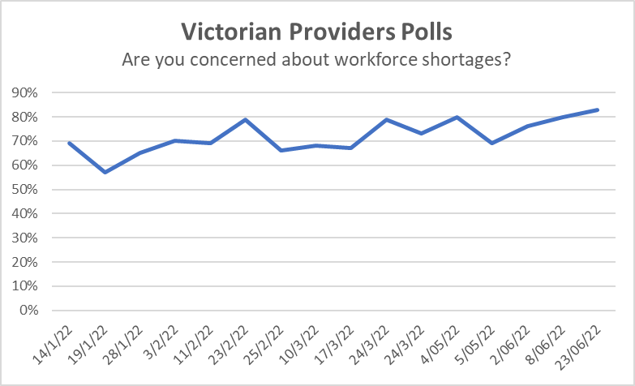

Staff shortages exacerbated by closed borders, vaccine mandates and competition for workers at the start of 2022 were further stretched with the rise of Omicron cases, winter flu and staff furloughs.

In January, 70% of providers listed workforce shortages as a top three concerns, which rose to 83% by the end of June.

## Business Viability

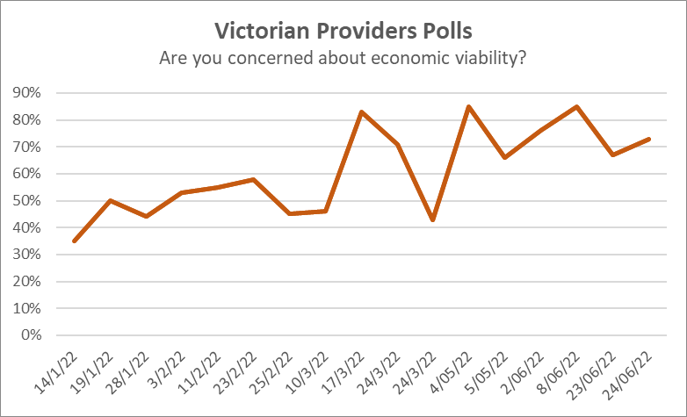

Many providers reported they expected to make a financial loss in 2021/22.

SCHADS award changes and cost impacts will be significant. Particularly factoring in broken shifts allowances, providers are reviewing their rosters to minimise costs and maintain service quality.

NDS is seeing an increasingly competitive, dynamic disability market.

## Heightened anxiety and stress

This is a line graph showing the rate of concern amongst providers about mental health and wellbeing of staff, and mental health and wellbeing of participants. The graph shows that mental health and wellbeing of staff was consistently a  key concern for about 60% of providers. Meanwhile, mental health and wellbeing of participants was consistently a key concern for 20-30% of providers. We saw a spike in concern about mental health and wellbeing of participants in February.


Fatigue and stress were ongoing issues. Change fatigue was widespread due to pressures from living with and dealing with COVID-19.

Staff operated at hypervigilant levels for too long, sometimes resulting in burn out or resignation.

In early 2022, maintaining resilience and energy emerged as a top issue in the polls.

NDS responses included the following workshops and webinars:

* Creating enabling workplaces workshops - covered psychological safety and wellbeing, engagement, connection, stimulation, and support. Participants could have a 20-minute post workshop coaching session.
* Videos on senior leadership wellness with SuperFriend and Beyond Blue presenting were published and widely promoted.

## Impact of Omicron

Since the outbreak of Omicron at the beginning of 2022, providers have been dealing with the added challenge of staff furloughs through COVID-19 infections, and the Public Health Orders for close contacts.

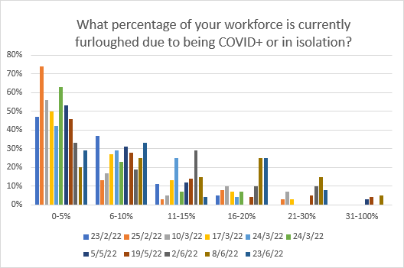

At the start of the year, most providers reported through the Polls, that they had 0% - 5% staff furloughed.

Significant numbers of providers, up to 30%, also have consistently reported 6%-10% COVID-impacted staff absences.

By May 2022, greater numbers of providers were reporting staff absences due to COVID-19 of 16-25%, 21-30% and even above 31%.

# Conclusions

The COVID-19 pandemic has posed a major challenge to the disability sector, and people with disability, service providers and government are to be congratulated on all the many efforts to respond to this and ensure that Victorians with disability have been protected as much as possible.

At NDS we believe the Safer and Stronger project and activities have made a valuable contribution to this work and helped harness some of the powerful collaboration across the sector and with key stakeholders including DFFH, Department of Health, and NDIA.

NDS played a valuable role as the peak body representing disability providers, as a conduit of rapid information to the disability sector and keeping government up-to-date on emerging issues and developments. NDS facilitated early identification of issues and supported collaborative solutions with relevant stakeholders.

The Safer and Stronger brand will continue, with the recognition that the focus of NDS is supporting providers with delivery of high-quality, safety-focused services for the sector.

The two-year project has left a valuable legacy with an online hub of resources, increased sector knowledge about infection prevention and control, an online engagement infrastructure of communities of practice, and a track record of provider collaboration which will stand us in good stead for challenges ahead.

The current challenges of ongoing viability, continuing IPC training to maintain currency with emerging health needs, workforce shortages and mental health and wellbeing are pressing issues for the disability sector.

The legacy of Safer and Stronger means NDS has the capacity, resources, trust, networks, knowledge, and infrastructure to address and overcome current and future challenges in collaboration with disability providers.

# NDS Resources

NDS produced resources specific to the disability sector, responding to the void highlighted by the COVID-19 pandemic; preparation for such an event was ill-prepared and under-funded across the globe, particularly for the protection of vulnerable communities.

Safer and Stronger responded swiftly to the emerging challenges to produce a suite of practical tools and resources, which were valued by the sector. These include:

### Victorian COVID-19 Hub

* [COVID-19 Disability Sector Toolkit](https://www.nds.org.au/index.php/covid-19-hub/victorian-covid-19-response/covid-toolkit)
* [Victorian COVID-19 Recordings](https://www.nds.org.au/index.php/covid-19-hub/victorian-covid-19-response/vic-covid-19-recorded-webinars?cookietags=1)

### Outbreak Management

* [First 24 hours guide (Victoria): Responding to a positive COVID-19 diagnosis](https://www.nds.org.au/images/resources/covid/VIC_COVID-19_First-24-hours_Response_Feb22.docx)
* [Handy guide to key COVID-19 contacts and resources in Victoria [doc]](https://www.nds.org.au/images/Accessible_Victorian_Disability_Service_Provi_Emma_Bloom.docx)
* [NDS guide to responding to a Snap Lockdown](https://www.nds.org.au/covid-19-hub/victorian-covid-19-response/snap-lockdown-checklist)
* [Responding to COVID-19: Lessons from 2020 recorded seminar](https://www.nds.org.au/covid-19-hub/victorian-covid-19-response/vic-covid-19-recorded-webinars/responding-to-covid-19-lessons-from-2020-recorded-seminar)

### COVID-19 Vaccinations

* [COVID-19 vaccinations FAQs](https://www.nds.org.au/item/covid-19-vaccine-rollout-for-the-disability-sector)
* NDS vaccine videos: [COVID Vaccine - Getting it done in disability](https://www.nds.org.au/covid-19-hub/covid19-vaccine#VaccineVid)
* [COVID-19 vaccination social scripts](https://www.nds.org.au/covid-19-hub/covid19-vaccine#Social_scripts)
* [NDS COVID-19 Vaccination Podcasts](https://www.nds.org.au/resources/nds-ndis-sector-development-podcast)
* [COVID-19 Safer and Stronger: Disability Vaccine Champions](https://www.nds.org.au/index.php/resources/covid-19-safer-and-stronger-disability-vaccine-champions)
* [My COVID-19 vaccination journey podcast with Rhino, a man with a brain injury](https://ndsresources.podbean.com/e/nds-my-covid-19-vaccination-journey-podcast-with-rhino-a-man-with-a-brain-injury/)
* [My COVID-19 vaccination journey podcast with Sonia, person with a brain injury](https://mcdn.podbean.com/mf/web/493byr/Sonia_podcast_V29eiwt.mp3)
* [My COVID-19 vaccination journey podcast with Sonia, person with a brain injury (highlights)](https://mcdn.podbean.com/mf/web/493byr/Sonia_podcast_V29eiwt.mp3)

### Business Continuity

* [NDS Mergers and Acquisitions videos for Boards and CEOs](https://www.nds.org.au/covid-19-hub/victorian-covid-19-response/covid-toolkit#business_continuity)
* [SACS Consulting Disability Resource Hub](https://www.nds.org.au/index.php/resources/sacs-consulting-disability-resource-hub)

### Infection and prevention control

* [The correct use of face masks - an introduction](https://youtu.be/1E7mtaq5_B0)
* [The application and removal of Cloth Masks](https://youtu.be/WwbOt57l1C0)
* [The application and removal of Surgical Masks](https://youtu.be/0rkcpC5XyM4)
* [The application and removal of N95 / P2 Masks](https://youtu.be/75vAF_9ClUk)

### Workforce

* [How to Create an Enabling Workplace — Video Series](https://www.nds.org.au/index.php/resources/creating-an-enabling-workplaces-video-series)
* [Strengthening Senior Leader Resilience and Wellbeing](https://www.nds.org.au/index.php/resources/strengthening-senior-leader-resilience-and-wellbeing)