Maximising Performance Framework

Context
Organisations need to support their staff to provide quality services to people with disability, as well as to improve their practice over time. In order to achieve this, it’s important to have a structure around staff development that continuously monitors staff behaviour and values, and supports them to improve and align their practice to applicable standards, like the NDIS Quality and Safeguarding Framework.
The Maximising Performance Framework can be used by organisational leaders to consistently and proactively develop the skills of their workforce, and engage with them in a regular and intentional way. Effective use of the framework will help leaders better understand staff as they share self-reflections, develop their sense of motivation to improve, and increase their sense of having progressed in their practice over time.
The structure of the Maximising Performance Framework represents a shift from more traditional approaches to performance evaluation where greater emphasis was placed on evaluating past actions, and less on building future desired performance. In implementing this Framework, it is important to ensure leaders have a focus on:
- Inspiring staff to want to improve practice over time
- Positively and regularly engaging with staff
- Setting clear expectations, aligned to organisational values and legislative standards
- Providing regular, clear feedback to staff about performance
- Having transparent and fair ways to evaluate performance
Aim
The framework provides managers, human resources and Change Leadership Committees advice on how to embed a Maximising Performance Framework that is future focused and aligned with the objectives of the organisation. Organisations that already have other frameworks for workforce supervision or performance development are encouraged to benchmark them against the provided framework for continuous development.

Benchmarking Instructions
If your organisation has a performance development / supervision framework, compare that to the elements of the framework as a benchmarking exercise. Some key questions to ask when comparing are:
- What do we hope to achieve as a result of performance development / supervision activities?
- Is performance development / supervision focused on employee coaching and growth, or more focused on evaluating past performance?
- Do managers have simple guidelines to share corrective feedback and develop staff skills?
- Consider how staff experiences the performance development / supervision process. Do staff report that this is an empowering, practical and useful process, or one that is confusing, frustrating, and unhelpful in improving their work practice? Does the investment cost of performance development / supervision (financial and psychological) match the return value?

Maximising Performance Framework Explained
The Maximising Performance Framework is designed to foster continuous improvement, aligning people’s performance with overall organisational performance. It is designed to ensure that staff has developmental conversations with their leaders, peers and people they support on an ongoing basis in both formal and informal ways. It assumes staff want to improve as well as perform well and that the role of the organisation is to support them to do that.
There is a graphical representation of a suggested Maximising Performance Framework on the next page while a detailed explanation of each element has been provided in the section ‘Elements of the Maximising Performance Framework’.
A stepped approach is suggested to implement and embed the Maximising Performance Framework. In Step One, it is suggested that formal goal setting and review process is carried out biyearly along with frequent informal check-ins throughout the year. See the formal Biyearly Contribution Chat (BCC) – ‘A Framework for Maximising Performance’ in the following pages. After piloting this approach for at least a year, we suggest that the provider organisations review the biyearly approach, and if they feel ready, progress to the shorter quarterly formal review and goal setting, which is the Quarterly Contribution Chats (QCC) – ‘A Framework for Maximising Performance’ in the following pages.

Instructions for Use
Familiarise yourself with the contents of this document and adapt the tools and practices to your organisation’s context and requirements.
Spend time planning beforehand, ensuring that leaders have the skills and time to coach their teams to use this framework with them.

BCC- A Framework For Maximising Performance (adapted from Bersin by Deloitte Research Report)
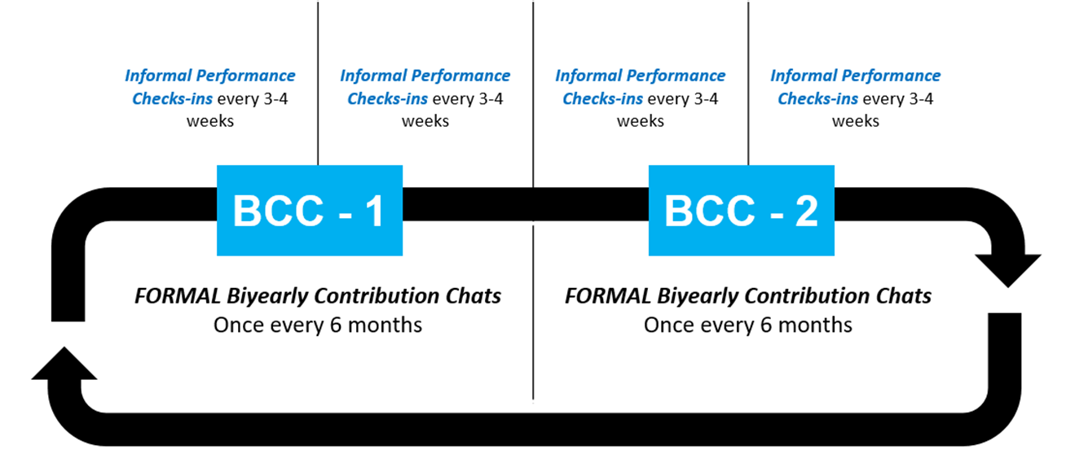
PERFORMANCE CHECK-INS | BIYEARLY CONTRIBUTION CHATS
Discuss how the goals are progressing  Exchange perspectives  Discuss ongoing learning and development  Address any barriers  Provide encouragement and reinforcement | Discuss the contributions made to the overall organisational objectives  Discuss the perspectives sought from the people being supported  Self-reflections of biyearly successes and challenges  Update goals if required  Discuss development goal

QCC – A Framework for Maximising Performance (adapted from Bersin by Deloitte Research Report)
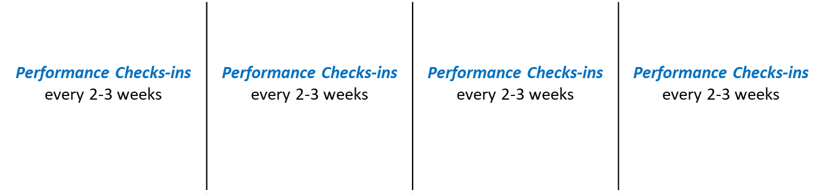

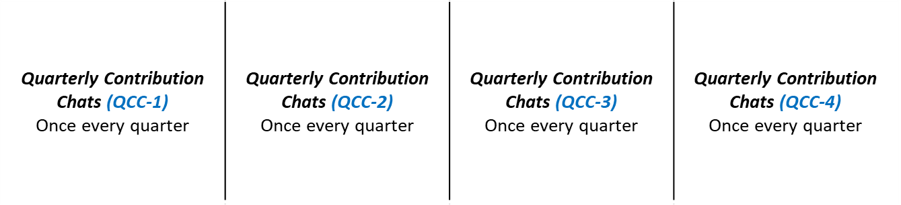
Q1
Q2
Q3
Q4

PERFORMANCE CHECK-INS | QUARTERLY CONTRIBUTION CHATS
Discuss how the goals are progressing  Exchange perspectives  Discuss ongoing learning and development  Address any barriers  Provide encouragement and reinforcement | Discuss the contributions made to the overall organisational objectives  Discuss the perspectives sought from the people being supported  Self-reflections of quarterly successes and challenges  Update goals if required  Discuss development goal

Elements of Maximising Performance Framework

1.  Set Expectations and Goals |  | 2.  Seek Stakeholders Perspective |  | 3.  Self-Reflection |  | 4.  Performance Check-Ins |  | 5.  Biyearly / Quarterly Contribution |  | 6.  Customised Learning Plans
- Set Expectation and Goals – Ensure goals and expectations are clear to both the manager and the team/individual staff member, developed collaboratively and aligned with the objectives of the organisation. The frequency of goal updates can vary but it is recommended they are updated at least every biyearly for BCC and on a quarterly basis for QCC. It is recommended that the same high level goals are shared by all throughout the organisation, however expectations would vary based on the job role. For example the high level goal of ‘a robust reporting culture’ could be shared with the senior and middle management as well as the support staff. However the senior management may be expected to achieve overall compliance towards this goal, middle management may be expected to educate and mentor support staff on just in time reporting and the support staff may be expected to accurately complete and submit the reports for example.
- Seek Perspectives of people with disability and their families - It is important you seek input from the people being supported, their carers or family members about their experience with your staff and services. The focus on continuous development could see you engage with individuals and families using a co-design or consultation process or a feedback system that supports continuous improvement. Perspectives can be sought informally through questions like: How could I improve your experience with our service?
- Self-Reflection – Practicing self-reflection helps people to be aware of their feelings and emotions, which is important in the workplace. As people develop this skill, they are more able to understand the reasons for their actions and reactions, to be in control of these, and to build more capacity to understand others. This can be described as ‘Emotional Intelligence’, which is a strong component of people being successful both personally and professionally. It is important that in addition to the perspectives you seek from the people being supported, your manager or colleagues, that you take time to have self-reflection on your strengths, weaknesses and opportunities for improvement /development. Use the guidelines provided in this document ‘Questions for Self-Reflection’.

- Performance Check-Ins - During these conversations, managers, teams and staff members can discuss a range of topics that can include self-reflections, insights from people accessing services, manager perspectives and development. The frequency and the timelines of these conversations depend upon the organisation, but it is recommended check-ins are undertaken at least once a month. These can be held in an informal manner for approximately 15-20 minutes face to face or via telephone. Check-ins can be initiated by either the manager or the staff member themselves. As check-ins are intended to be informal, they can be simple conversations that do not require collecting or updating data of the reviews (the administrative tasks) as that may be required in the formal review periods.
- Biyearly (BCCs) or Quarterly Contribution Chats (QCCs) – A formal future-focussed discussion, usually held on a biyearly or quarterly basis is dedicated to discussing how perspectives were shared, improvements that were implemented, and the quality of the service to the people supported. It can be used to set goals and expectations for the next quarter. We strongly recommend that any aspect of scoring and ranking the performance is removed from these discussions as these practices are shown to negatively impact the performance, collaboration and engagement. These formal Contribution Chats should be consistent with your organisation’s policies and procedures around staff performance and review.
- Familiarise yourself with the resources below and use them during the formal contribution chats as required:
- Review - Use ‘After Action Review’ (AAR) questionnaire from the BAP/ AAR tool from the Making Change suite of tools to review the performance at the contributions chats
- Improvement Coaching – Use the ‘Guidelines for Providing Development Coaching’, as shown in this document in order to develop or improve a required skill
- Corrective Feedback – Use ‘Guidelines for Providing Corrective Feedback’, as shown in this document to share your performance / behaviour related concerns and provide improvement coaching
- Define - Use ‘Before Action Planning’ (BAP) template to clearly map expectations and goals for the next period.

Guidelines for Providing Developmental Coaching

Step 1 – | Discuss an opportunity for development  Opportunities could require enhancing current skills and/or implementation of new acquired knowledge
\Step 2 – | Mutually Agree on a developmental goal  The developmental goals could be identified as a result of the After Action Review (AAR), discussions at the contributions chats (QCCs or BCCs), or identified by the staff member, or due to the changed scope of work
Step 3 – | Identify barriers that may slow down progress  Brainstorm the current aspects that could prevent the staff members to successfully achieve the outcomes of the goals on time. Barriers could relate to personal factors, process factors and/or environmental factors
Step 4 – | Mutually agree on solutions to achieve the goal  Identify solutions to overcome the barriers and achieve the outcomes. Make sure the solutions are clearly defined as actionable items, with performance indicators and realistic timelines
Step 5 – | Seek and give commitment  It is important that that you commit to providing any support and assistance required, and also seek commitment from the staff member to work towards the actions
Step 6 – | Follow up / frequent performance check-ins  You have frequent informal check-ins during the coming weeks to ensure the staff member is on track with the plan of achieving the outcomes

Guidelines for Providing Corrective Feedback
Step 1 – | Share the current performance concern / gap  Briefly share the concern statement. Separate the person from the problem e.g. Instead of saying I am concerned that you are not a team player, say I am concerned that the duty list is not being completed regularly on your shift, which impacts other team members.
Step 2 – | Share your specific experiences and observations about the current behaviour / performance  Briefly share specific instances that you have observed yourself or have been made aware of
Step 3 – | Explain the implications and impact of the current performance to the team, the people we support and the bigger organisation if sustained.  Briefly discuss about the social, legal, ethical, quality, safety, health, reputational or other implications
Step 4 – | Reiterate / explain the expected behaviour /performance  Ask about the staff member’s current understanding of the expectations. If their understanding is aligned with the actual expectations, then acknowledge and reinforce. If they have misunderstood, provide clarity about what is expected.
Step 5 – | Mutually agree on a developmental goal to address the gap  To develop a goal, brainstorm the characteristics that will inform the ideal end state. Then articulate them into a goal statement.
Step 6 – | Identify barriers that may slow down the progress  Brainstorm the current barriers that could prevent staff from achieving the outcomes on time. Barriers could relate to particular roles, processes or environmental factors
Step 7 – | Mutually agree on the solutions to achieve the goal  Identify solutions to overcome barriers and achieve the outcomes. Make sure the solutions are clearly defined as actionable items, with performance indicators and realistic timelines
Step 8 – | Seek and give commitment  It is important that you commit to providing any support and assistance required, and also seek commitment from the staff member to work towards the actions. People are more likely to achieve a goal when they have made a commitment to do so.
Step 9 – | Follow up / frequent performance check-ins  It is important that you have frequent check-ins (these can be informal, but intentional) during the coming weeks to ensure the staff member is on track with the plan of achieving the outcomes

Questions for Self-Reflection
What I have learned over the last quarter? (Skills, knowledge, experience, etc.)
What achievement am I proud of that has happened in the last quarter?
How have I demonstrated the organisational values in providing services to people with disability (and their families/carers)?
How have I added value to my organisation in the last quarter?
How have I added value to the lives of people I support?
What aspects of my interactions and the way I provide services can be further improved?
What is one area I would like to learn more about, to improve or develop?
What resources/ information do I need in order to learn and grow in the next quarter?
What formal or informal training, tools, or experience could benefit me in the next quarter?

Staff Performance Action Plan
My work priorities for the period (Insert QCC or BCC timeframe)
Team goals | My individual goals | Key actions | How will I know I have achieved this?
My development opportunities for the period (Insert QCC or BCC timeframe)
What do I need to learn to grow in my current role?
Current gaps in my skills, knowledge or competencies | How do I plan to close the gap? | Due date | Opportunities to apply this skill

Contribution Chat Process Flow (biyearly or quarterly)

Staff member seeks perspective from the people they support where possible |  | Staff member reflects on their achievements for the last six months or quarter (Refer to self-refection questions)

Manager invites the staff member for the Contribution Chat (BCC) or (QCC)
Staff member shares the self-reflections with the manager
Manager highlights and acknowledges the key achievements for the last six months or quarter
Manager and the staff member discuss how the organisational values were demonstrated
Manager and staff member discuss ways to demonstrate organisational values and Code of Conduct
If Manager has a concern about the staff member’s performance or behaviour, provide the corrective feedback
(Refer to the Corrective Feedback and Coaching Guidelines)
If the Manager or the staff member identifies an opportunity to develop or strengthen a skill, provide developmental coaching
(Refer to the Developmental Coaching Guidelines)
Manager and staff mutually set goals and expectations for the next six months or quarter
Manager and the staff member mutually develop a learning plan for the next six months or quarter
(Refer to the Staff performance action plan)
Manager and the staff have frequent performance check-ins, proportionate to the goals and expectations that have been set
(Refer to the Staff performance action plan)

References
David Rock, Beth Jones, and Camille Inge, Reengineering performance management: How companies are evolving PM beyond ratings, NeuroLeadership Institute, 2015.
Bersin by Deloitte (2017), Continuous Performance Management. Available at Marketing Bersin website (Accessed: 19 October 2018)

