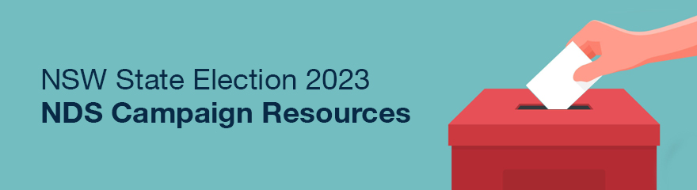

National Disability Services

NSW State Election 2023 Campaign Resources
The NSW State Election on 25 March is a crucial opportunity to advocate for state government policies that strengthen the disability support sector and progress genuine inclusion for people with disability.
National Disability Services (NDS) will be calling on all candidates and political parties to make commitments across key disability policy areas.
Disability service providers with networks and relationships in their local community can play a crucial role in this campaign. Together, we can build support across the state for stronger and more inclusive disability policies.

Social media posts
Below are some suggested posts for providers to promote the campaign issues on social media. Feel free to add information about your organisation, experiences and concerns.

Sample post: Campaign overview
Suggested post: week of 13 February
Download social graphics
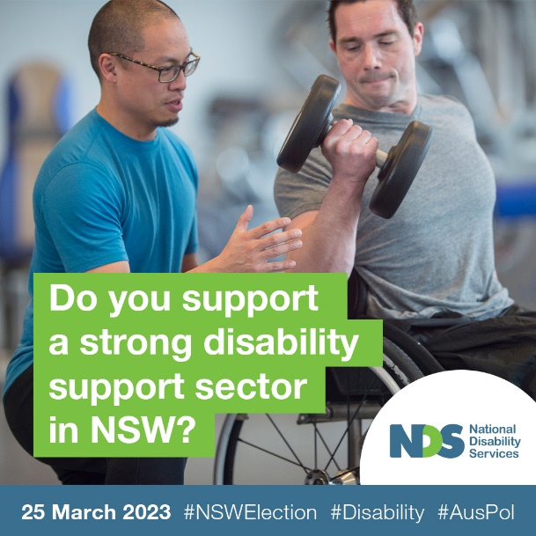
The #NSWElection on 25 March is a crucial opportunity to strengthen the disability support sector. ✊
We’re supporting a campaign led by @NationalDisabilityServices calling on candidates and political parties to make election commitments across key disability policy areas.
Whether you’re a person with lived experience or someone who provides support to people with disability, you can play a crucial role in making this happen. Together, we can build momentum across the state for stronger and more inclusive disability policies.
Show your support for the campaign online, and ask your NSW candidate if they support a strong disability support sector in NSW.
Learn more about the key election asks:
https://www.nds.org.au/news/nds-releases-nsw-election-platform
#AusPol #nswpol #Disability

Sample post: Speaking directly to candidates
Suggested post: week of 20 February
Download social graphics
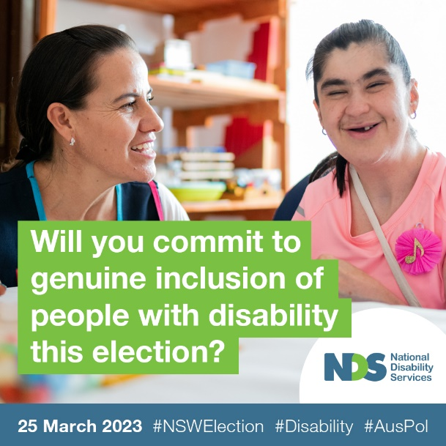
This #NSWElection on 25 March, we want to see all parties commit to strengthening the disability support sector. 💪
That’s why we’re supporting a campaign led by @NationalDisabilityServices calling on all candidates and political parties in the election to make policy commitments across key disability policy areas.
We’re asking our local candidate [tag your mp] to commit to the four areas of most need:
✅ #Workforce: invest in building capacity.
✅ #Housing: Commitment to providing access to suitable housing
✅ #Support: Supporting people with disability outside the NDIS framework
✅ #Employment: Improving the employment and economic participation opportunities for people with disability
[name of MP], will you commit to genuine inclusion of people with disability this election?
Help us build momentum across the state for stronger and more inclusive disability policies.
#AusPol #nswpol #Disability

Sample post: Key priorities (4 posts)

Post one – Workforce
Suggested post: week of 27 February
Download social graphics
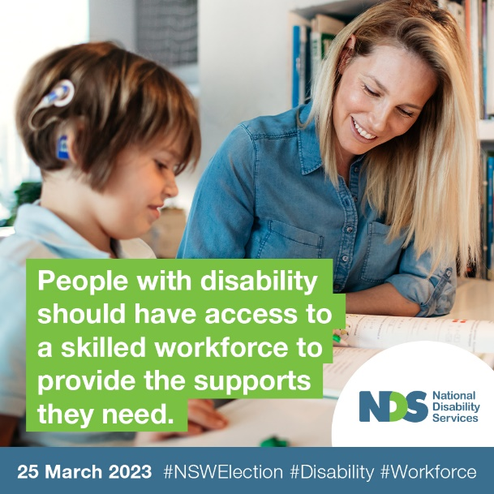
This #NSWElection on 25 March, we want the @NSWGovernment to ensure people with disability have access to a resilient disability support sector and skilled workforce. 💪
This includes funding strategies and actions to promote careers in the NSW disability sector to address key workforce shortages, and investment into the retention of a skilled disability workforce.
Help us build momentum across the state for stronger and more inclusive disability policies by asking your local candidate the question: “What is your party going to do to ensure that people with disability have access to a resilient disability support sector and skilled workforce?”
#AusPol #nswpol #Disability #Workforce

Post two – Housing
Suggested post: week of 6 March
Download social graphics
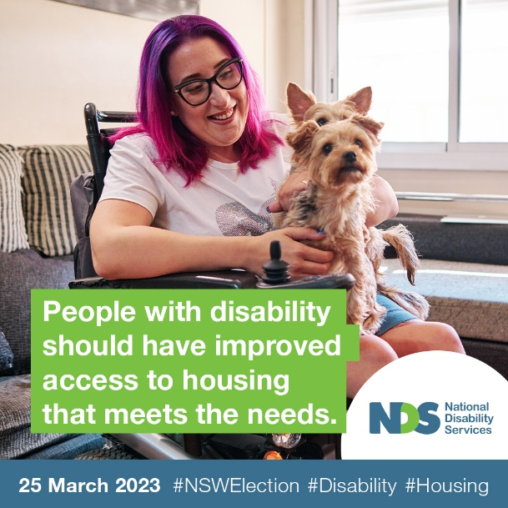
Current housing strategies are not meeting the needs of people with disability. This #NSWElection on 25 March, we want parties to commit to providing access to suitable housing for people with disability. 🏡
This includes making the National Construction Code accessible building guidelines mandatory for new builds, investing in appropriate disability specific housing responses, and ensuring that suitable state-owned housing is available to people with disability.
Help us build momentum across the state for stronger and more inclusive disability policies by asking your local candidate the question: “What will your party do to improve access to housing that meets the needs of people with disability?”
#AusPol #nswpol #Disability #Housing

Post three – Support outside the NDIS
Suggested post: week of 13 March
Download social graphics
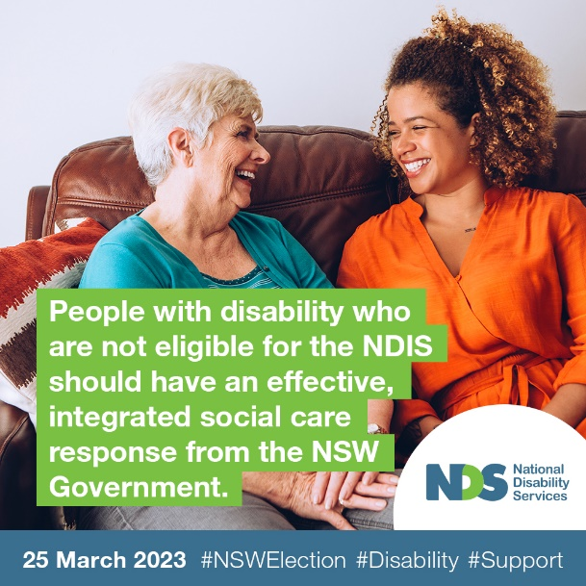
Less than 12 per cent of people with disability in NSW are receiving NDIS supports. This #NSWElection on 25 March, we want the @NSWGovernment to commit to developing an effective, integrated social care response for the people with a disability who are not eligible for the NDIS.
This includes collaborating with the NSW disability support sector to better understand gaps and implement strategies that will deliver support, and investing in access to mainstream services across health, housing, education and training, and employment.
Help us build momentum across the state for stronger and more inclusive disability policies by asking your local candidate the question: “What strategies do you have that will deliver supports at a state level to people who fall outside the scope of the NDIS?”
#AusPol #nswpol #Disability #Support

Post four – Employment and Economic Participation
Suggested post: week of 20 March
Download social graphics
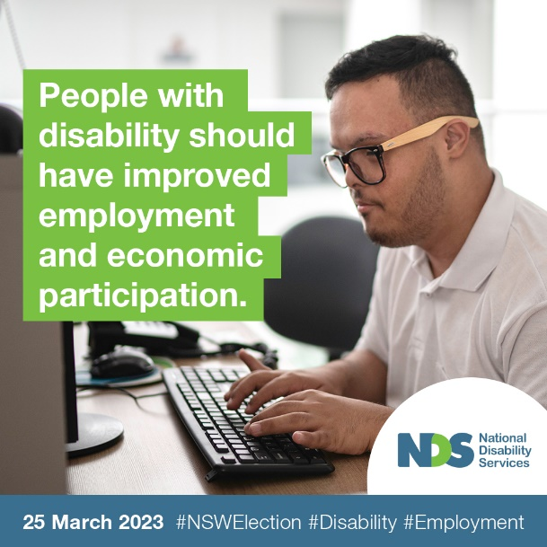
This #NSWElection on 25 March, we want parties to commit to improving the employment and economic participation opportunities for people with disability. 💸
This includes actively addressing the barriers to employment for people with disability, funding the development and implementation of a strategy that improves access to jobs, and targeted NSW government procurement with social enterprises.
Help us build momentum across the state for stronger and more inclusive disability policies by sharing this post or asking your local candidate the question: “Will your party commit to improving employment and economic participation for people with disability?”
#AusPol #nswpol #Disability #Employment

Questions for local candidates:
- [Tag MP] there is a severe shortage of workers across the disability sector. How will your party ensure people with disability have access to a skilled workforce to provide the supports they need?
- [Tag MP] current housing strategies are not meeting the needs of people with disability. How will your party improve access to housing that meets the needs of people with disability?
- [Tag MP] less than 12 per cent of people with disability in NSW are receiving NDIS supports. What strategies do you have that will deliver supports at a state level to people who fall outside the scope of the NDIS?
- [Tag MP] the unemployment rate for people with disability is more than double the average rate. Will your party commit to improving employment and economic participation for people with disability?
- [Tag MP] people with disability are reporting the same information to multiple state and federal government agencies, wasting time and effort that providers can better use to provide supports for people with disability. If elected, would your party work with federal agencies to eliminate duplication of reporting and improve efficiency?
- [Tag MP] are you committed to strengthening the disability support sector and improving the way the @NSWGovernment works with the community across government agencies?

More Information
NSW State Election 2023 – NDS Campaign Resources
For any enquiries on the NDS campaign, please contact Debbie Jaggers, State Manager NSW, debbie.jaggers@nds.org.au, 02 9256 3186

