Promoting the safety of children with disability – accessible slides

Slide 1

Promoting the Safety of Children with Disability
In the context of the Victorian Child Safe Standards
Presentation developed by Dr Deborah Absler

Slide 2

Zero Tolerance Framework
NDS developed the Zero Tolerance Framework to address abuse, neglect and violence towards all people with disability. 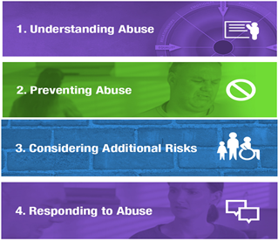

Slide 3

Why is there a focus on the safety of children with disability?
- All children have the right to feel and be safe.
- Growing evidence that children with disability experience an increased risk of abuse across all services and locations.
- Children with disability need all their workers to know how to keep them safe and protected from abuse.

Slide 4

Why is there a focus on the safety of children with disability – because it is needed
Children with disability are:
- More than 3 times higher risk of physical violence
- More than 4 times higher risk for emotional abuse and neglect
- Nearly 3 times more likely to experience sexual abuse
- More likely to have experienced repeated incidents of sexual abuse by the time they are 18
We all have a moral, ethical and legal responsibility to actively address this.

Slide 5

What is happening nationally to keep children with disability safe?
National initiatives include:
- The National Framework, Creating Safe Environments for Children (2016)
- The National Child Protection Framework (2009-2020)
- Royal Commission into Institutional Responses to Child Sexual Abuse (2017)
- Draft National Statement of Principles Child Safe Organisations (2017-18)
- Signatory to UN Convention on the Rights of the Child, UN Convention on the Rights of Persons with Disabilities

Slide 6

New Victorian legislation & statutory bodies to keep children with disability safe
- The Child Wellbeing and Safety Amendment (Child Safety Standards) Act 2015
- The Reportable Conduct Scheme 2017
- The Commission of Children and Young People

Slide 7

The Victorian Child Safe Standards
- Embedding a culture of child safety through effective leadership
- Having a Child Safe Policy of Statement of Commitment to Child Safety
- Having a clear Code of Conduct that establishes appropriate behaviour with children
- Screening, supervision, training and other human resource practices that reduce the risk of child abuse by new and existing personnel
- Clear processes for responding to and reporting suspected child abuse
- Identifying and reduce or remove risks of child abuse
- Strategies to promote the participation and empowerment of children

Slide 8

The Victorian Child Safe Standards
- To ensure safety and protecting children from harm and abuse is embedded in the everyday thinking and practice
- Compulsory for all organisations providing services to children
- Acknowledges additional needs of:
- Children with disabilities
- Aboriginal children
- Children from culturally and linguistically diverse backgrounds

Slide 9

Organisations working with children with disability are now required to:
- Promote the rights and safety of children
- Actively protect children from abuse
- Establish clear processes for staff

Slide 10

What do the Standards mean in a practical way for organisations?
Organisations must develop a culture which:
- Encourages children to “have a say”
- Listens and responds to children
- Promotes and advocates children’s rights and safety
- Embed child safe culture; are we keeping children with disability safe in every action we take?

Slide 11

Thinking about children with disability being at risk can be confronting and challenging
- It is very distressing
- Children being at risk challenges core values and long established practices of our organisations
- Organisations have not been as safe as they need to be
- Making changes can feel hard
- But is a valuable opportunity to create safe places for children

Slide 12

The Standards; let’s ask ourselves:
- What does each Standard mean for our organisation?
- What does it mean for the children & young people that attend our organisation?
- What can we do to ensure our work is informed by these standards – what needs to change?
- How can we involve children & young people in making our organisations safe?
- How can we tell it is working and making a difference for children?

Slide 13

Standard One: Embedding a culture of child safety through effective leadership
Boards and senior management need to:
- Understand that safety and cultural change requires deliberate steps
- Demonstrate an active commitment to child safe culture
- Champion child safety across all organisational levels
- Clarify what is unacceptable behaviour
- Encourage disclosure, take action and support those who disclose
- Foster participation and the voice of your people in the organisation

Slide 14

Standard One: What can be done to achieve a Child Safe culture?
- Establish Board Standing Committee on Child Safety
- Establish Child Safety Standing Committee
- Appoint a Child Safety champion to report on achievements and raise concerns
- Include Child Safety as a standing item in committees
- Allocate funding to implementation of child safety
- Actively facilitate and listen to the voice of children and young people, and request their input in decision making at individual and organisational levels
- Demonstrate organisational openness to make everyone feel welcome, heard and treated with respect

Slide 15

Standard Two: Making a commitment to child safety with a policy or statement
Statement of commitment to child safety publicly displayed an in a child friendly format.

Slide 16

Standard Three: Having a Code of Conduct that establishes appropriate behaviour with children
- A Code of Conduct outlines expected behaviour required by all staff and can include privacy issues, complaints procedures and reporting guidelines
- Individual signed copies are stored in personnel files
- Children, young people and families are consulted in development of the Code
- The Code is publicly available in an accessible format and discussed with children and young people

Slide 17

Standard Four: Screening, supervision, training and other human resource practices
Reducing the risk of child abuse by new and existing personnel.
Staff selection:
- Job adverts to note organisation’s commitment to the rights and safety of children and young people
- Comprehensive assessment of a person’s suitability to work with children with disability with screening checks
- Include specific scenarios to identify attitudes, values, preferred styles
- If possible, observe the potential employee with children
- Seek feedback from children, young people and families about new staff

Slide 18

Standard Four: Training and professional development
Training on child safety needs to be provided to all staff and volunteers including the Board, management and casual staff, and address:
- How to promote children’s safety
- Difference forms of abuse – emotional, physical, sexual, financial and neglect
- Risk factors for children with disability
- How to recognise signs of abuse, neglect and violence
- How to talk about abuse with children
- A focus on trauma, developmental stages and resilience
- How to support children and parents, and workers

Slide 19

Standard Four: Supervision
- Quality supervision is critical to developing a Child Safe culture
- It encourages staff to reflect on practice and consider potential risks to children and young people
- Regular supervision allows the organisation to monitor and address staff performance, raise issues and provide professional support

Slide 20

Standard Five: Clear processes for responding to and reporting suspected child abuse
Organisations need clear procedures for all staff and volunteers to follow if:
- There are concerns about a child’s safety or a child or family has a concern or complaint
- A child discloses abuse – who to report to, next steps
- Reportable Conduct Scheme requirements

Slide 21

Standard Five: Keep in mind
- Children can show us in many ways when something is wrong and they have felt unsafe, or experienced harm or abuse
- Trust your instinct and take the situation seriously
- Let them know they did the right thing by telling you
- Take the required actions to protect the child or young person
- Make sure all involved receive support and debriefing

Slide 22

Standard Six: Identifying child abuse risks for children with disability and ways to reduce them
It takes many components to build a Child Safe organisation.
- Organisations need to undertake a risk analysis – what is our climate, culture and norms?
- Is this a safe place for everyone to raise concerns?
- Do we listen to children’s views?
- Are there physical care activities with minimal level of observation and supervision?
- Are there risk factors in the physical environment?
- Are there risk factors in the staffing model?
Self-assessment guidelines are available.

Slide 23

Standard Six: Risk factors in organisational culture
Environmental risk factors include:
- Organisations with a ‘closed’ environment
- Lack of active empowerment of children and young people
- Where there is a strong power differential between staff and children
- Strong loyalty between staff which may deter reporting
- Lack of protection for whistle blowers

Slide 24

Standard Six: Identifying child abuse risks for children with disability and ways to reduce them
Risk factors for children with disability include:
- The severity of disability – children with multiple disabilities and particular combinations of disabilities e.g. physical and intellectual disability
- Children required intimate personal care
- Communication needs – children who cannot communication verbally or have other sensory challenges
- Risk of ‘child to child’ abuse
- Children and parents who may be reluctant to complain
- Limited access to developmentally appropriate sexual and relationship information
- Increased likelihood of social isolation

Slide 25

Standard Six: Identifying child abuse risks for children with disability and ways to reduce them
Children with disability are at risk of abuse due to some myths and assumptions. But we know that:
- Children with disabilities can have the same (physical, emotional, sexual) feelings, responses and development as other children, go through the same stages and can have the same reactions
- Talking about bodies, sexuality, relationships can be helpful to all children and young people
- Talking about ways to keep safe is important – just use different methods matched to their needs

Slide 26

Standard Six: Identifying child abuse risks for children with disability and ways to reduce them
- Grooming is the criminal activity of becoming friends with a child in order to persuade them to enter into a sexual relationship
- Can also involve grooming adults so that they become “desensitised to perceive potentially risky behaviour as harmless”
- Important to learn the signs and to feel empowered to act on your concerns

Slide 27

Standard Seven: Empowering children to share their feedback and experiences about feeling safe
“Creating awareness among children is one of the best ways to protect them.”
- A Child Safe organisation actively elicits, welcomes and embraces the voice and involvement of children and young people
- Children are informed of their rights and provided with support to express their thoughts, feedback, complaints and concerns
- Support children and young people in ways that match their strengths and abilities

Slide 28

A final thought
- Talking about feeling safe to children with disability is an important conversation and is supported by having many other conversations that need to happen as stepping stones.
- Don’t start with the hard topics – create an environment where you talk on a regular basis about everyday topics; their interests, friends, family; what they do and don’t like; and then act on their advice.
- It’s worth it.

Slide 29

Any questions?

Slide 30

Thank you
NDS has developed these slides to assist disability service providers create Child Safe organisations. The slides and a range of other useful resources – developed by NDS and other bodies – will shortly be available on the NDS website.
Phone: 03 8341 4300
Email: ndsvic@nds.org.au
Twitter: @ndsvic

National Disability Services Limited (NDS) believes that the information contained in this publication is correct at the time of publishing. However, NDS reserves the right to vary any of this publication without further notice. The information provided in this publication should not be relied on instead of other legal, medical, financial or professional advice.

Slide 31

Collaboration Agreement
- During transition to the NDIS, where SDA and SIL are delivered jointly by separate entities, a Collaboration Agreement between the two is required
- This contract sets out the roles and responsibilities of SIL and SDA provider, to ensure compliance with the Disability Act
- The Disability Act recognises the supported independent living provider, which is the face of the joint service
- The Collaboration Agreement links the responsibilities of the two entities
- SDA Rules 2018: SDA providers must have documented arrangements with each participant’s other providers who deliver SIL in SDA

Slide 32

DHHS sample agreement
- DHHS have published a sample Collaboration Agreement, available online
- Sample includes:
- Terms of discussions amongst residents, SIL provider, and SDA provider
- SDA Service Agreement to align with the Residential Statement
- Fee collection
- Amendments to residential statements
- VCAT and dispute resolution
- Duration of Agreement
- Warranty and indemnities
- This is a sample only

Slide 33

Analysis of sample Agreement
- Responsibility of SIL provider to represent residents in negotiations with SDA provider
- Responsibility on SIL provider to collect fees
- No reference or scope for financial remuneration for supported independent living provider
- More detail is needed
- Nevertheless, the document highlights the key sections that should be considered to comply with the Disability Act

Slide 34

What to expect and how to approach
- There may be variable arrangements between SIL and SDA providers, depending on negotiations
- Some new SDA providers intend to be more involved in working with residents, as compared to previous arrangements
- Sections to consider:
- Maintenance and repairs ( including pest control, test and tag, damage to amenities, organising relevant trades )
- Terms of engagement and dispute resolution
- Vacancy management and associated processes
- Emergency response
- Rent collection and fees
- Fire safety and compliance
- Insurance

Slide 35

Other considerations
Details such as
- Invoicing processes
- Property transition
- Maintenance requests
- Property modifications
- Property inspections
- Occupational health and safety
- Initial purchase and replacement of goods and furniture
- Schedule of repairs and maintenance of fixtures, furniture, and appliances

Slide 36

DHHS collaboration agreement
- National Disability Services hosted a consultation with DHHS regarding the Collaboration Agreement where DHHS is the SDA provider
- The document is thorough, but may need further clarity around:
- Notice to vacate
- Responsibility for participant relocation
- Continuity of Support arrangements
- Dispute resolution processes
- Final document to be confirmed soon

Slide 37

Tips for providers
- Consider the types of services your organisation provides and how responsibilities should be determined
- Consider and clarify reasonable timeframes
- Consider whether it is appropriate to negotiate a ‘management fee’
- Include attachments
- Bear in mind, SDA Rules 2018: SDA providers must have documented arrangements with each participant’s other providers who deliver SIL in SDA

Slide 38

Supported Independent Living ( SIL )
Navigating housing in the NDIS

Slide 39

Background: SIL quoting
- All providers are required to submit a quote
- Benchmark pricing is to be used as a guide only
- The purpose of the quote is to identify
- Individual supports that will be available for the person
- Typical roster of supports that is shared
- Available supports to ensure the smooth operation of the household

Slide 40

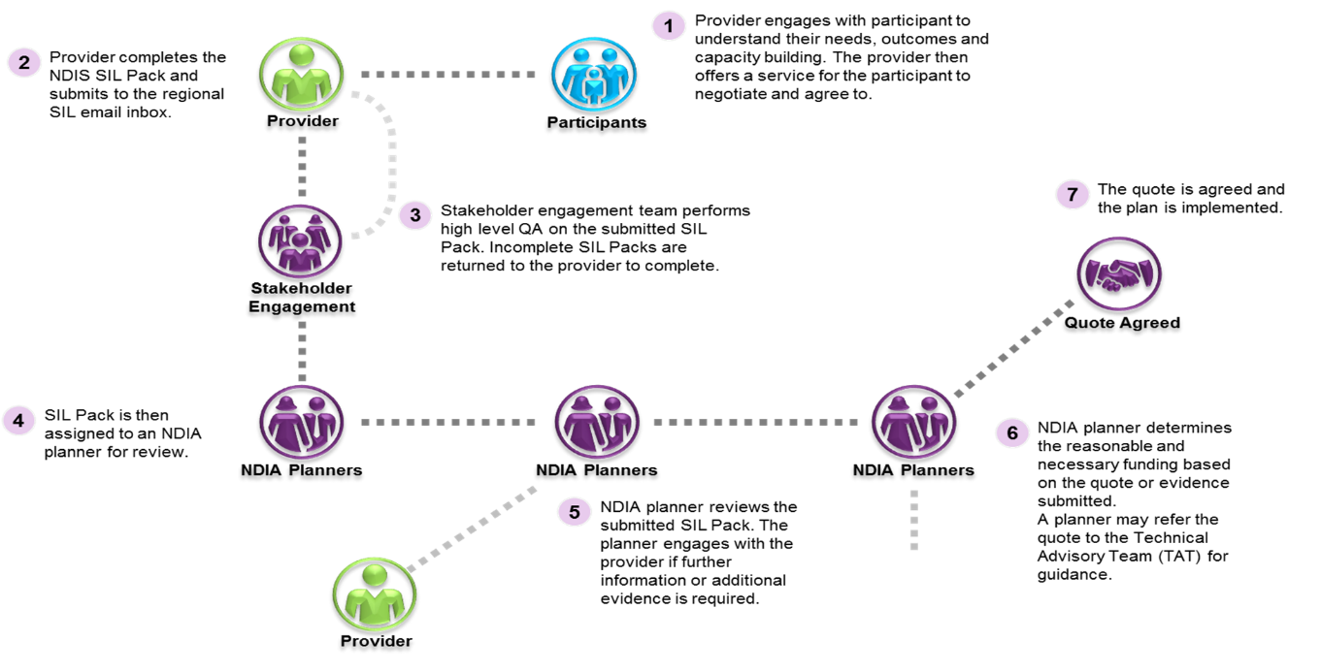
Source: NDIA

Slide 41

What supports are included in a SIL quote?
SIL is funded for 53 weeks per year, and should include:
- Supports delivered in the home to assist participants to live independently ( for example direct supports, supports to manage household tasks )
- Supports delivered or activities undertaken with all or a number that are not delivered in the home such as going out for a meal, attending doctor’s appointments
- Supports that are not appropriate for a different provider to deliver
- Staff time to support participants while transporting them in the community

Slide 42

What supports are excluded from a SIL quote?
- Community access supports or other NDIS supports delivered ( ie. day program )
- Participant absences from a residence
- Vehicle costs ( maintenance, depreciation and fuel )
- Non NDIS costs such as rent, board or utility costs

Slide 43

What should be considered when developing a SIL quote
- Participant support needs and choice
- Providers’ individual hourly rate and costings
- SIL quote inclusions and exclusions
- Additional public holidays
- Indexation

Slide 44

Completing a SIL quote
- Complete all areas identified in the templates
- Include notes to provide context e.g. rationale for irregular hours or why a participant requires a higher level of support
- Include as much information as possible and any relevant supporting documentation that is current
- Reference attachments in template, including page number
- Individualised supports should only be included where the support is exclusively for that participant i.e. support cannot be provided to others
- Provider should include information about handovers i.e. staff ratio and duration

Slide 45
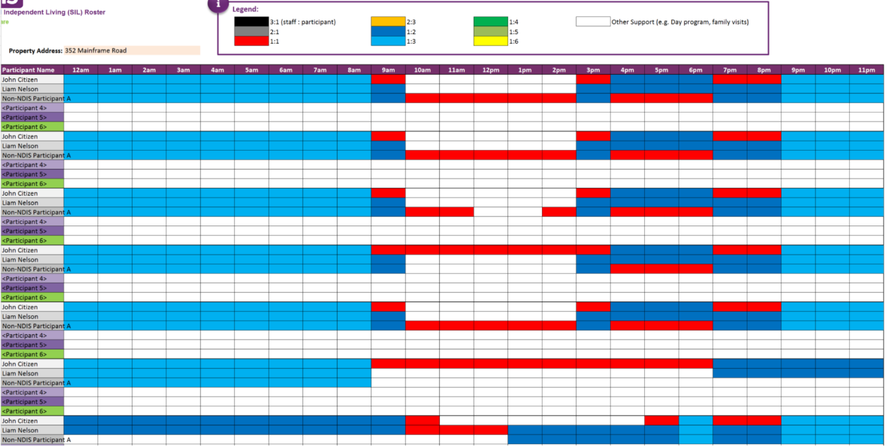

Slide 46
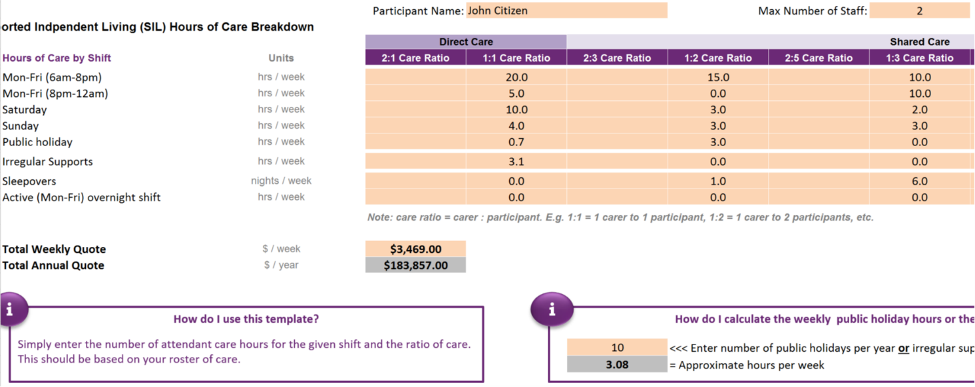

Slide 47

Submitting SIL quotes
- Submit individual quotes, even if you are submitting quotes for multiple residents
- Include all evidence and documentation
- If files exceed 20 megabytes, create a zip file with all documents and attach it to the email
- SIL quotes are submitted to the relevant regional NDIA SIL quote email address
- NDIA reviews and assesses the submitted SIL pack, and may require the provider to resubmit the quote if there are any errors
- Once the quote is approved, NDIA will create a SIL Service Booking

Slide 48

SIL quote emails
- Vic west
- Vic north
- Vic east

Slide 49

Top reasons quotes require re-submission
- No evidence or out of date evidence for above benchmark quotes
- Missing templates
- Providers entering too many hours for a day/week
- Providers including community access in supported independent living
- Missing notes from Roster of Care
- Roster of Care contradicts Hourly Breakdown
- Providers sending their own version of the tools ( or in pdf versions )
- Misunderstanding of 1:1 care
- Missing quote amount
- Incorrect ratios used
- Incomplete templates ( for example no outcomes, contact details )
- Participants not being consulted during the process

Slide 50

Vacancies and variations
- Consider the flexibility of the SIL quote, recognising that participant’s support needs may fluctuate
- Supported independent living providers are not able to claim for vacancies and may need to work with residents and/or housing provider to fill the vacancy

Slide 51

Any questions?

Slide 52

Lunch break

Slide 53

Specialist Disability Accommodation ( SDA )
Navigating Housing in the NDIS

Slide 54

Reasonable and Necessary
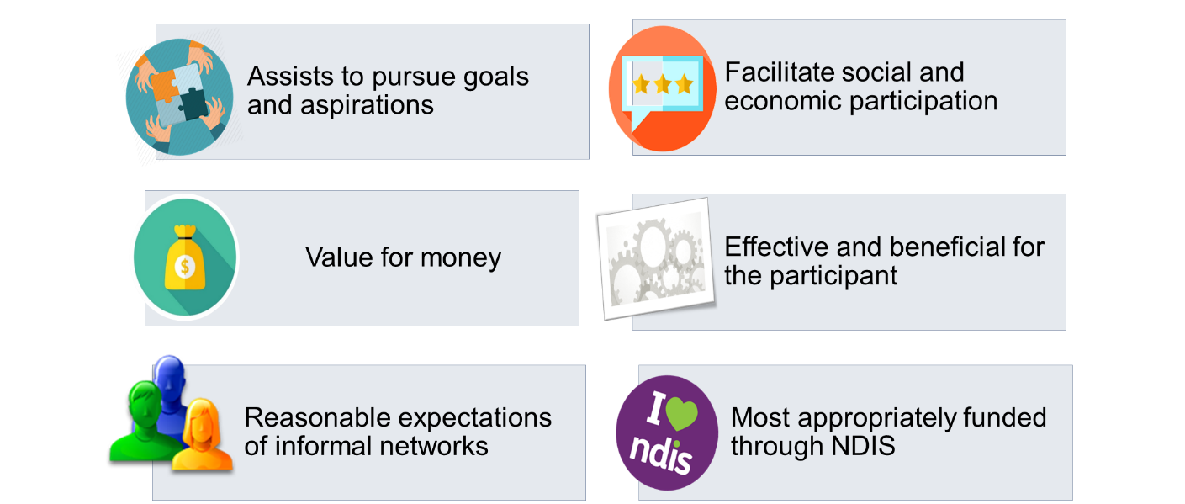

Slide 55

Eligibility
Has an extreme functional impairment
- to undertake one or more of the activities of mobility, self-care or self-management
- has a very high need for person to person supports in undertaking the activity even with assistive technology, equipment or home modifications
Has very high support needs
- previously lived in specialist disability accommodation for extended periods and this has impacted the capacity of the participant to transition to alternative housing
- a very high level need for person to person supports, either immediately available or constant, for a significant part of the day

Slide 56

Demonstrating that other options have been explored
If housing is identified as a goal, participants may receive funding to explore housing options:
- Capacity building supports
- Support coordination
- Specialist assessments
- Independent living skills
- Home modifications

Slide 57

The separation between housing and supports
- Registered NDIS providers are required to manage actual or perceived conflicts of interest
- There is an expectation that specialist disability accommodation providers will not influence a participant’s decision about who their support provider is
- There will be a transition period where providers will deliver both housing and supports
- SDA Practice Standards makes further comment on NDIA’s expectations of providers

Slide 58

Different ways to deliver SDA
- Single organisation delivers both SIL and SDA
- Owner of dwelling head leases to the SIL provider, SIL delivers both SIL and SDA
- Full separation between SIL and SDA
- Owner of dwelling leases the dwelling to an SDA provider
- The SDA provider subcontracts the tenancy management functions to a third party organisation

Slide 59

Pricing
- Consistent with the NDIS Pricing Framework, SDA prices are maximum prices
- Pricing includes allowances for:
- Fire sprinkler allowance
- Location
- Rent is calculated at 25% of disability support pension and 100% of Commonwealth Rent Assistance
- Pricing will increase to reflect consumer price index
- Specialist disability accommodation prices will be reviewed every five years

Slide 60

SDA Design Categories
Liveable Housing Design Guidelines
- Used in SDA Design Categories
- Detail minimum benchmarks to achieve specific standards ( silver, gold & platinum )
- Focus on increasing liveability rather than accessibility
5 Design Categories
- Basic ( only applies for existing or legacy stock )
- Improved Liveability
- Fully Accessible
- Robust
- High Physical Support
SDA Design Categories include additional minimum requirements
- Do not include minimum benchmarks or specifications ( for example dimensions )
- Difficult to assess / build

Slide 61

Legacy stock
- Defined as dwellings that accommodate 6 residents or more
- There is a commitment to phase out funding for legacy stock
  - After 5 years funding for dwellings with 11 or more residents will cease
  - Properties with 6 to 10 residents will only receive funding for 10 years post the region’s transition to NDIS
- The legacy stock price list is only available upon request

Slide 62

Payments
- Supported disability accommodation is a ‘quotable item’
- Providers will need to undertake a costing exercise to determine the SDA amount
- NDIA will create the service booking on behalf of the provider
- Providers must determine how often they claim payment from the participant
- Payments issues should be emailed to NDIS

Slide 63

Projected growth
State | Existing SDA residents | Per capita distribution of SDA | Difference
ACT | 210 | 470 | 260
NSW | 5,730 | 9,020 | 3,290
NT | 160 | 280 | 120
QLD | 3,340 | 5,650 | 2,310
SA | 1,720 | 1,990 | 270
TAS | 500 | 600 | 100
VIC | 4,260 | 7,200 | 2,940
WA | 1,590 | 2,980 | 1,390
Total | 17,510 | 28,980 | 10,680
Source: Summer Foundation

Slide 64

Payments to date
Table description:

Column 1: Active plans with SDA – ACT
Number of participants in kind 0, non in kind 15
Committed supports in kind $0, non in kind $252,764
Payments in kind $0, non in kind $52,655
YPIRAC participants 0

Column 2: Active plans with SDA – NSW
Number of participants in kind 1,520, non in kind 3,249
Committed supports in kind $12,138,702, non in kind $32,010,186
Payments in kind $473,065, non in kind $930,510
YPIRAC participants 20

Column 3: Active plans with SDA – NT
Number of participants in kind 0, non in kind 183
Committed supports in kind 0, non in kind $1,867,018
Payments in kind $0, non in kind $0
YPIRAC participants 0

Column 4: Active plans with SDA – QLD
Number of participants in kind 0, non in kind 587
Committed supports in kind $0, non in kind $5,642,976
Payments in kind $0, non in kind $286,994
YPIRAC participants 1

Column 5: Active plans with SDA – SA
Number of participants in kind 0, non in kind 53
Committed supports in kind $0, non in kind $541,130
Payments in kind $0, non in kind $0
YPIRAC participants 0

Column 6: Active plans with SDA – TAS
Number of participants in kind 176, non in kind 114
Committed supports in kind $1,795,070, non in kind $1,097,127
Payments in kind $0, non in kind $29,038
YPIRAC participants 0

Column 7: Active plans with SDA – VIC
Number of participants in kind 596, non in kind 443
Committed supports in kind $4,211,862, non in kind $3,704,128
Payments in kind $0, non in kind $214,446
YPIRAC participants 2

Column 8: Active plans with SDA – WA, all values are 0

Column 9: Active plans with SDA – Total
Number of participants in kind 2,292, non in kind 4,644
Committed supports in kind $18,145,634, non in kind $45,115,330
Payments in kind $473,065, non in kind $1,513,644
YPIRAC participants 23

Column 7: Active plans with SDA –
Number of participants in kind
Committed supports in kind
Payments in kind
YPIRAC participants

End of table description.

Source: Senate Estimates, A00018

Slide 65

Market response
- Providers are exploring use of existing assets
- Providers are considering redeveloping current service offerings ( for example short term accommodation )
- Parents / carers considering joint venture development
- Developers are partnering with support providers
- In some cases, providers are self-funding development / re-development
- Some banks have demonstrated an active interest in SDA

Slide 66

Future
- NDIA have demonstrated a commitment to providing ongoing funding for SDA
- Pricing and Payments Framework Review to be completed in 2018
- A second review of the prices will commence in 2021
- The NDIA have committed to provide information about demand as it becomes available
- The NDIA will engage a third party to further develop the SDA criteria along with a curriculum and certification process for third-party assessors

Slide 67

SDA Pricing and Payments Framework review: Terms of Reference
The Review will consider:
- Whether the framework allows the NDIA to set appropriate levels of funding and allows participants to exercise choice and control
- If the framework enables innovation by providers, and the development of new stock
- Factors that influence investor decision to participate in SDA
- The impact of price controls and scheduled framework and pricing reviews
- Options for the development of participant funding arrangements, and ongoing funding certainty

Slide 68

Any questions?

Slide 69

Vacancy Management
Navigating Housing in the NDIS

Slide 70

Offering residency in Specialist Disability Accommodation – Policy and Standards
- Providers delivering a residential service must comply with DHHS’ vacancy management policy
- New and existing government owned dwellings
- New and existing privately owned dwellings
- Providers must comply with this policy when the dwelling is enrolled with the NDIA as specialist disability accommodation
- Non-government providers can elect to either have the department’s VCTs to coordinate the vacancy, or operate their own process

Slide 71

DHHS vacancy coordination practice guidance
- Provides clear guidance for providers regarding the vacancy management process from declaring a vacancy to making an offer
- SIL and SDA providers will need to determine who will be responsible for each task (e.g. completing the marketing flyer template)
- Any enquiries about the vacancy will be filtered through Divisional VCT teams
- Generally, only participants with SDA eligibility confirmed in their plan will be considered

Slide 72

Advertising the vacancy
- Vacancies must be advertised for at least 10 business days
- Vacancies will be listed on the Housing Hub, and advertised in DHHS networks
- People on DSR and early transitioned NDIS participants will be considered for vacancies
- SDA providers may be required to develop a quote on request of the participant

Slide 73

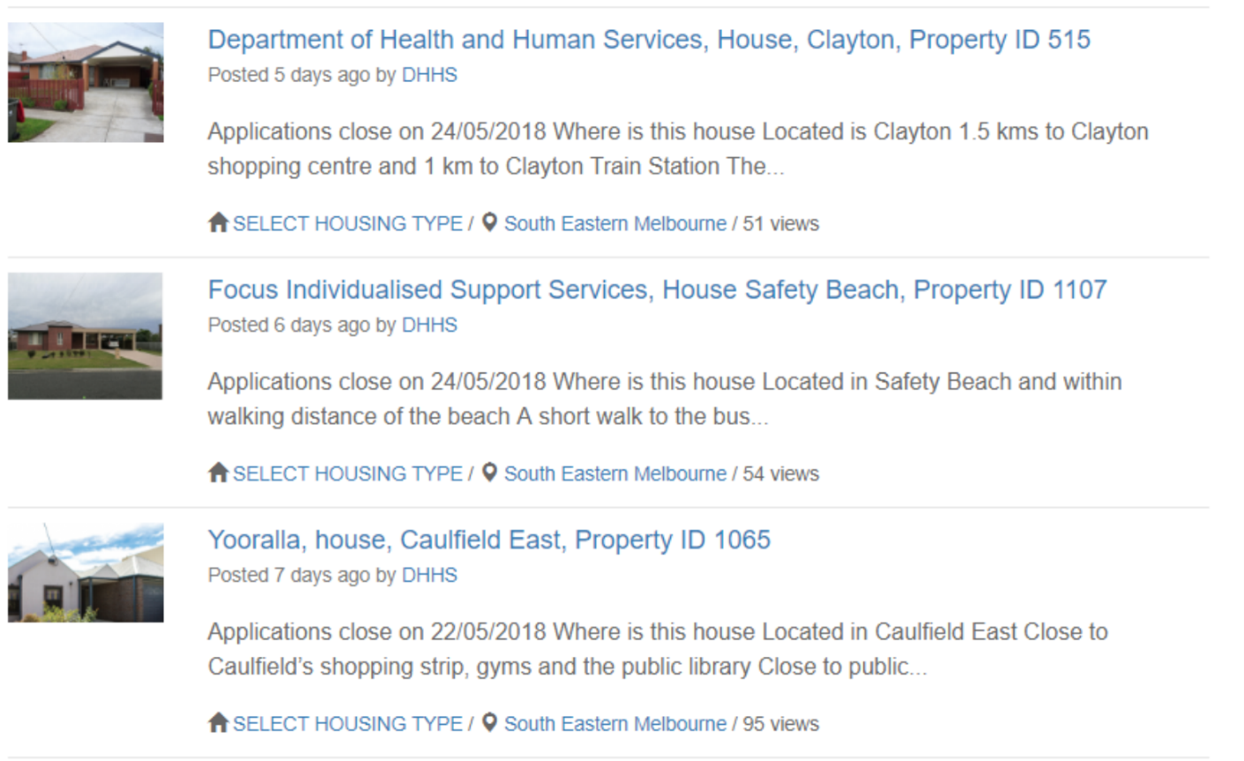

Slide 74
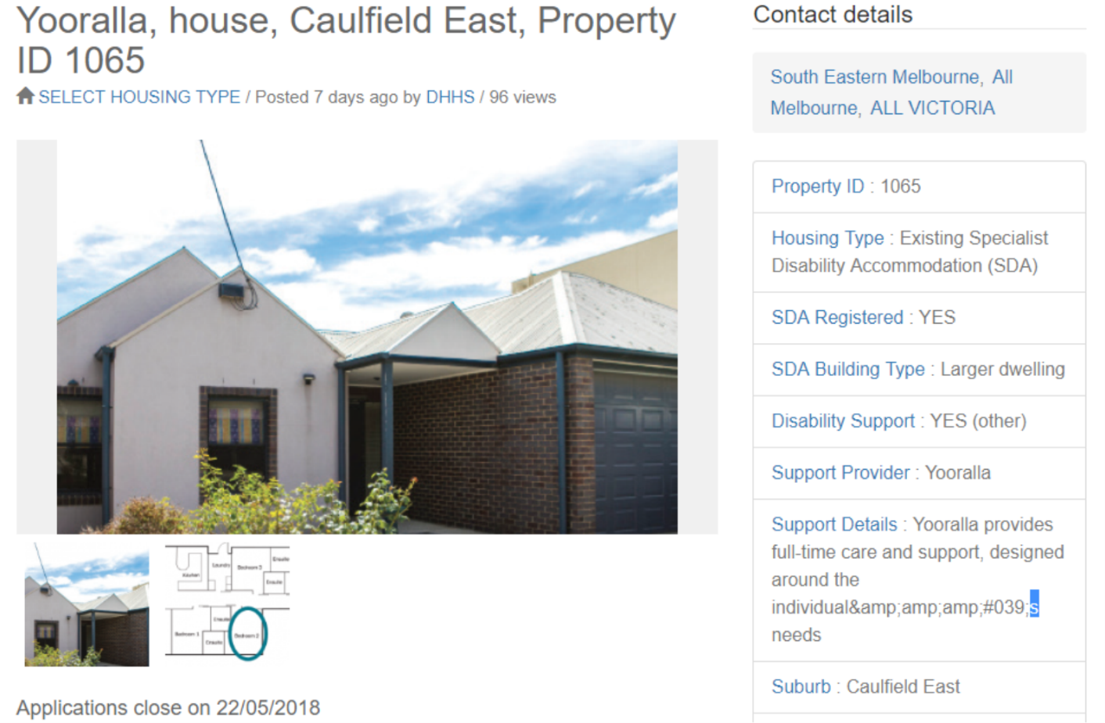

Slide 75

Identifying an appropriate participant
- Supported independent living providers must coordinate the open inspections
- SDA and SIL representatives must consider the applicants within 2 business days
- Divisional VCT coordinators will review all applications received to identify appropriate participants and clients
- Divisional VCT will chair and organise a vacancy coordination meeting
- SDA and SIL providers must demonstrate that they have acted with due care, skill and diligence when offering the vacancy to a participant
- A formal offer must be made, signed by the SIL representative
- Where the dwelling is not owned by DHHS, VCTs will not have any role or responsibilities following the vacancy coordination meeting

Slide 76

Vacancy management for providers delivering accommodation to people with psychosocial disability
- Providers should operate as they have been in relation to vacancy management
- DHHS are establishing a vacancy coordination process
- It is not clear whether non-government owned dwellings will be able to access the government-managed vacancy coordination process
- Non-government owned dwellings will need to determine how their vacancies are coordinated
- Providers will need to be aware of DHHS’ expectations identified in the Offering Residency in Specialist Disability Accommodation

Slide 77

Housing for the other 94%
Navigating Housing in the NDIS

Slide 78

Australia has a housing affordability crisis
- Home ownership is increasingly out of reach for many Australians
- There is immense pressure on rental affordability, which is driving prices up
- There is a very low proportion of rental affordability for people on a pension
- Increased pressure on public and social housing, and rising homelessness

Slide 79

Current trends in social housing
- 40% of households in social housing include a person with a disability
- There is a decline in the provision of new social housing
- Overall rental affordability is decreasing
- The proportion of social housing compared to private rentals is falling

Slide 80

Strong demand for mainstream housing amongst people with disability
- The Disability Housing Futures estimates that nearly a quarter of NDIS participants are currently inadequately housed:
  - Adults living at home with their parents
  - Unsuitable group housing
  - Affordability stress in private rentals
  - Homelessness
- Some of this demand will be met through social housing turnover, low-cost private rental housing in some regions, and SDA

Slide 81

NDIS supports in mainstream housing
- For the first time, funding is available for a person to access supports while living in mainstream housing
- Portability of supports
- Other supports to assist a person to live independently
- Drop in supports
- Assistive technology
- Home modifications

Slide 82

Additional supports around technology
- NDIS may fund participants to explore housing solutions
- Funding available to participants may include allied health, support coordination and/or other capacity building supports
- A participant must demonstrate that they have explored alternative options before receiving supported independent living supports
- NDIS funds ‘Assistance with accommodation and tenancy obligations’ under Improved Living Arrangements

Slide 83

Housing initiatives need a focus on disability
- National Disability Services is pleased with the Victorian Government’s housing and housing affordability strategy Homes for Victorians, announced in 2017
- However at this stage, there is not a focus on disability, and we don’t expect people with disability to be able to make the most of these initiatives
- We continue to await a plan for the 94% of participants without specialist disability accommodation
- There are many complexities around housing for people with disability

Slide 84

Group discussion
There is a well-identified need to improve access to public, social, rental, and affordable housing
- What do you see as barriers?
- What are the key things that will make a difference to improving housing outcomes?
- What are specific challenges in your region?

Slide 85

Implications and considerations
- How might the relationship between housing providers and support providers change?
- How is the role of Support Coordinator evolving to support participants to navigate the housing sector?
- Where might there be new opportunities for partnerships?

Slide 86

Any questions?

Slide 87

The all new National Disability Services Helpdesk
Coming Soon! All your NDIS questions answered, by us.
We’re launching the National Disability Services Helpdesk to NDS members and organisational associates.
All Victorian providers will be able to access the National Disability Services Helpdesk until August 2019 with the help of Victorian government funding.
The National Disability Services Helpdesk, modelled off the current Victorian NDS Helpdesk, will be integrated into the NDS website and easier to use. You’ll be able to search a bank of over 100 common questions and answers or ask a new question. Tap into National Disability Services experts from around the country.
We aim to answer questions within 3 business days and you’ll be able to track the progress of your questions.
Stay tuned for the launch by signing up for the current Victorian NDIS Helpdesk and the monthly National Disability Services newsletter.

Slide 88

NDS Regional Boards Forum – Coming to Sale, Shepparton and Mildura!
- Boards are at the forefront of NDIS transformation
- A unique opportunity to unite with other leaders in the sector, share knowledge and learn together
- Presentations from NDS, NDIA, and a change specialist
- Visiting Sale on 2 August
- Visiting Shepparton on 8 August
- Visiting Mildura on 9 August
Join us for practical strategies for your organisation’s NDIS transformation journey

Slide 89

Ask a question

Slide 90

Thank you
Phone 03 8341 4300
Email ndsvic@nds.org.au
Tweet @ndsvic
Vic NDS Website
End of document.

