Slide 1

Use of Allied Health Assistants (AHA) to Build Workforce Capacity in Rural and Regional Communities
Louise Jellie, MPower Inc

Slide 2

The Allied Health Assistant Project is supported by the Victorian Government

Slide 3

MPower Inc
- NFP agency based in south west Victoria, Warrnambool
- 72 staff: includes Disability Support Workers, Family Services, Therapists, Teachers, Assistants and Support staff
- Early Childhood Intervention (ECI) team: 13 therapists, 3 teachers, 3 ECI Assistants, 2 Allied Health Assistant (AHA) Trainees
- ECI supports: groups and 1:1 services,
- Natural environments and centre-based supports

Slide 4

Our participants: 0 to 17 years age group
- 29 per cent of participants have Autism
- 41 per cent of participants have Developmental Delay
- 13 per cent of participants have Intellectual Disability
- 17 per cent of participants have other diagnoses

Slide 5

Background
- Long waiting lists are a feature of the current participant experience in the South West
- Allied Health Professional recruitment and retention is an ongoing issue in rural and regional communities
- Referrals over time for Mpower have had an upward trend
- NDIS – rural and regional thin markets
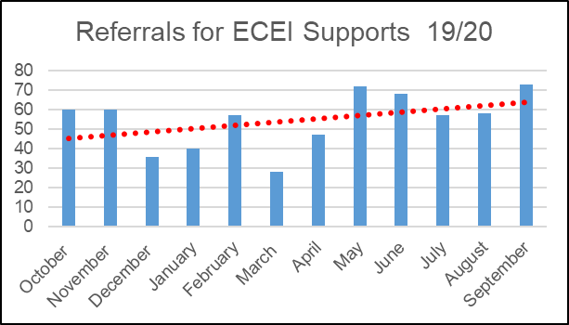

Slide 6

The AHA Project
- Victorian Regional Readiness Fund: Supporting the NDIS Workforce and Service System (rural and regional)
- Model: AHA Trainees working in the field whilst completing Certificate 4 in Allied Health Assistance
- Partnership with Kyeema Support Services (Portland): Disability Support Worker and playgroup
- Training for existing Allied Health Professional staff: Supervision and Delegation Framework

Slide 7

The Traineeship Model

Traineeship
- Two early career trainees
- 18 months traineeship
- Completing Cert 4 Allied Health Assistance
- Online provider
- Supportive Team environment

Slide 8

The AHA Training

AHA Courses
- Not always available in local communities
- Not plentiful online
- Not disability specific
Covid ….
- Access to online study increased
- Access to “on the job training” decreased

Slide 9

What we did learn
We need to look at:
- training of AHA differently
- the needs of AHA trainees
- the needs of the AHP
- the use of DSW – what are we expecting
Training is required for both the AHA and the AHP

Slide 10

What we did learn
- Supervision of new trainees takes time
- Change management is needed to introduce a new model to an existing team
- Groups are best to start with opportunities for good modelling and teachable moments
- Not all families want to use AHA as part of their suite of therapies
- Education is needed for families and participants
- Good resources are available for AHPs
- Partnerships with Group Training Providers
- Model works well within an agency

Slide 11

Outcomes
- Two new trainees in the service system
- Increase in skills AHP
- Waitlist affected by Covid in 2020
- The in-house training model
- Two new trained AHAs
- Understanding of the AHP - AHA relationship
- Partnership with the traineeship provider

Slide 12

From the trainees

Why apply for the role
- close to home
- family experience because of my brother
- a position I felt I was passionate about
- interested in learning more about kids with disabilities and how they learn,
- I have a passion for children and I want to gain experience with kids in early childhood intervention.

The Course: Cert 4 in Allied Health Assistance
- very medical
- I have gained an array of new knowledge from OHS standards to medical terminology and the legal side of working with clients
- I am loving it.
- The course work is challenging, but rewarding.
- I’m learning something different every day.

Slide 13

From the trainees

What do you like about the role?
- I love everything about the role, the staff, the activities and tasks, but more importantly I love how rewarding you feel after helping a child learn something or achieve something new. It makes work all the more enjoyable knowing you can help someone or brighten a child’s day.
- I love the role because I get to interact with all kinds of children and I love gaining experience in new areas

When I finish ….
- My plan after the traineeship would be to work at Mpower in ECIS, have a full time job and gain even more experience in the industry. Allied health will allow me to explore more options but right now I am enjoying what I do at Mpower
- I have no idea what I want to do when I complete the course at this stage but something with kids for sure

