Slide 1

Our Communities Pathways Project
Gippsland LaTrobe Aboriginal Advocacy Support Services Pty Ltd

Slide 2

Acknowledgement of Country
- Gippsland Aboriginal Advocacy Support Services Acknowledges the Traditional Aboriginal owners of the lands across Australia and pays respect to the Traditional Owners and ongoing custodians of the lands – T he Aboriginal Communities and people.
- We would also like to Acknowledge that the recording of this presentation was done on Gunai / Kurnai land and we would like to pay our respects to Elders past and present

Slide 3

Why we started this project?
- We wanted to build training and education pathways that offer Aboriginal and Torres Strait Islanders a range of entry pathways into the disability sector.
- We wanted to improve the representation of local Aboriginal and Torres Strait Islanders caring for people with disabilities.
- Create sustainable jobs, supported traineeships, offer work experience and placement for ATSI to begin learning about what working in the sector looks like.

Slide 4

Our target and focus areas
- Attract ATSI people to the disability sector
- Upskill ATSI people to meet minimum qualification requirements
- Recruit ATSI people
- Retain, grow and develop our local ATSI workforce

Slide 5

Are you Aboriginal of Torres Strait Islander and interested in a career in Aged Care or Disability Services?

Key Messages for Community
- It’s a great career if you enjoy working with Community Elders, kinship carers, children with disabilities and ATSI families
- You can make a difference
- Essential skills and what’s required
- Looking after yourself, your family and your community
- Your work is meaningful and your contribution will be acknowledged

Come and try The Taste tester we will provide you with information about:
- What Aged Care and Disability work involves
- Hear from Employers of the potential employment opportunities
- Hear from other Community Members who work in the space
- Find out more information on pre-employment course running in 2020.

Slide 6

Self paced, online modules, the new kind of learning?
COVID-19 meant goodbye to classroom learning and adapting to new kind of normal
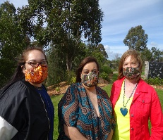

Slide 7

Key building blocks
- Recognition respect and engagement
- Building trusting relationships
- Preparation of culturally safe workplace
- Meeting National Disability Standards
- Vision and Commitment

Slide 8

Disability Induction eLearning Program
The Disability Induction Program prepares people to work in the disability sector by introducing them to and encouraging a person-centred approach its A five-part eLearning program designed to introduce people to the disability sector.

Work with Diverse People
This course gave students the skills and knowledge required to work respectfully with people from diverse social and cultural groups and situations, including Aboriginal and Torres Strait Islander people.

Slide 9
- Flexibility. This was a major draw for those students who needed some wiggle room when it came to attending scheduled classes
- Self-paced learning meant that the students could start completing the targets at any time, and could arrange a learning schedule that met their own individual, family and community needs.
- Some online learning was at no cost to the organization and compared to classroom learning was cheaper and could be individualized to suit each participants role.
- Feedback received suggested some training that was more hands on would be better suited to classroom such as manual handling for practice opportunities.
- Lack of interaction with other students and opportunity to question if unsure of something.
Image of NDS’s Manual Handling for Disability Support Workers Training and NDS’s Work Health and Safety (WHS) awareness and duty of care Training.

Slide 10

What we achieved? What was the impact?
- Created a positive experience in education & training for local ATSI people
- Everyone continued onto to complete further education and training in some shape or form
- Created formal traineeships for interested students completing certificate 3 individual support
- ATSI workforce taking on some of that caring responsibility

Slide 11

Graduates from the pathways project - Let us introduce ourselves
A photograph of Lucille, Community Engagement Officer; Rehana, Admin and HR Officer; Maree, Support Coordinator Life Transition Planner; Nicole, Communication and Innovation Officer; Tanisha, Project Manager; and Dave, Housing and Tenancy Officer
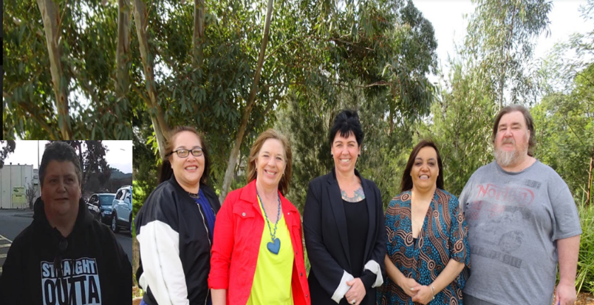

Slide 12

What we heard, what we learnt and what we know
- It is widely acknowledged that Aboriginal and Torres Strait Islander peoples are more likely to access services if they have access to Aboriginal workers.
- Aboriginal and Torres Strait Islander peoples represent a disproportionately high number of Australians with a disability.
- Having a job benefits all people in our ATSI communities.
- Pre employment training provided for ATSI workers can be beneficial to non-Aboriginal workers and supports knowledge sharing.
- A positive culturally safe workplace attracts ATSI talent, drives community engagement, impacts happiness and satisfaction, and affects performance.

Slide 13

Further resources and reading
- NDS’s Aboriginal Torres Strait Islander Employment Guide Toolkit
- Koolin Balit Aboriginal Health Strategy
- Insert the attribution line in the credits section of your presentation. If it’s not possible, place it wherever it's visible on a web page, close to where you’re using the resource.
- This presentation has been designed using resources from Powered Template website

