Slide 1

Digital Support Innovation
Mind Australia
Victorian Regional Readiness Fund
November 2020

Slide 2

What we knew before we started
Mind customers in regional and remote locations experienced a greater challenge in accessing services than those in metropolitan locations due to:
- The limited services available in regional areas
- The need to travel further to receive services; for those who don’t have easy access to transport this is especially difficult

Slide 3

What was the concept?
We wanted to:
- Continue providing our customers with individual support, which was provided via Telehealth
- Create and trial the addition of an app that customers could download and access on their phone or other device
- Test if the app provided additional benefit to our customers

Slide 4

What did the funding allow us to do
The funding made available to us from the grant provided us with the ability to:
- Fund the licencing requirements needed to use an app based platform
- Recruit and appoint a support worker to work with the customers
- Ensure adequate resources to address the aims of the pilot

Slide 5

Developing the tools
The development of the tools was a detailed and considered process, co-designed with our Participation team which ensured that the customers perspective was always forefront.
We wanted to replicate some of the fundamental tools that we know support our customers, and present them in a format that they could complete independently.

Slide 6

Mind Consent form
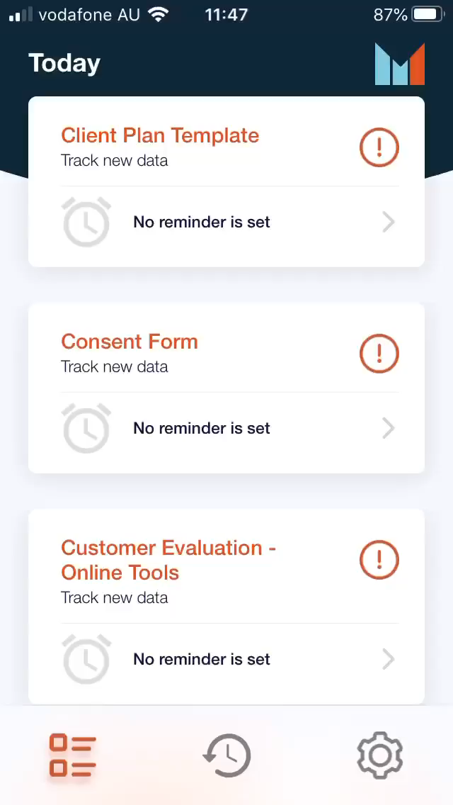

Slide 7

Weekly Check-in
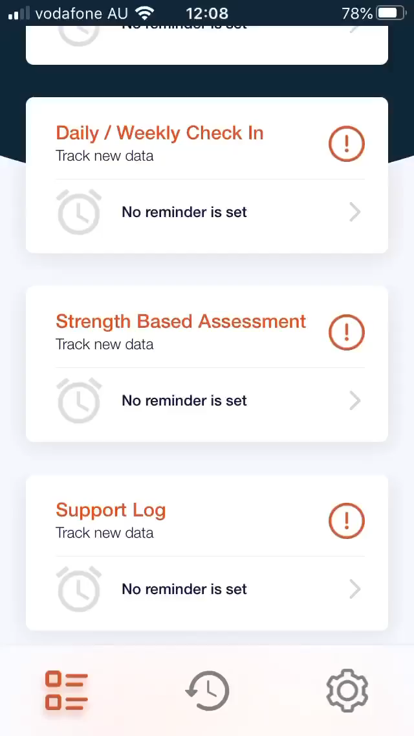

Slide 8

What else we did
- We developed a Service Operational Manual for staff which outlined the expectations and processes related to Service Delivery
- We developed a flyer for service promotion
- We developed a Customer Journey to support staff in ensuring that customers received a consistent experience
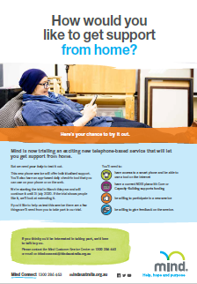

Slide 9

Feedback from our Customers
“Loved the prompts and wording of the tools”
“Liked the check-in option but wouldn’t want to replace the app for service delivery”
“Loved the option of the smiley face”
“Really liked the flexibility of being able to check in when not face to face available”
“Would want this as an option on-going”

Slide 10

The Challenges
- COVID19
- The short term nature of the pilot was a barrier to uptake with some of the referrals we received
- Access to a phone or device – some of the customers referred did not have access to a mobile phone, computer or laptop

Slide 11

What could be useful to others

Language
The language used in a tool presented directly to a customer needs to be designed differently.

NDIS Assistive Technology
What we discovered was:
- Assistive Technology could not be utilized as a funding source to support the costs associated with the technology.
- Software, including apps, are not able to be funded.

Slide 12

What could be useful to others

Technology
The customer needs:
- To have a device with the capacity and memory to download and use apps
- To have the capacity to navigate apps independently, or with minimal support
The platform needs:
- To store information securely
- Provide a space for collaboration
- Be intuitive and easy to use
- Be able to be updated and redesigned easily
- Reduce administration time for staff rather than add to it

Slide 13

Where to from here
- We will continue to offer customers the ability to receive supports via Telehealth where this can meet their needs – this increases the ability of those in regional and remote locations to access the supports they require.
- We will continue to assess the suitability of digital service offerings.

Slide 14

Contact
Any additional queries can be directed to Kelly Bougioukos by email: kelly.bougioukos@mindaustralia.org.au
Mind Australia website
Mind Connect: 1300 286 463
Carer Helpline: 1300 554 660

