NDS & DHHS Webinar: Safer and Stronger – accessible slides

# Slide 1

## NDS: Safer and Stronger – Disability Services and COVID-19 webinar

### Friday 6th November 2020, 10:00am – 11:00am

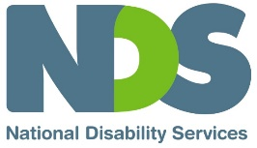

# Slide 2

## Welcome and Introductions

Sarah Fordyce – Victorian State Manager (Acting), NDS

# Slide 3

## Agenda

* DHHS update – James MacIsaac, Executive Director Disability, Disability and Communities Branch, DHHS
* Public Health update – Professor John Catford – Senior Medical Adviser, DHHS
* NDIA update – Stephen Broadfoot, Director Branch, Manager Engagement Brach, NDIA
* DHHS cleaning guidelines – Louise Hobbs PhD, Principal adviser, Infection Prevention and Control (IPC), DHHS
* Provider Perspective – Cindy Thomassen, Chief Executive, Ability Assist
* Q&A – Facilitated by Sarah Fordyce,NDS

# Slide 4

## DHHS Update

**James MacIsaac**

Executive Director Disability, Disability and Communities Branch

Department of Health and Human Services

# Slide 5

## NDSV Safer and Stronger Webinar COVID-19 and Disability

Disability Update 6 November 2020

James MacIsaac, Executive Director, Disability

Department of Health and Human Services

Visit [DHHS website](http://www.dhhs.vic.gov.au/coronavirus)

COVID-19 hotline 1800 675 398

# Slide 6

## Overview

**Key updates**

Updated [Disability COVID Sector plan](https://www.dhhs.vic.gov.au/disability-services-sector-coronavirus-covid-19) (22 October)

* Update on [roadmap restrictions](https://www.dhhs.vic.gov.au/disability-services-sector-coronavirus-covid-19)

**Key current priorities**

* Strengthening supports for providers to prevent, prepare for and manage outbreaks
* Planning for changes impacting people with disability and providers as restrictions are eased under the roadmap to reopening
* Workplace directions - reducing mobility

# Slide 7

## Clarification – roadmap restrictions

The community sector roadmap specifies that all community services including **disability services remain “restricted” during Step 3 and the last step** of the roadmap

This will continue to mean that only services that are **essential to a person’s health, safety, behaviour or wellbeing** can operate during this time.

What about centre-based disability day services?

* Centre-based disability day services provided can be provided if essential for people living in their homes / family homes
* Centre-based disability day services provided are not considered essential for people living in disability residential services.

[Industry Restriction Levels Community Services](https://www.coronavirus.vic.gov.au/sites/default/files/2020-10/Industry-Restriction-Levels-Community-Services.pdf)

# Slide 8

## Clarification – roadmap restrictions – cont.

**Why are centre-based disability day services restricted?**

* All indoor services, including centre-based disability day services, are considered high risk environments for people with disability due to difficulties with physical distancing in these largely indoor settings.
* Such settings also have less ventilation than outdoor spaces and therefore pose a greater risk of coronavirus spreading through droplets in the air.
* Disability service providers are encouraged to facilitate outdoor activities for people with disability that can be safely provided to smaller numbers of people at a time (within applicable gathering limits), and via non-contact and remote technologies where available.

**What are the rules for outdoor group activities?**

* Outdoor group activities or classes can take place with up to 10 people and the disability workers to run these sessions.
* Participants must keep at least 1.5 metres distance between themselves and others, and must wear a face mask, unless people have a lawful reason for not doing so.

# Slide 9

## Clarification – roadmap restrictions contiued

**What about Australian Disability Enterprises (ADE)?**

* ADE operate across a vast range of industries
* ADE can currently operate in line with the applicable Step 3 industry roadmap steps and associated industry roadmap requirements which can be accessed at [DHHS Business Sector](https://www.dhhs.vic.gov.au/business-sector-coronavirus-disease-covid-19)

**What about further easing of restrictions?**

* It is expected that restrictions for the community will be eased again from 8 November 2020
* Updated advice will be provided re: any changes for people with disability or disability service providers next week.

# Slide 10

## Workplace (Additional Industry Obligations) directions-cont.

**Mobility – residential service workers in outbreak settings, and from metro to regional Victoria**

Metropolitan Melbourne (restricted area)

New requirements mean a staff member (or contractor) who has worked at a care facility where there has been an outbreak of coronavirus (COVID-19) can’t immediately work at another care facility.  Staff in these situations must wait a minimum of 14 days and test negative for coronavirus (COVID-19) before working at a different care facility.

Regional Victoria (relevant area)

New requirements mean a disability residential service provider in regional Victoria must not let a staff member (or contractor) work where the staff member (or contractor):

* has worked at a care facility in metropolitan Melbourne; or
* worked at another care facility in regional Victoria at the time a confirmed case was present at the other facility;
* Unless the person has tested negative for coronavirus (COVID-19).

# Slide 11

## Workforce update

* The $15m Disability Worker Mobility Reduction Payment initiative was introduced on 1 September 2020 to assist service providers and workers to meet financial costs associated with restricting workers to a maximum of two sites. This built on the efforts of providers to restructure rosters and cohort workers.
* We are seeing positive trends from Victoria’s ‘transfer’ accommodation providers who have reduced the proportion of workers at more than two sites from 12.4% in July 2020 to 2.1% in October 2020.
* Epidemiological analysis is underway to give better insight to the effect of worker mobility on COVID-19 cases in disability settings.
* More information on [worker mobility reduction payment factsheet](https://www.dhhs.vic.gov.au/disability-worker-mobility-reduction-payment-factsheet-covid-19-doc)

# Slide 12

## Accessibility statement and publishing information

To find out more information about coronavirus and how to stay safe visit [DHHS.vic – coronavirus disease (COVID-19)](https://www.dhhs.vic.gov.au/coronavirus)

If you need an interpreter, call TIS National on 131 450

For information in other languages, scan the QR code or visit [DHHS.vic –Translated resources - coronavirus (COVID-19)](https://www.dhhs.vic.gov.au/translated-resources-coronavirus-disease-covid-19) For any questions call the Coronavirus hotline 1800 675 398 (24 hours).   
Please keep Triple Zero (000) for emergencies only.

To receive this presentation in another format email [disabilityf@dhhs.vic.gov.au](mailto:disabilityf@dhhs.vic.gov.au)

Authorised and published by the Victorian Government, 1 Treasury Place, Melbourne.  
© State of Victoria, Australia, Department of Health and Human Services, 6 November 2020

# Slide 13

## Public Health Update

**Professor John Catford**

Senior Medical Adviser

DHHS

# Slide 14

**NDIA update**

Stephen Broadfoot

Director, Branch Manager, Provider Engagement Branch

NDIA

# Slide 15

## Clean Start

Louise Hobbs

Principal advisor

Infection prevention and control advice cell

# Slide 16

## COVID-19 Transmission

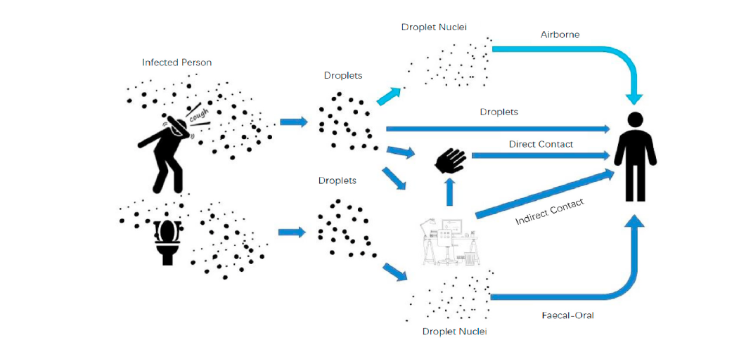Guo M, Xu P, Xiao T, He R, Dai M, Miller SL. Review and comparison of HVAC operation guidelines in different countries during the COVID-19 pandemic. Building and Environment. 2021;187:107368.

# Slide 17

## Persistence of SARS-CoV-2 virus on surfaces

|  |  |  |
| --- | --- | --- |
| **Surface** | Example | Days or Hours |
| **Metal** | Doorknob, Jewellery, Silver wear | Up to 7.5 days |
| **Glass** | Drinking glasses, Mirrors Windows | 2 to 28 days |
| **Ceramics** | Dishes, Pottery Musa | 5 days |
| **Paper** | Newspaper, Magazines | Up to 5 days |
| **Wood** | Furniture, Decking | 1 day |
| **Plastic** | Milk bottles, Bus seats, and Elevator Buttons | 3 to 28 days |
| **Stainless Steel** | Refrigerator, Pots/Pans, Sink, Water bottles | 2 – 28 days |
| **Cardboard** | Cardboard, Shipping boxes | 1 days |
| **Aluminium** | Soda cans, Tin foil, Water bottles | 2 – 8 hours |
| **Cooper** | Pennies, Tea Kettle, Cookware | Up to 4 hours |
| **Food** | Chicken, salmon, pork (refrigerated and frozen food) | Up to 21 days |

SARS-CoV-2 solid surface persistence; rapid review. 2020. Infection prevention and control advice cell. Unpublished.

# Slide 18

## Role of the environment – temperature

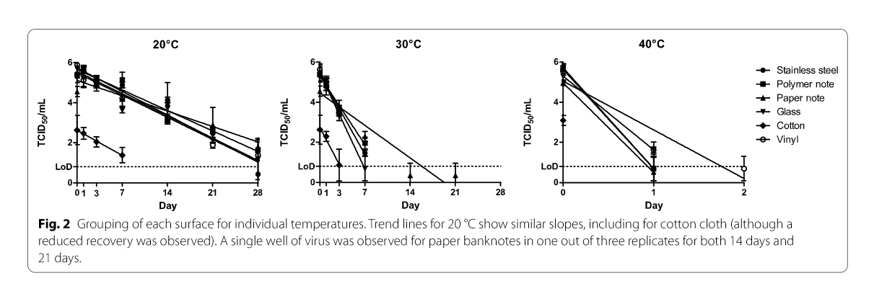Riddle S, Goldie S, Hill A, Eagles D and Trevor DW. The effect of temperature on persistence of SARS-CoV-2 on common surfaces. 2020, Virology Journal, 17:145.

# Slide 19

## Role of environment – setting

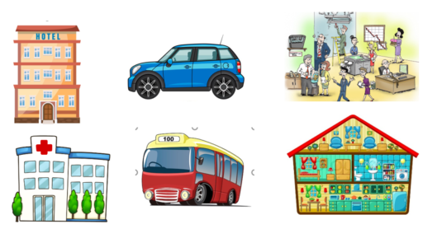

# Slide 20

## On-site visits

Variation in cleaning practices

* Cleaning is largely unregulated
* Absence of expected standards
* No required training to become a cleaner or run a cleaning service

Decorative image

# Slide 21

## Ability to scale cleaning services based on COVID-19 risk



# Slide 22

## Environmental cleaning guidelines

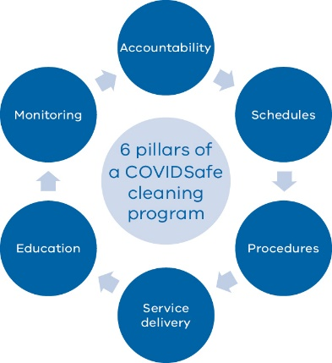

* Owner occupiers, boards, CEOs.
* In-house cleaning service
* Contracted services
* Schedules in place that cover:
  + High touch surfaces
  + Minimally touched surfaces
  + Waste removal
* Frequency determined by activity level
* Roles and responsibility documented
* COVIDSafe Plan
  + Available equipment
  + PPE
* How to clean
* All staff who have a role in cleaning need to be trained
* Has the expected standard of cleaning been met

# Slide 23

## COVID-19 deep clean

The following steps should be taken;

* Risk assessment
* Identify high touch surfaces
* Create a COVID-19 cleaning schedule
* Monitor cleaning undertaken

List of high touch surfaces

# Slide 24

## Resources

Guidelines

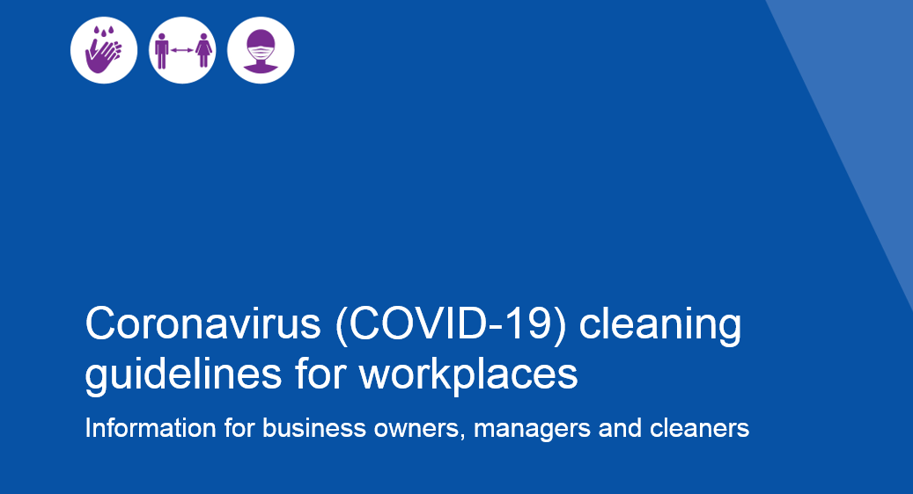

**Factsheets**

**Cleaning guidelines** **– cleaning workforce**

All cleaning workers must follow the below COVIDSafe cleaning guidance to help prevent the introduction of coronavirus (COVID-19) in the workplace,

**Cleaning guidelines – cleaning supervisors**

All cleaning supervisors must follow the below COVIDSafe cleaning guidance to help prevent the introduction of coronavirus (COVID-19) in the workplace

**Cleaning guidelines – building owners and managers**

All building owners and managers must ensure their workers follow the below COVIDSafe cleaning guidance to help prevent the introduction of coronavirus (COVID-19) in the workplace.

[Infection Prevention Control Resources](https://www.dhhs.vic.gov.au/infection-prevention-control-resources-covid-19#guidelines-and-resources-for-environmental-cleaning)

# Slide 25

## Provider Perspective

Cindy Thomassen

Chief Executive

Ability Assist

# Slide 26

## Q&A

Questions from Q&A box and those submitted in advance to NDS

# Slide 27

## Thank you

Short survey – link in the chat box

[NDS Coronavirus Hub](https://www.nds.org.au/covid-19-hub) - [Victorian COVID-19 Response](https://www.nds.org.au/index.php/covid-19-hub/victorian-covid-19-response)

End of document.