NDS and DHHS Webinar: Safer and Stronger – accessible slides

Slide 1

NDS: Safer and Stronger – Disability Services and COVID-19 webinar

Friday 20th November 2020, 10:00am – 11:00am

Slide 2

Welcome and Introductions
Sarah Fordyce – Victorian State Manager (Acting), NDS

Slide 3

Agenda
- DHHS update – James MacIsaac, Executive Director Disability, Disability and Communities Branch, DHHS
- Public Health update – Professor John Catford – Senior Medical Adviser, DHHS
- NDIA update – Toni Van Hamond, Director, Market & Provider Engagement Vic/Tas, NDIA
- Provider Perspective – Gavin Bussenchutt, Manager, Quality and Risk, Wellways
- Q&A – Facilitated by Sarah Fordyce, NDS

Slide 4

DHHS Update
James MacIsaac
Executive Director Disability, Disability and Communities Branch
Department of Health and Human Services

Slide 5

NDS Safer and Stronger Webinar COVID-19 and Disability
Update 20 November 2020
James MacIsaac, Executive Director, Disability
Department of Health and Human Services
Visit DHHS Coronavirus website
COVID-19 hotline 1800 675 398

Slide 6

Overview

Key updates
- Roadmap restrictions
- PPE guidance
- Workforce update – mobility reductions in transfer homes
- Key lessons emerging from the Victorian experience

Current priorities
- No active disability cases - last active case cleared on 30 October
- Strengthening supports for providers to prevent, prepare for and manage outbreaks
- Planning for changes impacting people with disability and providers as restrictions are eased under the roadmap to reopening
- Workplace directions - reducing mobility

Slide 7

Roadmap to re-opening
- The Victorian Government Coronavirus (COVID-19) roadmap to re-opening (the roadmap) sets out the steps and trigger points for easing of restrictions across Victoria.
- The steps enable a safe, steady and sustainable path out of restrictions and into COVID Normal and is based on Public Health advice.
- Victoria is currently in Step 3 of the roadmap (both regional and metropolitan areas) which specifies that disability services remain ‘restricted’. Work is currently underway to consider appropriate changes for the Last Step.
- Currently for centre based day services, a maximum of 20 people may be in the facility, with a maximum of 10 people present in each room as long as density and other COVID safe requirements are met.
- Following recent revisions to the Restricted Activity directions, people with disability, like the rest of the Victorian community, have increased opportunity for social interaction and activities outside the home; such as exercise, recreation and visiting family.

Slide 8

Roadmap – last step and COVID normal
- Restrictions will continue to be revised based on public health advice with the aim of people with disability, like all members of the community, resuming their usual services or activities when it is considered safe to do so and where COVIDSafe principles can be implemented.
- The last step and COVID Normal will see usual services and activities resuming for a greater number of people as gathering limits indoors and outdoors increase (within density quotients).
- Services will need to continue to meet the six COVIDsafe principles:
- Physical distancing (including the 4 square metre rule)
- Wear a face mask
- Practice good hygiene
- Keep records and act quickly
- Avoid interactions in enclosed spaces
- Create workforce bubbles.
- Advice will continue to be updated for people with disability and disability service providers at Information for people with disability coronavirus and Disability services sector coronavirus

Slide 9

Other key public guidance and support - PPE
- We continue to review and update our PPE guidance in consultation with our public health colleagues.
- As restrictions ease alongside lower rates of community transmission, the requirement for particular types of PPE is being re-examined.
- A current area for review is the mandatory requirement for disability support workers to wear both a surgical mask and eye protection in all situations where they are supporting a person with disability, for example accompanying a client to a cafe.
- We are also commencing a program of face to face PPE training for disability support workers with support from NDS and our Education Cell in public health. We will be using a ‘champions’ model to support those who have undertaken PPE training to share their learnings with other co-workers.
- A PPE ready reckoner is also close to finalisation. It will provide practical advice for services to calculate how much and what types of PPE they need to have on hand, based on the size of their service - for both prevention and outbreak supply. Information on local PPE supply options will also be included.

Slide 10

Workforce update
- The $15m Disability Worker Mobility Reduction Payment initiative was introduced on 1 September 2020 to assist service providers and workers to meet financial costs associated with restricting workers to a maximum of two sites. This built on the efforts of providers to restructure rosters and cohort workers.
- We are seeing positive trends from Victoria’s ‘transfer’ accommodation providers who have reduced the proportion of workers at more than two sites from 12.4% in July 2020 to 1.4% in November 2020. The proportion of workers at only one site has increased from 75.3% to 86.8%.
- Early data from NDIS funded providers indicates around 80% of workers are only at one site.
- Epidemiological analysis has provided some preliminary insights to the effect of worker mobility on COVID-19 cases in disability settings.
- More information on disability worker mobility reduction payment factsheet

Slide 11

Key lessons emerging from the Victorian experience
- COVID-19 and accompanying social distancing restrictions had a disproportionate impact on people with disability. To be effective, our response needed to consider this impact across all life domains
- Establishing a dedicated disability response through the VDRC was critical to enjoin program and public health response, and provide incident case management, coordination with the sector
- The necessity of sharing intelligence between State and Commonwealth sources
- The need to provide clear, practical and easy to understand guidance to people with disability and service providers as well as clear communication channels – e.g. Disability Sector Plan

Slide 12

Key lessons continued
- The disability sector (and workforce) has been very responsive in respect of preparedness and resilient to the challenges of public health restrictions
- Prevention is key - need for dedicated infection prevention and control support and training for a ‘non-heath’ workforce and outreach from public health
- Access to emergency accommodation for people with disability and workers to isolate away from home. In broad terms, most active cases in disability residential settings were able to isolate and be supported without the need for emergency accommodation
- Maintaining adequate workforce supply to respond to critical service continuity risks was a key challenge for outbreak sites.
- Balancing the need for minimising mobility and ensuring a proportionate response to impact on workforce

Slide 13

Accessibility statement and publishing information
To find out more information about coronavirus and how to stay safe visit DHHS Vic – coronavirus disease
If you need an interpreter, call TIS National on 131 450
For information in other languages, scan the QR code or visit DHHS Vic – Translated coronavirus resources
For any questions call the Coronavirus hotline 1800 675 398 (24 hours). Please keep Triple Zero (000) for emergencies only
To receive this presentation in another format email Disability Taskforce
Authorised and published by the Victorian Government, 1 Treasury Place, Melbourne
© State of Victoria, Australia, Department of Health and Human Services, 20 November 2020

Slide 14

Public Health Update
Professor John Catford
Senior Medical Adviser
DHHS

Slide 15

NDIA update
Toni Van Hamond
Director, Market & Provider Engagement Vic/Tas, NDIA

Slide 16

Provider Perspective
Gavin Bussenchutt
Manager, Quality & Risk, Wellways Australia

Slide 17

Limbering Up an agile response to COVID-19

Slide 18

Wellways Response
COVID-19 Response Management Team
Enterprise Level Business Continuity Plan
Regional level Pandemic Management and Escalation Plans
Program Specific COVID-19 Safe Plans and COVID-19 Response Plans
Individual planning - reassuring participants
Building confidence in staff

Slide 19

Keeping in Touch
A resource hub to help you discover engaging ways to support positive mental health and community connection. Everyone is welcome.
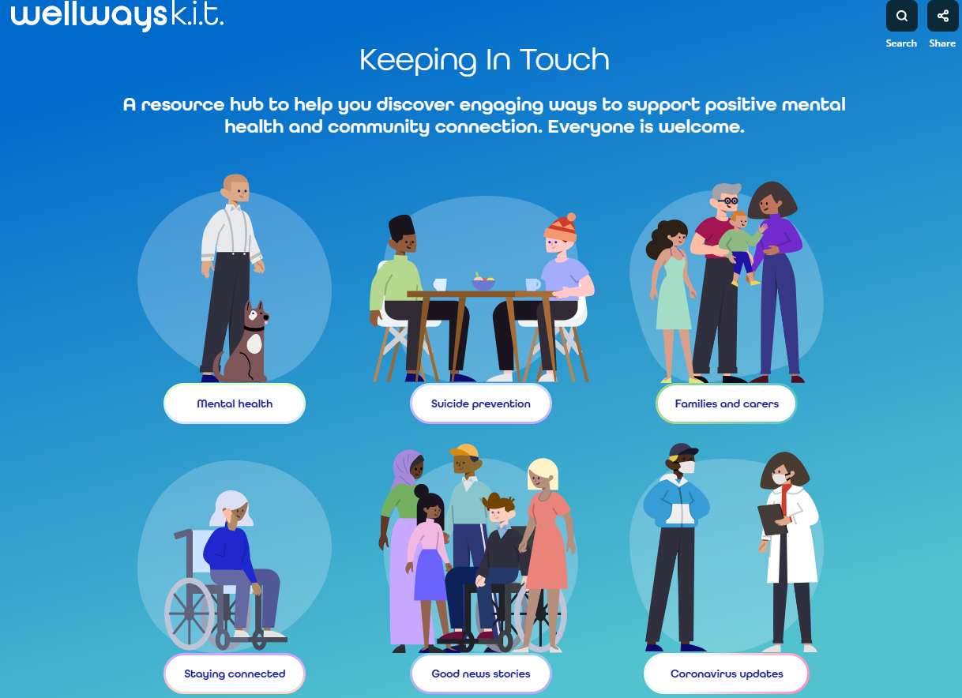

Slide 20

Resources to help keep you connected
Getting connected where you live
A wellways staff member discusses how COVID-19 has changed their sense of neighbourhood.
Brainwaves podcasts
A weekly community radio program produced and presented by people with a lived experience of mental

Slide 21

Wellways COVIDSafe Plan

Hygiene
Guidance | Action to mitigate the introduction and spread of COVID-19
Provide and promote hand sanitiser stations for use on entering building and other locations in the worksite and ensure adequate supplies of hand soap and paper towels are available for staff | Wellways has implemented site coordinators across all sites. Site Coordinators are here to support safe working environments. Site Coordinators work with managers to ensure:  - adequate supplies of hand sanitizer  - hand sanitiser stations across the work site including site entry  - waste bins are available to dispose of paper/towel gloves  - ensure appropriate signage is in place e.g. hygiene posters / how to wash hands.  A list of site coordinators can be found here http://staff.wellways.org/office-access.html  Wellways site coordinator guide provides further details in relation to the site coordinator role: COVID-19 Site Coordinator Guide  The below resources can be downloaded from our Staff COVID-19 site:  - Office Protocols  - Stop the spread office window sign  - Hygiene posters
Where possible: enhance the airflow by opening windows and adjusting air conditioning. | Wellways has implemented site coordinators across all sites. Site Coordinators are here to support safe working environments. Site Coordinators work with managers to ensure:  - That window and air conditioning are set for optimum air flow at the start of each workday or shift  A list of site coordinators can be found here http://staff.wellways.org/office-

Slide 22

Wellways COVID-19 Response Checklist
Wellways will declare on COVID-19 Response if there is one positive case of COVID-19 in a staff member, participant, or frequent attendee of a residential facility.
Wellways will establish a Response team and will coordinate a response undertaking the below listed actions:
Response | Action | Staff Responsible | Due by |  | Comments
Initial Response to a confirmed COVID-19 positive case | Senior Management and Executive Leadership Team notified of a confirmed COVID-19 case
 | Senior Management to assemble a Response Management Team (RMT). Include a lead liaison from your team who will coordinate actions between DHHS, Health Service (if required) and Wellways.
 | The RMT meets at least daily in the initial phase of the response.
 | Notify Disability Rapid Response Group via DDRG@dhhs.vic.gov.au and contact the hotline 1300 651 160. Maintain regular communication throughout response.
 | Arrange deep cleaning onsite with support of Assets team
 | Implement schedule for increased frequency of environmental cleaning

Contact tracing – Collate a spreadsheet and provide it to DHHS. Include at a minimum the names and contact details of:
- The residents
- Family/caregivers (if appropriate)
- Staff, volunteers and visitors
- Any leave activities / outings that participants have taken
 | Ensure everyone is contacted and advised to either get tested and self-isolate (direct) or monitor for symptoms (indirect)
 | Messaging to staff and participants to reinforce standard precautions i.e. hand hygiene, cough etiquette, physical distancing and PPE.

Slide 23

Wellways COVID-19 Monitoring Register
We’re monitoring Wellways staff and participants’ health and safety because it’s our priority. Managers should fill out this form if a staff member calls in sick with COVID-19 symptoms after seeking advice from a GP. Managers should also notify us if a participant is undertaking testing for COVID-19. This information will alert a team that is working to ensure Wellways can continue supports throughout the COVID-19 outbreak.

Name*
Please enter staff/participant name

Staff or participant
Please confirm persons relationship with Wellways as either staff or participant.
[select or enter value]

Region
[select or enter value]

Program / Team
[text was not legible]

Date
What date was the concern raised or diagnosis confirmed?
[choose from date selector]

Contact with staff/partcipants
Has the person had contact with staff, participants or other individuals in the last seven days?

Notification
Has the Program/Team manager and Regional manager been notified? If not please notify immediately
[select or enter value]

Response taken by manager
What response/follow up has occurred e.g. notified staff / participants who have had contact, staff work from home etc.

Slide 24

Active Cases

Total staff cases by Status: 530
Confirmed: 1
Cleared: 486
Suspected: 29
Quarantined: 14

Active cases for VIC/TAS: 29
Tasmania
Cleared: 7
Active: 2
Western Victoria
Cleared: 54
Active 6
South East Melbourne
Cleared: 47
Active: 5
Murray
Cleared: 59
Active: 15
Gippsland
Cleared: 43
Active: 1
Fairfield
Cleared: 10
East North West Melbourne

Active cases for NSW/ACT: 45
ACT
Cleared: 9
Western NSW
Cleared: 14
Active 3
Sydney
Cleared: 3
Active: 3
Southern NSW
Cleared: 7
South West Sydney
Cleared: 24
Active: 2
Northern NSW
Cleared: 17
Active: 2
Murrumbidgee
Cleared: 47
Illawarra Shoalhaven
Cleared: 13
Central Coast
Hunter
Albury
Cleared: 10
Active: 2

Active cases for QLD: 1
North
Cleared: 24
Active: 1
South
Cleared: 20
Carer Gateway Service
Cleared: 19

Active cases by State: 45
Queensland: 1
New South Wales: 11
Victoria: 30
Tasmania: 3

Slide 25

How we work now
[Extract of a Wellways email from Laura Collister to Gavin Bussenschutt of Monday 15 June 2020 at 4:42 PM]
Hi Gavin,
I want to share with you my hopes for how we work together as the world reawakens from the global coronavirus (COVID-91) pandemic.
I’m going to avoid using terms like “returning to normal” or “back to business as usual” because I think we can do better than that.
Over the last three months we have advanced what we’re here to do despite the constraints and urgency around COVID-19 – let’s build on our success.
Physical distancing has reinforced the importance of connection and coproduction – listening to participants and one another. These will continue to guide how we work.
We’ve also learned that flexible work arrangements (like calling participants and working from home) combined with face-to-face contact can achieve positive outcomes.
Many participants have told us they love connecting virtually and, in some cases, we’ve been able to support and connect people we couldn’t have otherwise reached. And, as schools open and social calendars start filling up, many of you say you find working out of the office is more productive.
I want us to continue collaborating virtually and working flexibly while at the same time recognizing that most of our work is done outside of our offices and benefits from or must be done in-person.

Slide 26

COVID-19 Management Resources
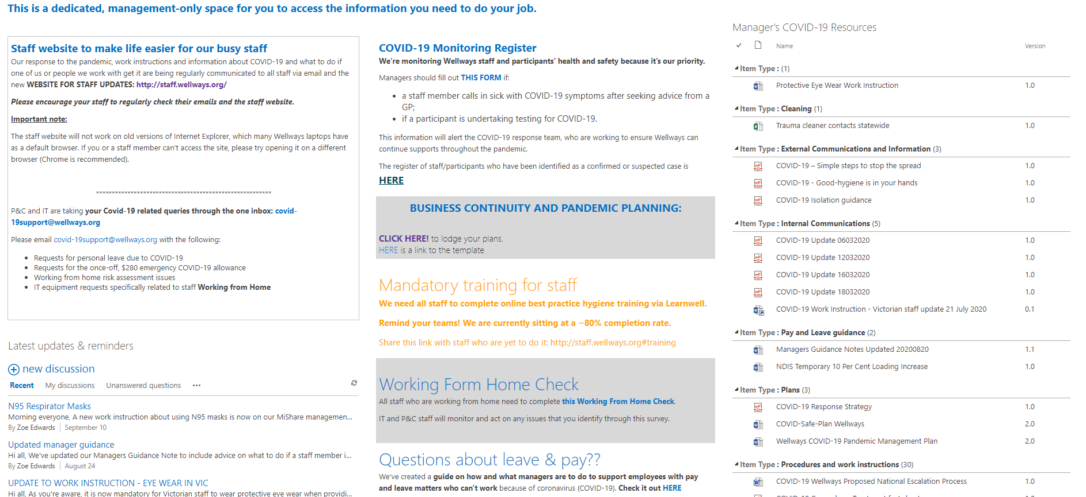

Slide 27

Work Instructions
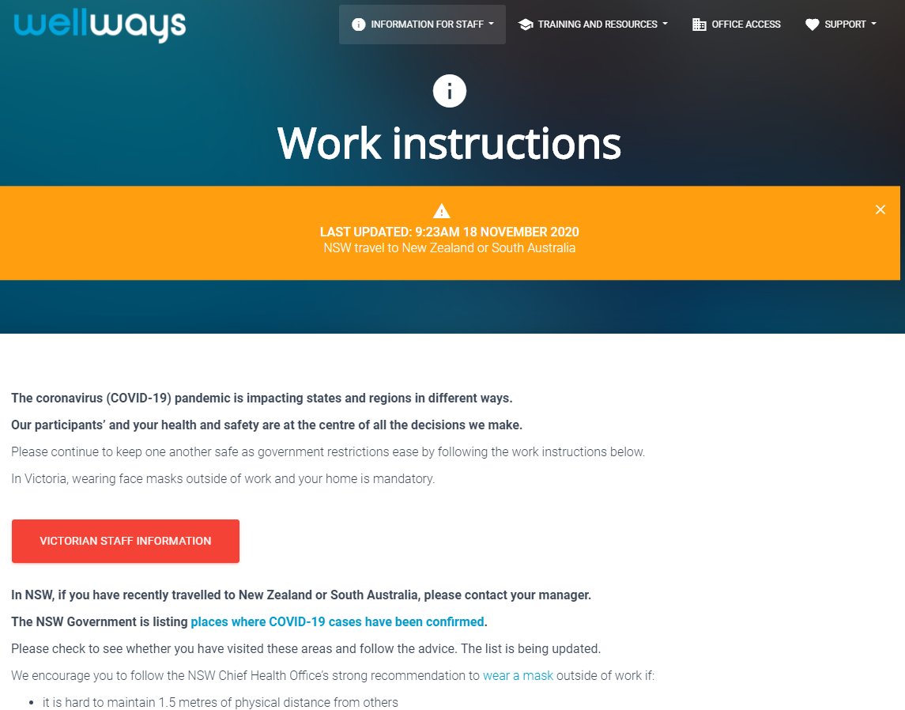
Webpage screenshot reads:

Work instructions
[Orange pop up box reads:] Last updated: 9:23am 18 November 2020. NSW travel to New Zealand or South Australia
[Text continues] The coronavirus (COVID-19) pandemic is impacting states and regions in different ways.
Our participants’ and your health and safety are at the centre of all decisions we make.
Please continue to keep one another safe as government restrictions ease by following the work instructions below.
In Victoria, wearing a face mask outside of work and your home is mandatory.
[Red button reads:] Victorian Staff Information
In NSW, if you have recently travelled to New Zealand or South Australia, please contact your manager.
The NSW Government is listing places where COVID-19 cases have been confirmed.
Please check to see whether you have visited these areas and follow the advice. The list is being updated.
We encourage you to follow the NSW Chief Health Office’s strong recommendation to wear a mask outside of work if:
- It is hard to maintain 1.5 metres of physical distance from others
[Screenshot ends]

Slide 28

Work instructions
Stay at home when
- If you have symptoms of COVID-19
- If you have tested positive for COVID-19
Screening participants
- If you think a participant has COVID-19
- If a participant has tested positive for COVID-19
- If a participant has been sent home to await diagnosis and manage their symptoms in self-isolation

Slide 29

Essential Services Travel Authorisation
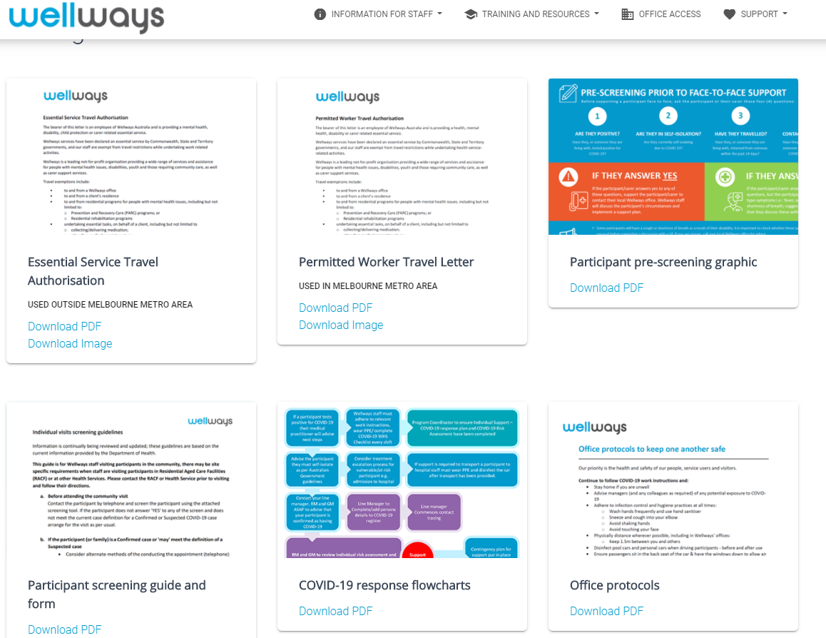

Slide 30

Supporting People to Stay infection free 100%
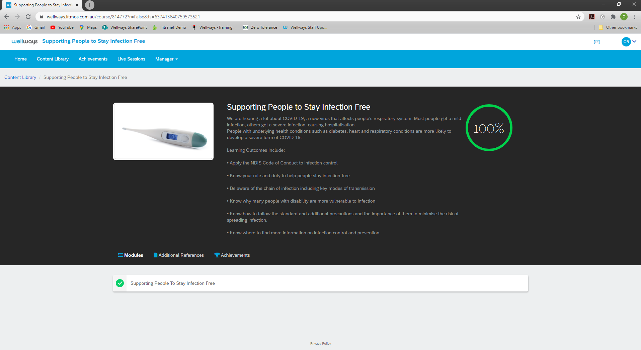
Webpage screenshot reads:
Supporting people to Stay Infection Free
We are hearing a lot about COVID-19, a new virus that affects people’s respiratory system. Most people get a mild infection, others get a severe infection, causing hospitalization.
People with underlying health conditions such as diabetes, heart and respiratory conditions are more likely to develop a severe form of COVID-19.
Learning outcomes include:
- Apply the NDIS Code of Conduct to Infection control
- Know your role and duty to help people stay infection-free
- Be aware of the chain of infection including key modes of transmission
- Know why many people with disability are more vulnerable to infection
- Know how to follow the standard and additional precautions and the importance of them to minimize the risk of spreading infection.
- Know where to find more information on infection control and prevention.

Slide 31

Photos 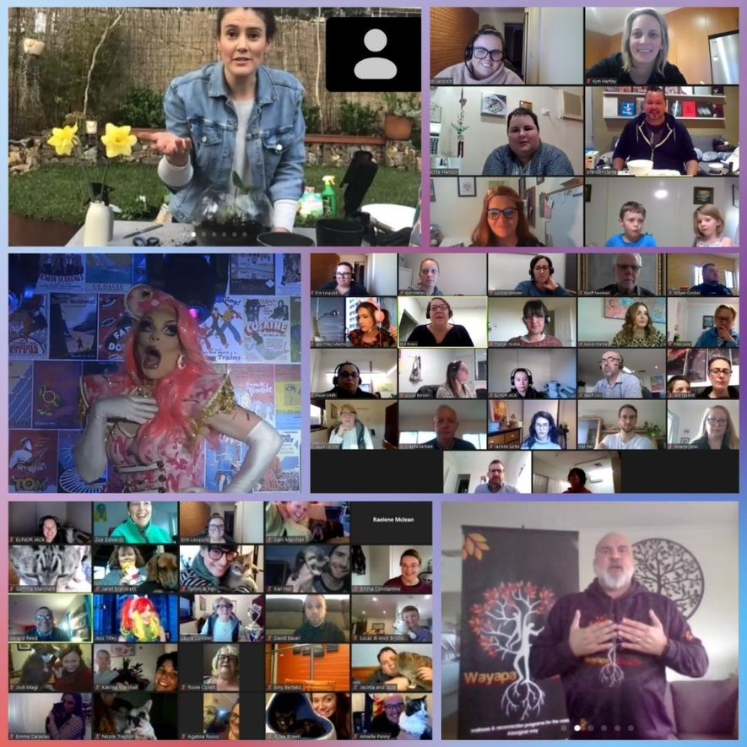

Slide 32

What we take with us
- We already had a strategic imperative to improve comms throughout the org
- COVID-19 turbo charged our strategy
- Enhanced connection – more regular contact with people – not in the traditional sense however we are bringing people from across the org together more frequently
- Innovative Practice – virtual support one on one and groups
- A stronger focus on staff wellbeing
- Flexible workforce – staff working from home
- Limbering up - Greater flexibility an agile organisation

Slide 33

Q and A
Questions from Q and A box and those submitted in advance to NDS

Slide 34

Thank you
Short survey – link in the chat box
NDS Coronavirus Hub - Victorian COVID-19 Response
End of document.

