NDS & DHHS Webinar: Safer and Stronger – accessible slides

Slide 1

NDS: Safer and Stronger – Disability Services and COVID-19 webinar

Wednesday 21st October 2020, 10:00am – 11:00am
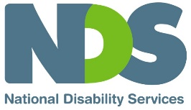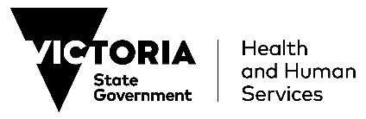

Slide 2

Welcome and Introductions
Sarah Fordyce – Victorian State Manager (Acting), NDS

Slide 3

Agenda
- DHHS update – James MacIsaac, Executive Director Disability, Disability and Communities Branch, DHHS
- Public Health update – Professor John Catford – Senior Medical Adviser, DHHS
- NDIA update – Toni van Hamond, Provider & Markets Engagement, NDIA
- Public Health Team – Dana Carpenter, Infection Prevention & Control Outreach Manager, DHHS
- Provider Perspective – Natarsha Warren, General Manager Community and Lifeskills, Bayley House
- Q&A – Facilitated by Sarah Fordyce, NDS

Slide 4

DHHS Update
James MacIsaac
Executive Director Disability, Disability and Communities Branch
Department of Health and Human Services

Slide 5

NDSV Safer and Stronger Webinar COVID-19 and Disability
Disability Update 21 October 2020
James MacIsaac, Executive Director, Disability
Department of Health and Human Services
Visit DHHS website
COVID-19 hotline 1800 675 398

Slide 6

Overview
Key updates to provide in today’s presentation
Updated public health advice of relevance to residential services and people with disability
- Care Facilities/Workplace Directions
- Quarantine and close contacts
- Hydrotherapy
Work with Victorian health services to support prevention and preparedness of disability service providers
Key current priorities
- Strengthening supports for providers to prevent, prepare for and manage outbreaks via the Victorian Disability Response Centre
- Reducing workforce mobility and strategies to support a surge workforce
- Planning for changes impacting people with disability and providers as restrictions are eased under the roadmap to reopening

Slide 7

Roadmap to reopening
The roadmap to reopening for community services is available at Industry Restriction Levels Community Services
- The Roadmap identifies that until COVID Normal non-residential group and centre based services are restricted to essential services for client safety and wellbeing, and where online services are not practical.
- Residents of disability residential services can attend centre based services in COVID Normal.

Slide 8

Care facilities directions
Amendments to the Care Facilities Directions have been made from 11.59 pm on 18 October 2020 and apply to all disability residential services:
- one household at a time can now visit residents in regional areas for a maximum of two hours a day
- disability residential service providers must ensure visitors declare in writing before coming into contact with residents that they:
- are free of coronavirus (COVID-19) symptoms
- have not in the preceding 14 days been in contact with a confirmed case and
- are not currently required to self-isolate or self-quarantine.

Slide 9

Workplace (Additional Industry Obligations) directions
Disability residential service providers are now required to comply with specific areas of the Workplace (Additional Industry Obligations) Directions.
Note: Disability residential service providers will have a grace period of seven days to implement the changes to the directions in recognition of new administrative arrangements which need to be put in place.
Declaration in writing at start of shift
All workers (including sessional staff from other service providers) must declare in writing before commencing work in the disability residential service that they are:
- free of coronavirus (COVID-19) symptoms; and
- have, in the preceding 14 days, not been in contact with a confirmed case and
- are not currently required to isolate or quarantine.
Record-keeping obligations
Disability residential service providers must keep records in relation to all people who attend the disability residential service.

Slide 10

Workplace (Additional Industry Obligations) directions-cont.
Mobility – residential service workers in outbreak settings, and from metro to regional Victoria
Metropolitan Melbourne (restricted area)
New requirements mean a staff member (or contractor) who has worked at a care facility where there has been an outbreak of coronavirus (COVID-19) can’t immediately work at another care facility. Staff in these situations must wait a minimum of 14 days and test negative for coronavirus (COVID-19) before working at a different care facility.
Regional Victoria (relevant area)
New requirements mean a disability residential service provider in regional Victoria must not let a staff member (or contractor) work where the staff member (or contractor):
- has worked at a care facility in metropolitan Melbourne; or
- worked at another care facility in regional Victoria at the time a confirmed case was present at the other facility;
- Unless the person has tested negative for coronavirus(COVID-19).

Slide 11

Quarantine and close contacts
New public health advice updated on 14 October now requires the following groups to quarantine:
- Primary close contacts of confirmed cases until 14 days after last close contact with the confirmed case, regardless of any negative test result
- Secondary close contacts, until 14 days since the exposure of the primary close contact to the confirmed case; OR until the primary close contact tests negative, and is symptom free, at least 48 hours after the last contact between the primary and secondary close contacts.
- Anyone tested as part of an outbreak investigation, unless specifically advised otherwise by the department.
More information about definitions of primary and secondary close contacts and quarantine requirements is available at self quarantine.

Slide 12

Hydro-therapy
Allied health professionals are able to provide 1-1 hydrotherapy sessions in regional Victoria and metropolitan Melbourne.
- Non-residential indoor swimming pools, including council pools, may be able to operate if they are not open to the public to provide hydrotherapy.
- Allied health professionals can provide services to people at these facilities for clinical reasons.

Slide 13

Health services cluster forum 20 October 2020
Objectives
- Bring together health service clusters and the department to discuss joint activities underway to support disability services in prevention and preparedness
- Share information and approaches being taken by the nine health clusters across Victoria – four metro and five rural/regional
- Discuss proposals for data and intelligence gathering to support an assessment of the level of risk across the sector
- Identify common themes and issues, key learnings, and other strategies to support disability service providers.
Participants
Victorian Disability Response Centre (VDRC) including DHHS and NDIA, Infection Prevention and Control Outreach Nurses (IPCON) in DHHS public health, Health Cluster leads, Disability Liaison Officers, key health service representatives involved in contacting or visiting disability services and NDSV

Slide 14

Health services cluster forum – key themes
Key themes
- Consistent, well-coordinated and accessible communication to providers
- Consistency in approach to infection control strategies
- PPE – training, supply
- Advice on waste management and cleaning
- Timely testing of clients/residents
- Recognise different approaches required in different areas of the State
- Encouraging opportunities to strengthen partnerships between health and disability sectors now and into the future

Slide 15

Health services cluster forum – next steps
Next steps
- Learnings, themes and actions will be documented and shared with attendees
- A second follow up forum will be held in a few weeks to discuss actions and strategies to enhance the prevention and preparedness program of work
- Input and advice from providers will be coordinated through NDSV's Safer and Stronger Project
- An upcoming NDSV webinar will focus on prevention activities with speakers from health clusters and the IPCON team

Slide 16

Accessibility statement and publishing information
To find out more information about coronavirus and how to stay safe visit DHHS.vic – coronavirus disease (COVID-19)
If you need an interpreter, call TIS National on 131450
For information in other languages, scan the QR code
or visit DHHS Translated resources
For any questions call the Coronavirus hotline 1800 675 398 (24 hours).
Please keep Triple Zero (000) for emergencies only.
To receive this presentation in another format email Disability Taskforce disabilityf@dhhs.vic.gov.au
Authorised and published by the Victorian Government, 1 Treasury Place, Melbourne
© State of Victoria, Australia, Department of Health and Human Services, 21 October 2020

Slide 17

Public Health Update
Professor John Catford
Senior Medical Adviser
DHHS

Slide 18

NDIA update
Toni van Hamond
Director, Provider and Markets Engagement VIC/TAS
NDIA

Slide 19

Public Heath Team
Dana Carpenter
Infection Prevention & Control Outreach Manager
DHHS

Slide 20

IPCON Disability Visits to Date
659 Total Disability Contacts
293 Total Disability Visits
Outbreak sites contacted = 31
Prevention sites contacted 315
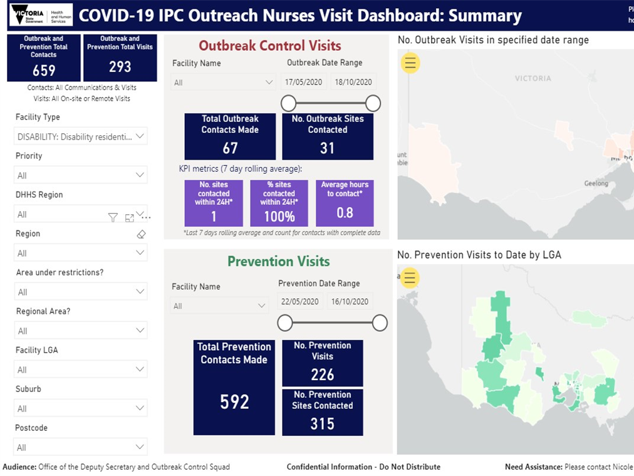

Slide 21

IPCON Total Visits
- Dashboard can be filtered by LGA, region, suburb etc.
- All facilities listed, and contact recorded
- Our team visits various industries, including disability, as per figures below across a variety of settings
- See total visits in 5 months:
- Outbreak and Prevention Total Contacts 3369
- Outbreak and Prevention Total Visits 1894
- Contacts: All Communications & Visits
- Visits: All On-site or Remote Visits

Slide 22

IPCON Next Steps
- PPE Training / Train the Trainer
- Return visits and follow-up on recommendations given
- Further Disability Visits as indicated
- Webinars / Education focus on prevention

Slide 23

Provider Perspective
Natarsha Warren
General Manager, Community and Lifeskills
Bayley House

Slide 24

Q&A
Questions from Q&A box and those submitted in advance to NDS

Slide 25

Thank you
Short survey – link in the chat box
NDS Coronavirus Hub - Victorian COVID-19 Response
End of document.

