NDS & DHHS Webinar: Safer and Stronger – accessible slides

Slide 1

NDS: Safer and Stronger – Disability Services and COVID-19 webinar

Friday 11th September 2020, 10:00am – 11:00am
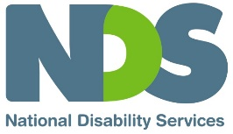

Slide 2

Welcome and Introductions
Sarah Fordyce – Victorian State Manager (Acting), NDS

Slide 3

Agenda
- DHHS update – James MacIsaac, Executive Director Disability, Disability and Communities Branch, DHHS
- Public Health update – Professor John Catford - Senior Medical Adviser, DHHS
- NDIA update – Stephen Broadfoot, Branch Manager, Provider Engagement Branch
- Clinical Waste in Disability Settings – Rachel McConville, Waste Education Officer, Victorian Health and Human Services Building Authority
- Provider Perspective – Natasha Williams, Executive General Manager, genU Ability and Aged Care
- Q&A – Facilitated by Sarah Fordyce, NDS

Slide 4

DHHS Update
James MacIsaac
Executive Director Disability, Disability and Communities Branch
Department of Health and Human Services

Slide 5

NDSV Safer and Stronger Webinar COVID-19 and Disability
Disability Update 11 September 2020
James MacIsaac, Executive Director, Disability
Department of Health and Human Services
Visit DHHS website
COVID-19 hotline 1800 675 398

Slide 6

Overview
Key updates to provide in today’s presentation
- Updating advice and guidance for sector and community on Victoria’s roadmap for recovery
Key priorities
- Strengthening supports and outbreak responses via new Victorian Disability Response Centre
- Building surge capacity and reducing workforce mobility
- Proactive supports for providers to prevent, prepare for and manage outbreaks
- Ensuring clinical in-reach along a care continuum for COVID positive residents

Slide 7

Reopening too soon risks more lock-downs by Christmas
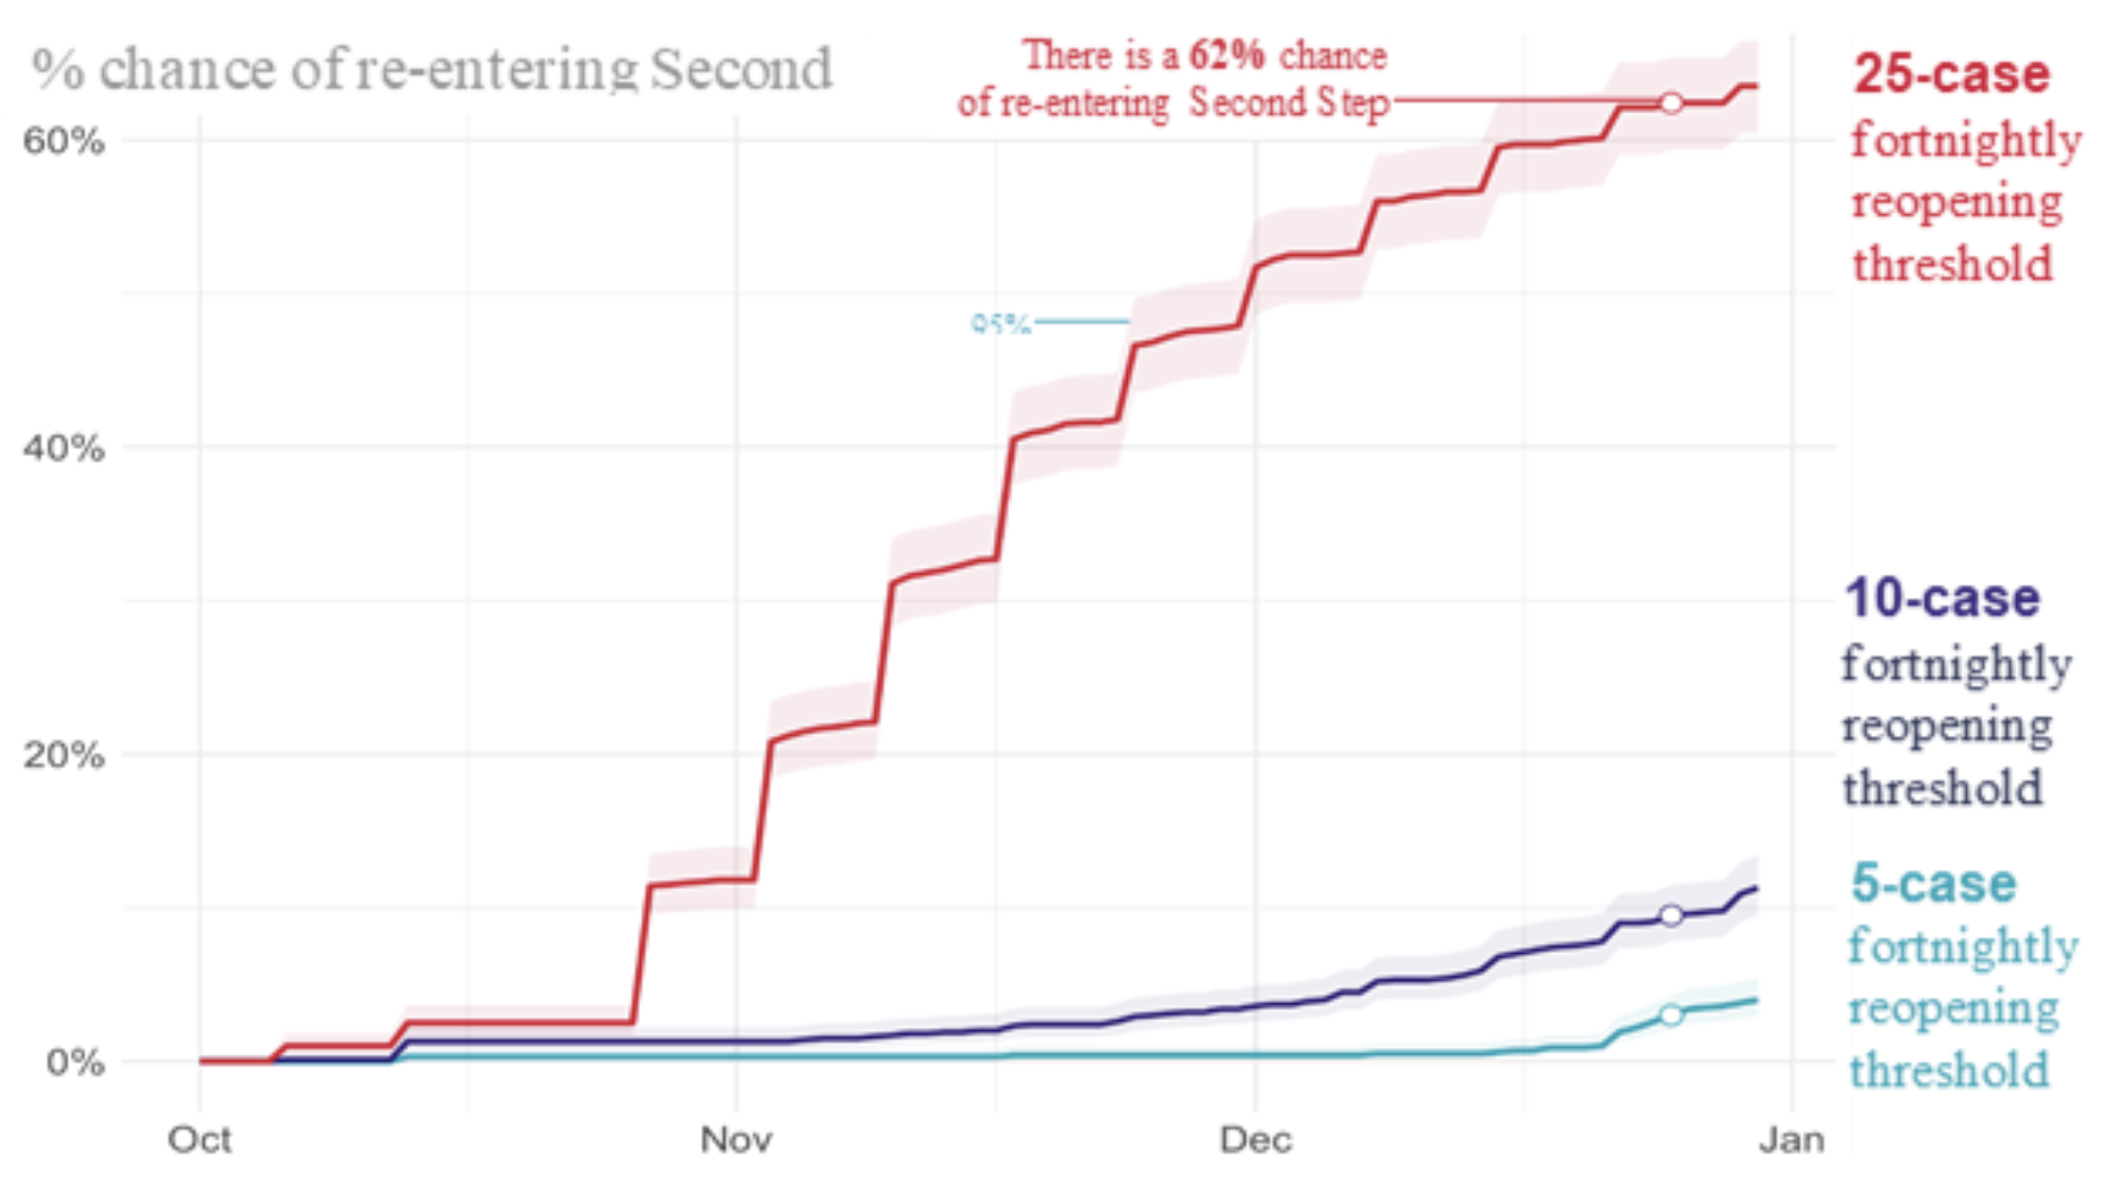

Slide 8
Aggressive suppression is our best bet to avoid a yo-yo effect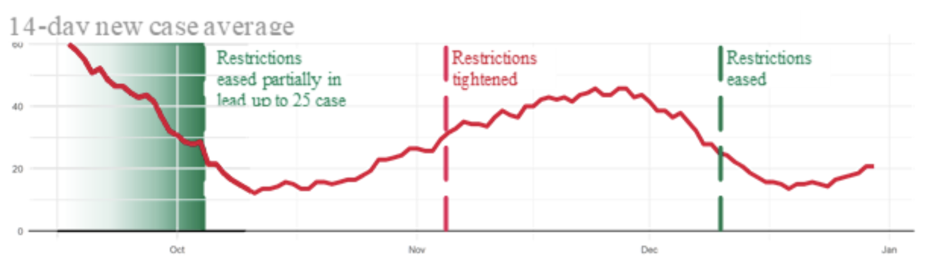

Slide 9

Roadmap for recovery – metropolitan Melbourne
First Step: from 11:59pm 13 September
- Curfew extended to 9pm – 5am
- Public gatherings: 2 people or a household meeting outdoors for 2 hours
- ‘Single social bubbles’ – 1 nominated visitor for people living alone/single parents
- Outdoor playgrounds within 5km of home can be accessed
- Disability services heavily restricted, for example limitations on visitors to residential services
Second step: from 28 September, or average daily case rate of 30-50 new cases
- Term 4 return to school for students at special schools
- Public gatherings increased to 5 people from maximum of 2 households
- Child care/early education re-opened
- Outdoor pools open
- Disability services remain heavily restricted, for example, limitations on visitors to residential services
Third Step: from 26 October, or average daily case rate of <5 new cases
Last Step: from 23 November or no new cases for 14 days statewide
- Restrictions for individuals and disability services to ease in lead up to COVID Normal
COVID Normal: No new cases for 28 days and no active cases in Victoria, no outbreaks of concern in other Australian jurisdictions.

Slide 10

Roadmap for recovery – regional Victoria
Second Step: from 11:59pm 13 September
- Public gatherings increased to 5 people outdoors from maximum of 2 households
- ‘Single social bubbles’ – 1 nominated visitor for people living alone/single parents
- Outdoor playgrounds and outdoor pools open
- Term 4 return to school for students of specialist schools
Third Step: Average daily case rate of <5 new cases, 0 cases of unknown source
- No restrictions on reasons to leave home
- Public gatherings increased to 10 people outdoors
- ‘Household bubble’ – one nominated household, with up to 5 visitors at a time
- Restrictions for disability services to ease in lead up to COVID Normal
Last Step: from 23 November and no new cases for 14 days statewide
- Significant easing of restrictions for individuals and disability services in lead up to COVID Normal

Slide 11

Worker Mobility Reduction Payment initiative
Financial support for workers and providers
    - Addressing the impacts of restrictions on worker mobility for residential workers and providers
    - Reducing mobility of workers critical as part of COVID-19 prevention strategy
    - Commenced 1 September 2020 and will be available until 31 December 2020
    - Information on payments and arrangements released to providers by Victoria and Commonwealth
    - Initiative guided by principles that recognise the impact of public health orders and take into account differing arrangements for NDIS and state funded ‘transfer’ providers
    - Principles also set out requirement that providers have available evidence to demonstrate relevant costs incurred

Slide 12

COVID-19 outbreaks in disability settings
As at 10 September, there are 30 active cases of COVID-19 in disability and community setting (including SRSs)
13 cases are in facility based settings
- 7 staff members and 6 residents/ participants
17 cases are in community based settings (including SRSs)
- 10 staff members and 7 participants
A total of 11 facility based sites are currently affected.

Slide 13

Some Key Reminders
- Providers must email DRRG@dhhs.vic.gov.au immediately as they become aware of a first positive test at any disability residential service, in either a staff person or resident. (This will engage a Disability Incident Case Manager)
- Frontline staff should all have completed the Commonwealth Australian Government Department of Health Infection Control training at COVID-19 Training
- New E-learning modules are available on the DHHS website COVID Safe learning package and Personal Protective Equipment (PPE) learning package
- All staff should know that when any testing is done on staff or residents of a residential service where there is a positive case, the person taking the test should be advised to label the sample as ‘OUTBREAK PRIORITY (P1)’
- Isolation plans should be in place for each site detailing how resident isolation and staff replacement will be managed in the event of whole staff & resident group being identified as Close Contacts (including what other locations may be used)

Slide 14

Key issues
- Communication across the sector and with people with disability
- Two dedicated pages on the DHHS COVID-19 website:
- For people with disability
- For the disability sector
- Testing
- PPE and masks
- Infection prevention education

Responses
Disability sector plan & Isolation Management
Face masks for disability support workers
Restrictions
- Coronavirus restrictions Disability Service Providers
- PPE fact sheet
- Coronavirus fact sheet requests for PPE by community services providers
Get tested kit (promoting testing): Promotional material Coronavirus
Priority processing of test results for people with disability
Multiple testing sites across Victoria. In-home testing available.
Call to test COVID-19
Requirement for disability support workers to use single use disposable masks and eye protection
PPE sources: private suppliers, national stockpile (NDIS providers).
DHHS supply: CSPPE@dhhs.vic.gov.au Priority to positive cases
COVIDSafe and PPE e-learning modules are available on the DHHS website
Infection and prevention control team visits to services - requests can be made to
Email: silprovider.inbox@dhhs.vic.gov.au

Slide 15

Public Health Update
Professor John Catford
Senior Medical Adviser
DHHS

Slide 16

NDIA update
Stephen Broadfoot
Branch Manager for Provider Engagement
NDIA

Slide 17

Clinical Waste in Disability Settings
Rachel McConville
Waste Education Officer
Victorian Health and Human Services Building Authority

Slide 18

Clinical and Related Waste
Victorian Health and Human Services Building Authority

Slide 19

Why manage clinical waste correctly?
Staff and workplaces are responsible for the storage, handling and disposal of clinical waste.
Managing clinical waste correctly:
- reduces infection risk for staff and patients
- ensures compliance with EPA and WorkSafe requirements
- reduces damage to the environment
- reduces waste management costs

Slide 20

Clients who do not have COVID-19

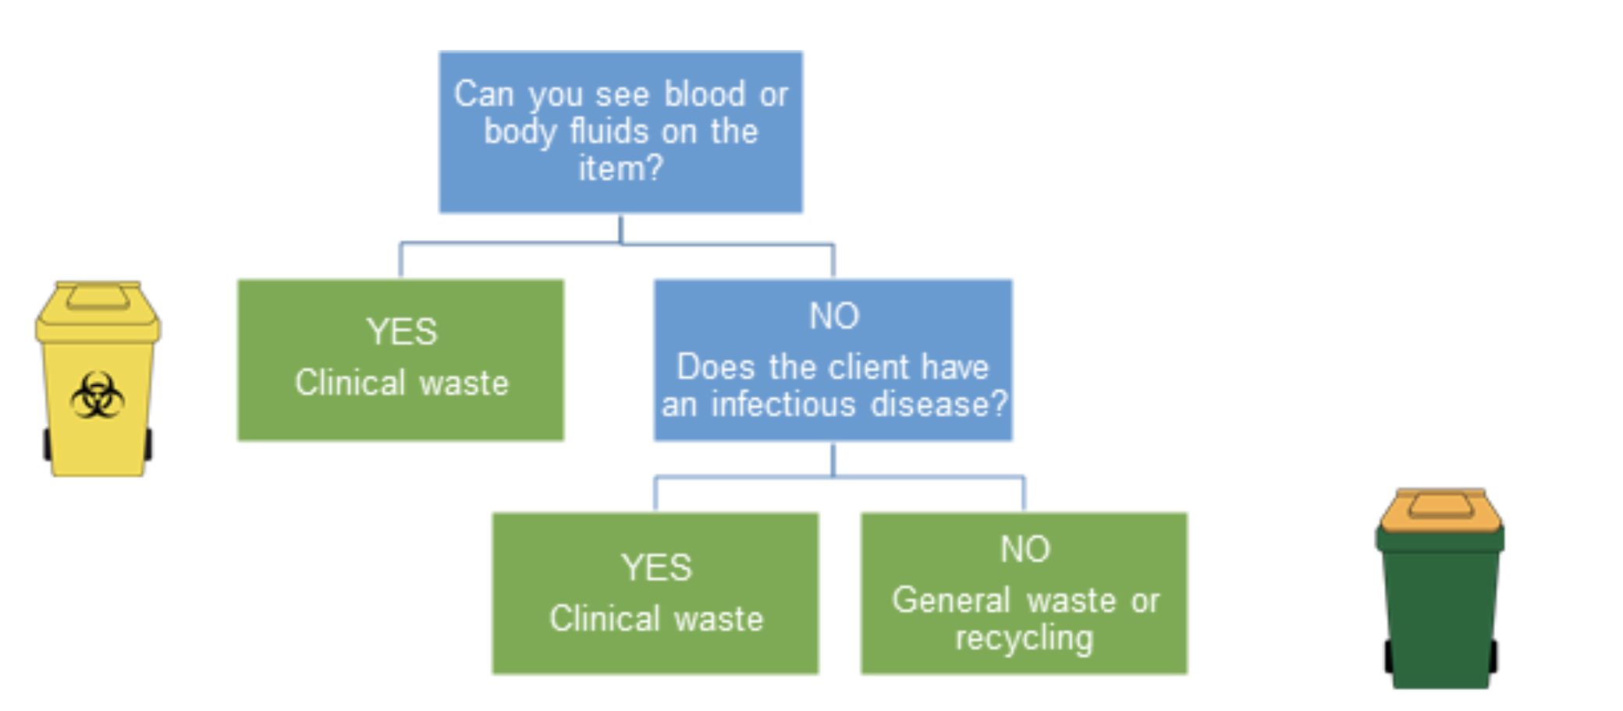
Note: Faeces, urine, vomit and sputum are not body fluids, unless you can see blood in them

Slide 21

Clients who do not have COVID-19 example
Jessica needs to dispose of a used continence aid. It does not have blood on it and the client is not suspected of having an infectious disease. Jessica disposes of the item in the general waste bin.
Dave is disposing of a tissue with some blood on it. He places it in the clinical waste bin.

Slide 22

Clients with confirmed or suspected COVID-19
All waste from a patient confirmed, or suspected of having, COVID-19 must go into a clinical waste bin.
Not all waste from a site with COVID-19 patients is clinical waste.

Slide 23

What is suspected or confirmed case?
Suspected – a client who meets the clinical criteria for testing
Confirmed – a client who has tested positive to COVID-19

Slide 24

Clients with confirmed or suspected COVID-19 example
Jessica has been looking after a client who has COVID-19. She disposes of all PPE and any other waste items that have been in the patients room in the clinical waste bin.
Dave is in the kitchen preparing food in a facility with COVID-19 patients. The patients have not entered the kitchen and so the waste items in the kitchen are disposed of in the general waste or recycling bin.

Slide 25

Other clinical waste
Sharps – anything able to cut or penetrate the skin
Pharmaceutical – any pharmaceutical substance or container
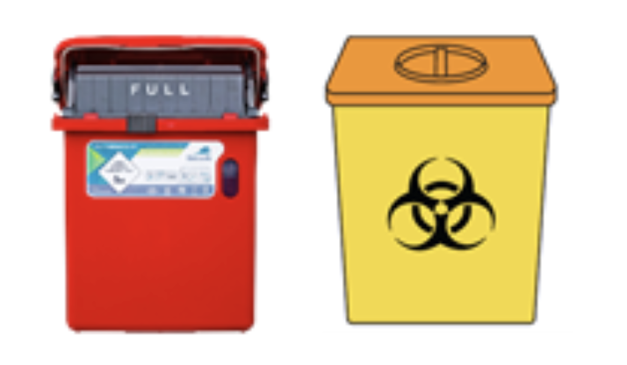
Anatomical – human tissue
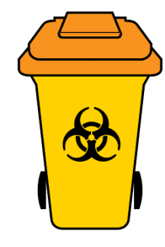
Cytotoxic – anything contaminated with a cytotoxic drug

Slide 26

References
DHHS
Coronavirus (COVID-19) Case and contact management guidelines
Coronavirus (COVID-19) PPE guidance for RACF Factsheet
Clinical Waste – Supplement for healthcare staff
The Blue Book – Guidelines for control of infectious diseases
EPA
Coronavirus (COVID-19): Disposing of clinical waste
Coronavirus (COVID-19): Disposing of PPE at home and in the workplace
Clinical and related waste operational guidance

Slide 27

Contact
rachel.mcconville@dhhs.vic.gov.au
Sustainability in Healthcare

Slide 28

Provider Perspective
Natasha Williams
Executive General Manager
genU Ability and Aged Care

Slide 29

NDS Safer and Stronger: A Workforce Reflection
Natasha Williams
September 2020

Slide 30

Workforce Preparation
- Safety Conversation; every resident, every worker, every family, every house (What if?)
- COVID Casuals and Standby Workers
- Minimised mobility in Melbourne
- Supplied PPE, set up Warehouse
- Business Continuity Planning and Training
- Prepared and sent Communications
- Engaged private testing company
- Prepared essential info for “ new workers”

Slide 31

The situations that have resulted in lockdown
- A worker test positive
- A sole provider notifies positive test- had visited in last week
- A sole provider tests positive after supporting resident during day (worked alongside genU staff)
- A resident unable to be tested after showing symptoms
- A resident showing symptoms and tested

Slide 32

The Outbreak
- Friday afternoon (positive worker)
- All staff close contact x 8
- Redeployed workers from other houses
- Needed to pay additional penalties
- Didn’t quite have enough PPE
- Communications delivered residents & staff
- Transparent Communications
- Waste and Cleaning in Place
- Unable to isolate positive resident

Slide 33

The Learnings
- PPE needs to be in place and have areas
- Importance of Donning/Doffing- competency Ax
- Staff in reserve (high complex houses and SWOT team in some areas)
- Virtual Supervision options
- Capital considerations in future
- Honest and constant safety conversations
- Knowing about outside/other employment
- PPE & isolation present issue for residents

Slide 34

Workforce
- Exhausted Staff
- Leave and surge concerns later in the year
- Leave planning needed now
- Recruited “new” workers (screened)
- Trained in “Covid related skills”,prepared and available to work (willingness to work surveyed)
- Work alongside experienced staff
- Now enrolled in CERT 3 and 4 in Disability
- Have 40 workforce ready staff in Melbourne areas

Slide 35

Contact
Natasha Williams
Executive General Manager Ability and Aged Care
Natasha.Williams@genu.org.au
0407950675

Slide 36

Q&A
Questions from Q&A box and those submitted in advance to NDS

Slide 37

Thank you
Short Survey link in the chat box
NDS Coronavirus Hub — Victorian COVID-19 Response
End of document.

