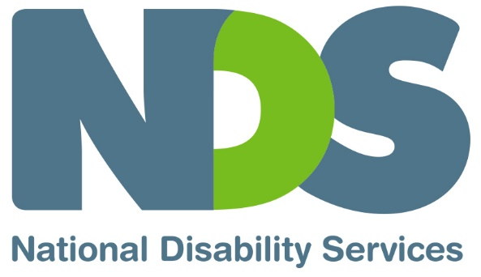

Social Media Platform Information Sheet
The use of social media is becoming an important part of a marketing strategy for disability service providers. A frequent question that NDIS providers have is, which social media platform to use. There is no doubt that social media can reach a wide audience and is a powerful tool to promote your organisation, but with many options available, what platforms should you be using, and how do you use it?
Begin by defining your audience. Get clear on who you want to reach and find out where these demographics are online. A great and accurate way to find out is to ask people. You can do this via regular communications as well as by talking to participants, stakeholders and others in your community. Also, have a look at how other providers and people in the sector are using social media. What platforms have the highest reach and what posts are connecting with their audience and attracting strong engagement? Another helpful resource is the Sensis Social Media Report, providing statistics on how people and businesses use social media in Australia.
Another key consideration is does the social media platform allows you to communicate what you need. Each social media platform has different features, so while one platform might be effective for securing event registrations, another may be more effective in announcing and engaging people in a new program or service.
Let’s look into the features, capabilities and mindset of the different social media platforms.

Facebook
Facebook is undoubtedly the most popular social media platform for both consumers and businesses, and is used extensively for entertainment and current affairs. However it has an increasing focus on advertising (pay-to-play), which can be a cost effective option to reach people quickly. Pay to play content is essentially an algorithm that weaves paid advertising into users feeds.
Organic reach refers to the number of people who see your content without paid distribution. Content posted on Facebook is typically short and snappy and is ordered based on popularity, so think creatively about ways your posts can stand out and connect with people. You will find that a quick search on the topic ‘NDIS’ on Facebook brings a flood of search options. Well-known NDIS providers use Facebook posts regularly to explain complex NDIS language and procedures. This can be a proactive way of attracting participants.

Instagram
Instagram is owned by Facebook, however this platform is mostly visual, and is often used to share inspiration and passions. This gives disability providers an opportunity to use imagery to give personality to the organisation. There is something very powerful about an image that can tug on the heart strings, or tell a story, so if this is your forte, Instagram might be worth using.
There are more small-to-medium organisations using Instagram compared to Facebook, focusing on building branding and inspiring audiences. For example a Victorian disability provider uses Instagram to introduce each employee, including back of house and admin, which helps prospective clients understand the organisation’s structure and connect on a more personal level with staff.

Twitter
Twitter is less about family and friends and more about sharing news or answering questions. It is known for its role in breaking news, the hashtag function (a word or phrase preceded by a hash symbol) means it is possible to see what topics are trending for example #disability #inclusion #carers are all topics we can search on twitter.
It can also be a good medium to communicate with participants or other stakeholders in a transparent way that others can view. Many thought leaders and media personalities are tracked on Twitter, so whilst this wouldn’t promote your organisation in a traditional sense, it could lend credibility to your brand and build an awareness and demonstrate that you are actively talking to people in the disability space. Organisations, including NDS, use Twitter to keep the sector informed about forthcoming events, resources and news. Additionally NDS shares posts from staff members including the CEO, David Moody. These posts ‘humanise’ the organisation and let people feel connected to the senior staff, who otherwise can sometimes are faceless and known to their clients.

LinkedIn
LinkedIn is the largest social media network for business people and professionals. This one is more about sharing professional and organisational milestones, and high-level management such as CEOs extending their networks. LinkedIn is less about attracting new clients or participants, however it is a great way to engage professional stakeholders or share career opportunities.

In the Disability sector, where there can be confusion and rapid change, building value and trust with your participants is perhaps the most important way of marketing your service. Social media can be an efficient, creative and far-reaching way to communicate to people and build that trust.

