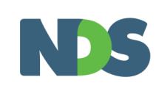
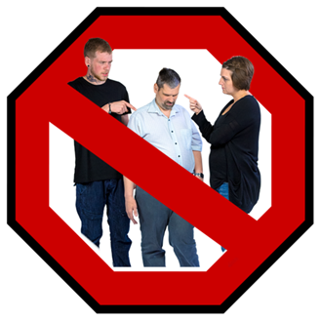

Zero Tolerance Forums

Abuse and neglect are not OK!

You are invited to come to a meeting on human rights and the safety of people with disability.
The meeting is called: Zero Tolerance Forums
We will talk about ways to help stop abuse of people with disability.

The meeting is in 3 parts:
Part 1
9.15am – 11.00am: ‘Staying Safe’
This is for people with disability and their support workers. There will be videos to watch.
An organisation called VALID will talk about human rights and different types of abuse. They will also tell you who to talk to if you need help.

Part 2
11.30 am – 12.45 pm: ‘Understanding Abuse’
This is for support workers and supervisors.
They will learn about why abuse and neglect happens, and how to help people with disability to be safe. You can also attend this session if you like.
Part 3
1.30pm – 3.30pm: ‘Restrictive Practices’
In this session we will talk about ‘restrictive practices’. This is when someone is stopping you from having your rights or your freedom.

The meetings are at these places and dates:
- Alice Springs: Double Tree by Hilton (82 Barrett Drive), Tuesday 29 August 2017, 9.00am - 4.00pm
- Tennant Creek: Tennant Creek Training Centre (65 Staunton St), Thursday 31 August 2017, 9.00am - 4.00pm
- Nhulunbuy: Nhulunbuy Training Centre (Chesterfield Circuit, Nhulunbuy), Tuesday 5 September 2017, 8.30am - 2.00pm
- Darwin: Michael Long Centre (70 Abala Rd, Marrara), Wednesday 6 September 2017, 9.00am - 4.00pm
- Katherine: Knotts Crossing Resort (Corner of Giles Street & Cameron Street), Friday 8 September 2017, 9.00am - 4.00pm

What to do if you want to go to one of these meetings:
To book a place at this meeting: Go to the NDS website event page, here: https://www.nds.org.au/events-and-training/zero-tolerance-forums
To talk to someone about the meeting: You can call Susan Burns on 08 8930 2823 or send her an email at susan.burns@nds.org.au

