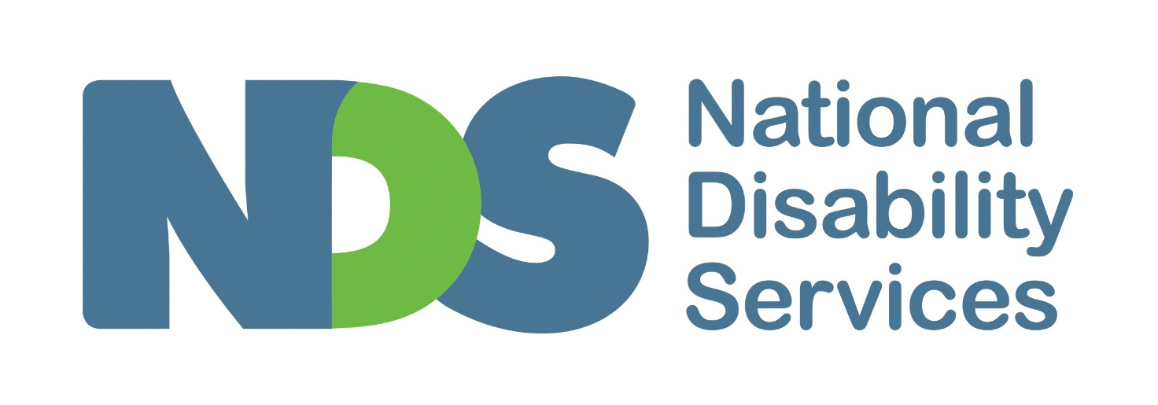

Call for Papers
National Disability Services Western Australia
2019 State Conference

What Matters Most
Solutions for Today and Tomorrow

Crown, Perth
16-17 September 2019

Call for Papers
The 2019 NDS WA State Conference, What Matters Most – Solutions for Today and Tomorrow will be held on 16-17 September 2019 at the Crown, Perth.
The conference will provide a forum to consider and share What Matters Most for the disability sector and people with disability into the future. It will cater to the range and variety of roles within the sector, together with people with disability, their families and carers.
NDS WA now invites expressions of interest to make a presentation or provide a poster for this event that showcases breakthroughs for good services. Abstracts should be related to one or more of the following focus areas:
- Quality and Safeguarding  - Meeting People’s Needs and Achieving Outcomes  - Technology Solutions  - Rural and Remote  - Diversity, Equality, Access and Inclusion  - Mainstream Services  - Employment Innovations  - Co-design in Practice | - Housing – Innovation and Solutions  - Research and Development  - Market Stewardship and Supply  - Skilling our Workforce  - Collaboration and Partnerships  - Creating Sustainable Organisations  - Managing and Communicating Change  - Employing People with Disability in our Sector
The conference program can cater for:
- Short (e.g. 15 minute) sessions that provide an overview of a key development, insight or an inspiring story; and

- Medium length sessions (e.g. 30 minutes) that inform, engage and seek input from the audience to inform future policy or sector/community development initiatives.

Call for Posters
We also invite you to submit an outline of a poster that would cover a project/initiative or practice which will be on display at the conference. Posters must be A2 in size (420mm × 594mm) and should adhere to accessible information guidelines and at a minimum text must be at least 14 point and in a plain, a sans serif font (e.g. Arial). The inclusion of images (high resolution) is encouraged. For assistance on creating accessible documents, please use this checklist as a guide.
Posters will be on display in the foyer throughout the two-day conference and the author(s) may elect to be available to answer questions on the day during any of the breaks.
Further information is provided in the Expression of Interest Forms. Completed Expressions of Interest Forms must be received by 5.00 pm Friday 3 May via WAConference@nds.org.au

Additional Information
You will be notified of acceptance of your paper or poster by Friday 24 May 2019 and the deadline for content is Friday 16 August 2019. This date provides enough time to ensure the papers can be provided to people who need them in an alternative format or in advance, including interpreters.
Presenters will receive free registration on the day of their presentation (excludes the sundowner event).
Registrations for the 2019 NDS WA Conference will open soon. In the meantime, please mark 16-17 September 2019 in your diary.
For more information or enquiries about the call for papers, please contact Geoff Holden at NDS WA on 08 9208 9808 or geoff.holden@nds.org.au.
Expression of Interest to Present at the 2019 NDS WA State Conference
Organisation:
Name of presenter/s:
Job title/s (if applicable):
Telephone:
Email:
Presentation title (maximum 20 words):
Subject matter (Refer to page two of the Call for Papers for focus areas):
Summary of presentation content (maximum 200 words):
Presentation content is relevant to which target audience (please tick one or more boxes):
☐ People with disability, families and carers
☐ Disability sector workers
☐ Disability sector managers/CEOs
☐ Other (please specify):
Biography of the presenter/s (maximum 100 words):
Submit EOI to present at the 2019 NDS WA State Conference by 5.00pm Friday 3 May 2019 to WAConference@nds.org.au

Expression of Interest in Supplying a Poster at the 2019 NDS WA State Conference
Organisation:
Name of presenter/s:
Job title/s (if applicable):
Telephone:
Email:
Poster title (maximum 20 words):
Subject matter (Refer to page two of the Call for Papers for focus areas):
Summary of the poster content (maximum 200 words):
Poster content is relevant to which target audience (please tick one or more boxes):
☐ People with disability, families and carers
☐ Disability sector workers
☐ Disability sector managers/CEOs
☐ Other (please specify):
(Optional) Availability to answer questions and/or speak about the poster (please tick one or two boxes):
☐ Not available Monday or Tuesday
☐ Available Monday 16 September 2019 lunch break
☐ Available Tuesday 17 September 2019 lunch break
Submit EOI to supply a poster at the 2019 NDS WA State Conference by 5.00pm Friday 3 May 2019 to WAConference@nds.org.au

