State of the Disability Sector Report 2017

The ground on which disability service providers operate is shifting. The NDIS can feel like a dense dark jungle; but there is light breaking through. If implemented well, the NDIS will give Australia a world-leading disability support system.

Contents
The state of play 4
The state of the operating environment 7
QLD case study 24
NSW case study 25
The state of the NDIS 27
SA case study 31
Tas case study 32
The state of the broader policy environment 35
NT case study 36
WA case study 37
The state of disability employment 39
ACT case study 42
VIC case study 44
The state of the disability workforce 46

The state of play

Disability service providers across Australia are at the frontier of reform. For most this means the National Disability Insurance Scheme, for some it means the new Disability Employment Services program. Both reforms expand competition and consumer choice. The ground on which disability service providers operate is shifting.

Being at the frontier of reform is a mixed blessing. If implemented well, the NDIS will give Australia a world-leading disability support system. The potential is already apparent in stories of NDIS participants getting support to achieve goals which were formerly out of reach. But the terrain ahead is uncharted, progress is arduous and the risks are considerable. Not all the stories are positive.

Under pressure: Most disability service providers support the direction of change, but they feel under immense pressure. The NDIS demands huge growth and change at the same time. As the Productivity Commission observed, this is “highly challenging” for disability service providers.

Add to this the implementation problems of the NDIS. These have dogged the scheme since July 2016 when the NDIS moved to full-scheme transition. NDIS systems faltered as the intake of participants dramatically increased. After three years of trial, the NDIS had brought in 30,000 people, 15 months later the number had increased to 113,000. The pressure to process people quickly led to short-cuts – phone planning instead of face-to-face planning, for example. Many new planners lacked the skills and experience required. The quality of participant plans fell.

Disability service providers have borne additional cost from inefficient NDIS processes. For example, they have to develop a detailed quote annually for every Supported Independent Living participant, which the National Disability Insurance Agency can then take many weeks to assess.

With the pace and complexity of change, timely information is crucial. But NDIS systems have struggled to respond.

The NDIS can feel like a dense dark jungle; but there is light breaking through. The NDIA knows there are problems. It is systematically reviewing the experience of providers and participants and has promised many improvements. Piloting the changes begins in December 2017.

In a major report on the NDIS published in October 2017, the Productivity Commission concluded that, while the NDIS’s costs are broadly on track, the timeline agreed by governments won’t be met. Among the causes: the workforce isn’t growing fast enough; and demand for services will outpace market supply – impeded by uncertainty, financial capacity and the scale of organisational change required.

Business confidence dampening: Survey findings in the 2017 State of the Disability Sector report reinforce the Commission’s findings. Only 58 per cent of disability service providers are planning to increase their services. They find staff hard to recruit, the policy environment is uncertain and they lack the working capital required to grow and change. Only four in 10 rate their financial condition as ‘strong’ or ‘very strong’, down from 53 per cent last year. Two-thirds worry they won’t be able to provide services at NDIS prices. In short, business confidence has dampened.

The Productivity Commission’s report echoes disability service providers’ concerns about the NDIA’s price-setting. It says price-setting should be transparent, granular, evidence-based and timely – and that prices should be regulated only when there is clear evidence for doing so. It argues prices should be set primarily to boost market development, not to enable the NDIA to manage the budget. It recommends price-setting be transferred to an agency independent of the NDIA.

Inadequate NDIS prices pose a risk not only to individual disability service providers but to the scheme as a whole. If the supply of high-quality services is insufficient, the NDIS would fail to deliver on its great promise. Many eyes will be focused on the outcome of the Independent Pricing Review established by the NDIA. It is due to report at the end of 2017.

Employment boost needed: Across disability services, a common vision is to build the capacity of people with disability to participate in social and economic life. This includes
employment, either now or in the future. Australia’s workforce participation rate for people with severe disability declined between 2012 and 2015 (the most recent figures available), from 30 per cent to 25 per cent. This disturbing trend requires a policy response.

A key part of the response must be to boost the capacity of DES providers and Disability Enterprises. DES providers have battled to maintain services over the past decade as real funding per service user declined. The new DES program will index funding and introduce a risk-adjusted formula designed to reflect the effort required to place people in jobs. This is good in principle but its application will need to be carefully monitored.

Disability Enterprises have the potential to expand jobs for people with disability as the NDIS removes the cap on employment places. But Disability Enterprises face uncertainties. If the Fair Work Commission imposes higher wage costs on them without additional funding, it would cost many jobs. There would also be a net cost to the NDIS, with displaced workers requiring non- vocational supports.

The NDIS must boost the take-up of employment supports. At present, they account for only 5.3 per cent of the plans of 15-24 year old participants and just 2.2 per cent for participants over 25 years.

Data has value: The State of the Disability Sector report exemplifies the value of data. As the NDIS is implemented, data collection and analysis are essential to inform market stewardship and reduce the risk of market failure. Disability service providers need data to plan and invest in service development. The NDIA has produced Market Position Statements, but more applied research is needed.

NDS is determined to see the NDIS succeed. Too much is at stake to let it fail. We are working with the NDIA to identify and resolve problems and we are keen to improve constructive engagement between the NDIA and the sector. NDS has provided much advice and data to the Productivity Commission and the Independent Pricing Review. This State of the Disability Sector report should help inform and influence the direction and implementation of important disability reforms.

Dr Ken Baker AM
Chief Executive
National Disability Services

The way forward:

Proposals we’d like to see implemented

- NDIS prices that reflect the realistic costs of providing high-quality supports and stimulate investment in growth and change
- A higher proportion of NDIS plans with employment supports
- The future of Disability Enterprises secured through increased procurement, NDIS prices that reflect the cost of supported employment and access to industry assistance
- The capacity of DES providers to attract and support job seekers boosted
- The National Disability Strategy more effective at driving change
- Increased investment in data analysis and research to underpin service growth and development
- Further investment in sector and workforce development that assists disability service providers to make the transition to the NDIS
- Less administrative burden on disability service providers through an efficient IT portal and streamlined processes
- Participants able to choose NDIS planners who have expertise and experience in disability support
- NDIS design issues resolved, including: emergency response; transport; and the interface with service systems such as health and education
- Increased flexibility and local decision- making in the NDIS
- Structured engagement between the NDIA and the disability services sector through a partnership forum

The state of the operating environment

The following data is produced from the fifth wave (W5) of NDS’s Annual Market Survey.

516 disability service providers responded. Forty-two per cent had income of less than
$1M, 27 per cent between $1M and $5M, 20 per cent between $5M and $20M and 11 per cent had income of $20M or more.

Twelve per cent were sole traders, up from five per cent in 2016. The inclusion of this cohort did not skew the overall results. Sixty-two per cent of respondents were not-for-profit organisations and 36 per cent for-profit organisations. Two per cent were not classified.

Ninety-six per cent of respondents were registered National Disability Insurance Scheme (NDIS) providers and 87 per cent have provided services under the NDIS.

The gap between demand and supply continues to grow

Growth in demand for disability services continues to outstrip supply. In the last 12 months, less than half of disability service providers (47 per cent) could meet all demand. The outlook for 2018 suggests the supply gap will continue to widen with only 43 per cent (compared with 53 per cent in 2016) of disability service providers expecting to meet demand.

Figure 1 Capacity to meet demand in the last 12 months and forecast for the next 12 months

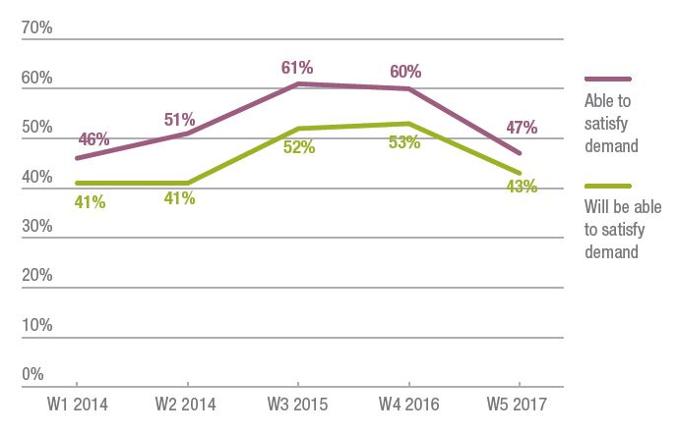
Nearly three quarters of disability service providers (73 per cent) saw demand increase in the last 12 months and four out of five (82 per cent) expect demand to increase further in the next year. However, as forecast last year, many are not keeping up. Only 56 per cent reported an increase to the overall scale and/or range of services with 58 per cent planning to increase services in the coming 12 months.

“It is undeniable that the supply response to the scheme is less than what will be required to deliver supports to participants.” Productivity Commission Report on NDIS Costs, October 2017

Figure 2 Actual and forecast demand

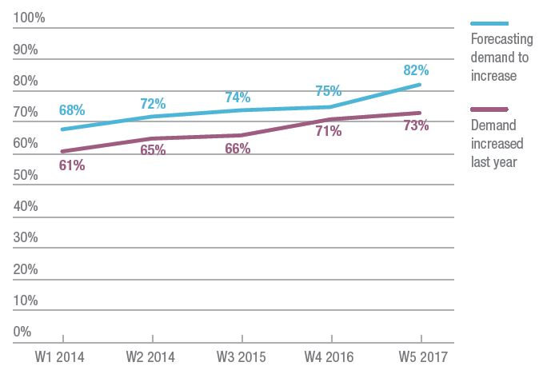

“Aboriginal children with disability are missing out on services because the process is so complicated and the information does not appear to be reaching their families.”

“The biggest concern will be, can we continue to provide services which are not adequately funded. The shortfall may result in refusal of service provision for some services.”

Figure 3 Changes to the scale and/or range of services last year

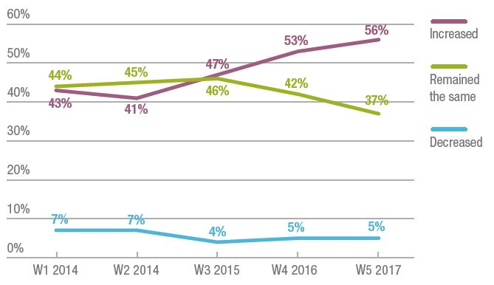
The percentage of disability service providers reporting ‘all client needs will be fully met by other organisation(s)’ remained at only eight per cent. One quarter (26 per cent) did not know if the needs of clients had been met elsewhere.

The number reporting ‘some client needs will not be met by other organisation(s)’ increased from 35 per cent to 43 per cent. However, organisations reporting that ‘none of these client needs will be met or will go without service’ improved, dropping from 10 per cent to five per cent.

Figure 4 Extent to which clients lost had their needs met by other providers

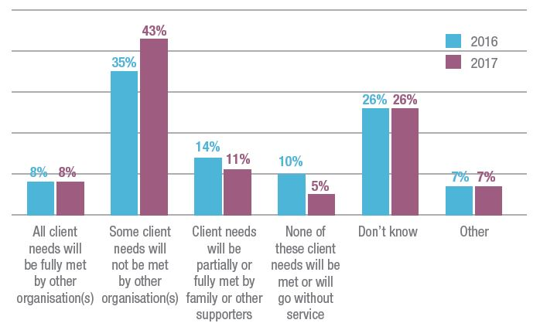
The extent to which clients are moving between disability service providers appears to have increased. Last year approximately half (49 per cent) of respondents reported not losing clients. This year, less than one third (31 per cent) retained all their clients. Most clients are still moving to existing not-for-profit organisations. However, eight per cent moved to new not-for-profit organisations and a similar percentage moved to small for-profits, including sole traders.

Figure 5 Client movements in the last 12 months

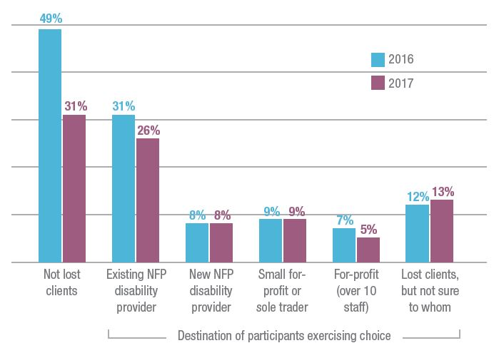
“Many of these clients are in areas where there are no other providers and we have long waitlists.”

“As a provider of services in Auslan it means that if we don’t provide the service no one else can.”
“We were unable to provide the service in a timely manner due to financial and workforce constraints.”
The profile of services provided by respondents was very similar to 2016. Sixty-three per cent provide assistance with social and community participation, 52 per cent provide services in daily personal activities, 51 per cent in life skills and 50 per cent in planning and coordination.

The main areas in which fewer organisations provided services this year were respite services (down from 47 per cent to 40 per cent), assistance with travel (down from 45 per cent to 37 per cent) and advocacy (down from 27 per cent to 21 per cent).

Figure 6 Services provided in the last 12 months

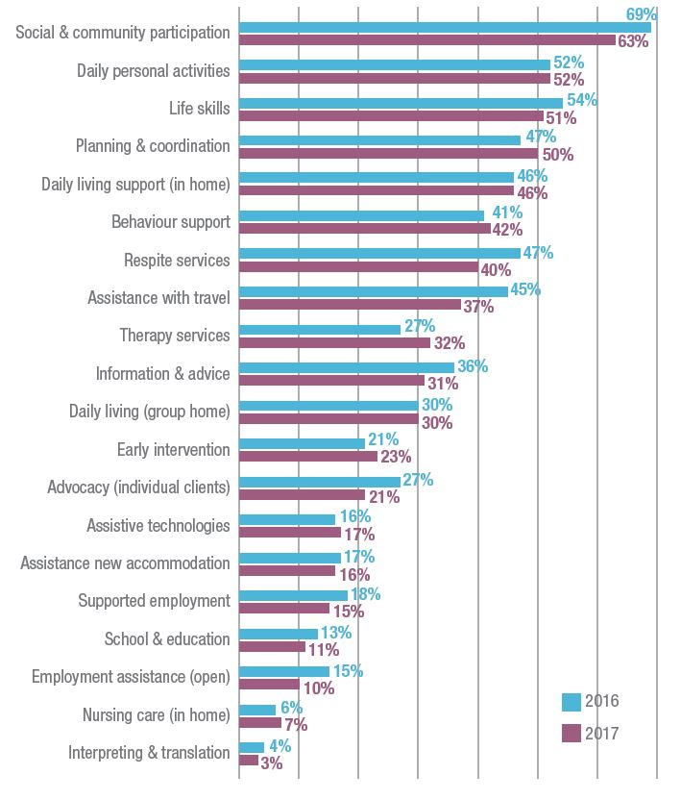
Respite continues to be the service most organisations are planning to reduce or close. The other key areas for service reduction and closure are advocacy, planning and coordination, assistance with travel, information services, supported employment and early intervention.

NDS is hopeful the recent increase to short-term accommodation prices (respite) will lower the number of organisations planning to reduce or stop this vital service.

Figure 7 Organisations expecting to reduce or stop providing services in the next 12 month

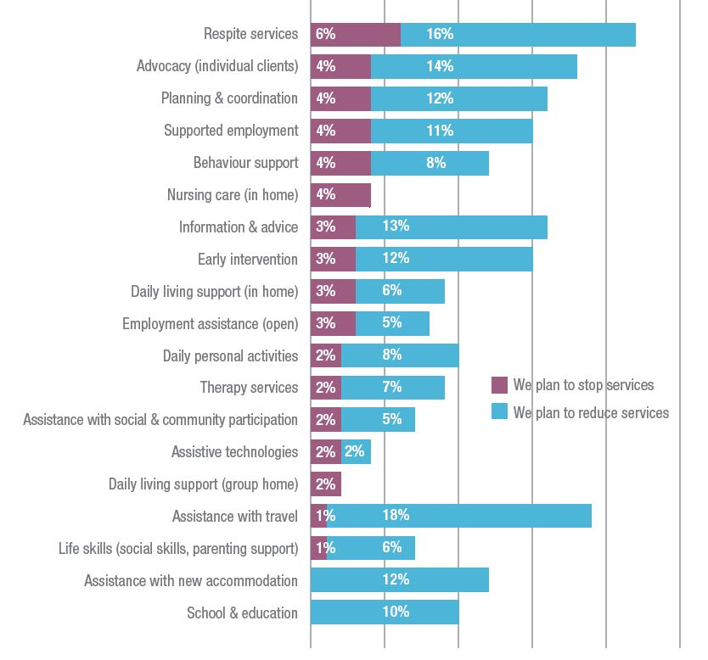

The percentage of organisations intending to introduce new services has grown from 38 per cent to 53 per cent. The most common areas to enter reflect services with low entry barriers and comparatively higher actual or perceived margins. These are planning and coordination (six per cent) and therapy services (five per cent).

“We are not interested in growing a big business, just a more effective business that caters to the needs of people with disability in our local community.”

Figure 8 Intentions to introduce new services for the first time in the next 12 months

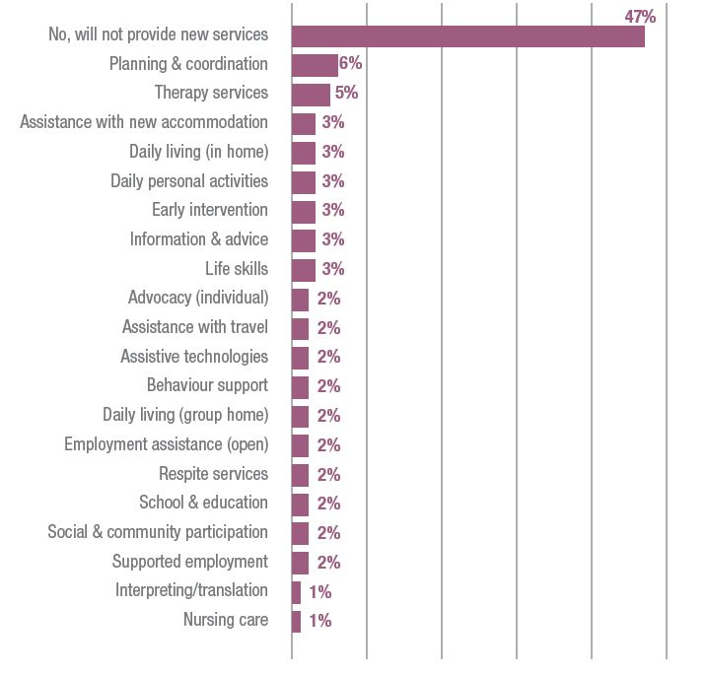

Just under half (47 per cent) of disability service providers are planning to provide services outside the disability sector next year. This is relatively unchanged from 48 per cent in 2016. Aged care in-home services and mental health services are the top sectors to enter. Organisations recognise they need to reduce risk and uncertainty through growth into these adjacent markets. We expect this trend will slow the growth of supply of disability services.

Figure 9 Intention to provide services not funded by NDIA or other disability funder

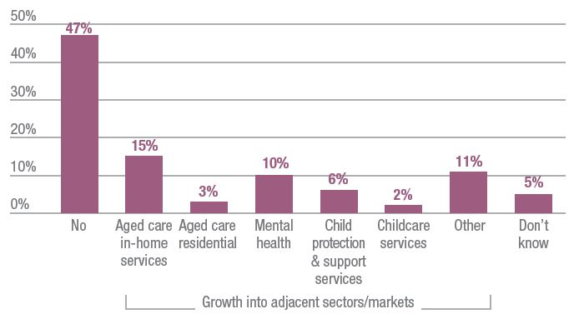

In 2015, prior to NDIS roll out in many areas, 68 per cent of disability service providers were planning to grow. This dropped to 58 per cent this year. Just under one third (31 per cent) reported they intend to remain the same in the coming year.

Figure 10 Intention to increase the range and/or scale of disability services this year

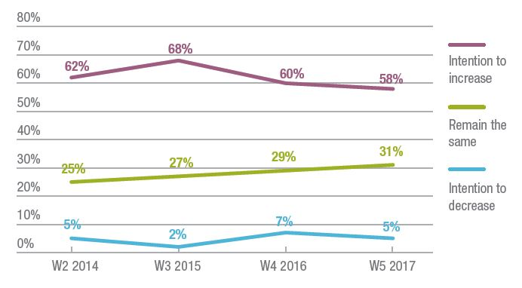
Over the last two years, there has been no significant change in the proportion of organisations discussing merger (38 per cent) or undertaking a merger (seven per cent). However, 21 per cent of organisations had discussed stopping the provision of disability services, but continuing other services. This is up from 16 per cent in 2016. Ten per cent of respondents had discussed winding-up.

Underlying causes and concerns

Disability service providers report their key concerns are: low NDIS prices; the costs of change; and uncertainty about their financial sustainability.

The number of organisations making a profit has fallen slightly. Only 34 per cent of those who made a profit recorded a profit of four per cent or greater. These results reinforce the findings from the NDS/UWA National Financial Benchmarking Study. The Productivity Commission referred to the value of this project in its report on NDIS costs and recommended it continue to be funded.

Figure 11 Profit/loss last financial year

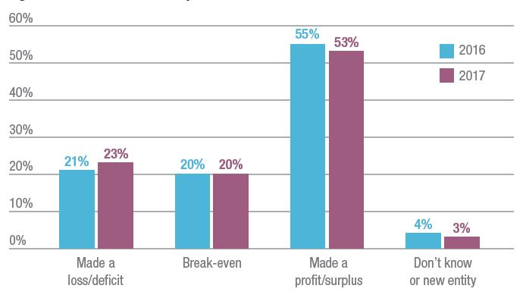

“Our strategy for year one transition is to retain our current customers, embed the new systems and processes, see how accurate our financial forecasting was and whether we can reduce our overheads to the limit required. If growth opportunities arise we won’t turn them away, we’re just not focused on growth for this year.”

The percentage of organisations reporting an expected profit in 2017-18 has increased slightly to 43 per cent. So too has the number expecting to make a loss – nearly one quarter (24 per cent). The number of organisations expecting to break-even has fallen (35 per cent to 29 per cent). Profit data represents the number of firms, not a dollar amount. While more organisations made a profit or loss, the overall profitability of the sector may be unchanged, have improved or worsened.

Figure 12 Expected profit/loss this financial year

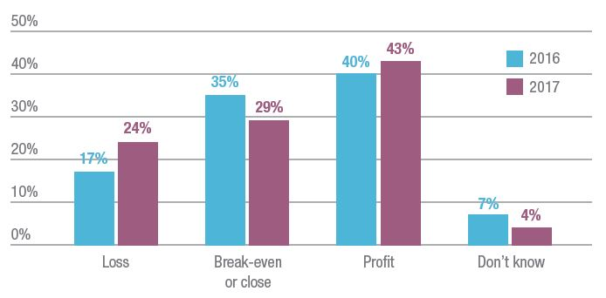

The sector is undergoing substantial change and growth simultaneously. Both of these actions require significant investment in new infrastructure, human resources, marketing and other areas. This is stretching the resources of disability service providers. As the majority of organisations are not-for-profit and have evolved their business models to fit previous government policies, they must consume existing assets or borrow to fund investment. Borrowing from lenders such as banks is not always easy for not-for-profits.

The majority of for-profits are small organisations, often sole traders who may also have limited access to resources to fund transition or growth. The percentage of organisations reporting less than sufficient resources increased from 23 per cent to 30 per cent. Only one in 10 respondents have more than sufficient resources.

“Despite almost two years of preparation for the NDIS, we are struggling with the changes we need to quickly make across so many areas to ensure ongoing high standards of care and financial viability of our business.”

Figure 13 Sufficiency of resources for disability services in the last 12 months

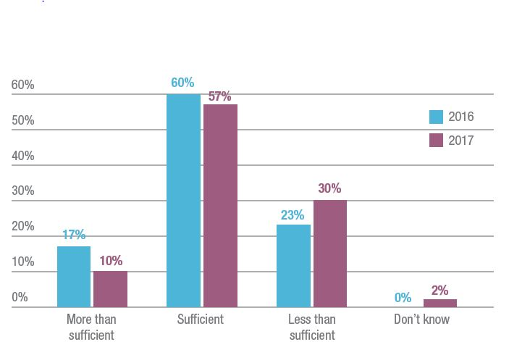

Looking ahead, disability service providers are less optimistic about their resource capacity. More than a third now predict they will not have sufficient resources to meet their needs for the provision of disability services in the next 12 months.

Figure 14 Sufficiency of resources for disability services in the next 12 months

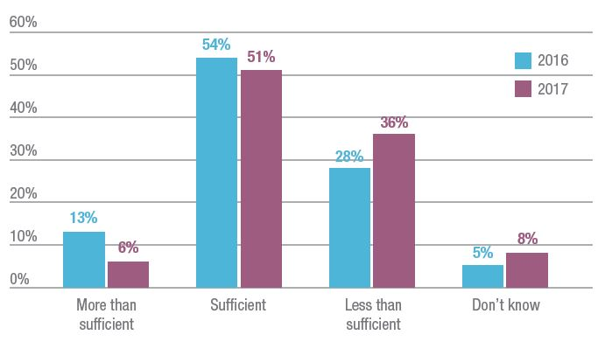

Fewer organisations reported exceeding or meeting all their operational objectives – down to
11 per cent and 28 per cent respectively. The number that only met some of their objectives grew to 13 per cent. On the other hand, the number meeting most of their objectives increased to
44 per cent.

Figure 15 Met our organisational objectives in the last 12 months

W1 2014 | W2 2014 | W3 2015 | W4 2016 | W5 2017
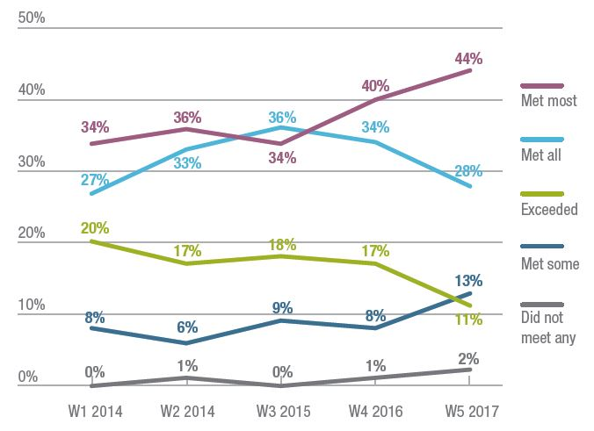

Overall self-rating of financial strength has fallen. Those rating themselves as very strong has fallen from 19 per cent to 10 per cent. Forty-two per cent now rate themselves as satisfactory.

Figure 16 Rating of current financial strength

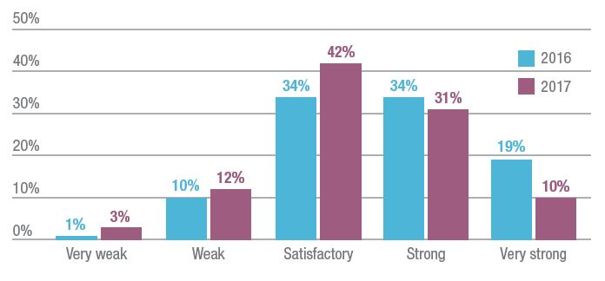

Opinions from the sector

The Annual Market Survey continues to track opinions regarding disability service providers’ own strategies, the roll out of the NDIS and the actions of government.

Sixty per cent of respondents agree or strongly agree to the statement they are worried about their ability to adjust to changes resulting from the NDIS. Twenty-one per cent agree or strongly agree their organisation will stay in the disability sector but are not focused on growth.

One in 10 organisations report they are considering getting out of the disability sector, reinforcing the findings regarding the intention of respondents to merge or wind-up. Ninety per cent of providers remain focused on improving productivity.

Figure 17 Providers’ opinions on their organisations’ strategy in the last 12 months

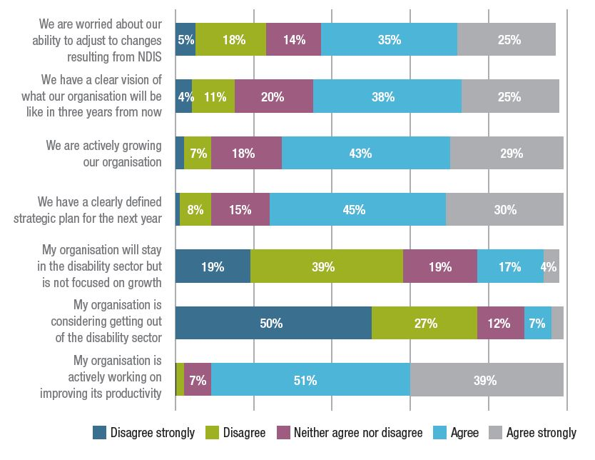

Opinions regarding government handling of the NDIS have become more negative in the last 12 months. Seventy-four per cent disagree or strongly disagree the government is anticipating or responding to the needs of organisations, up from 62 per cent last year. In 2016, 58 per cent of respondents disagreed or strongly disagreed the National Disability Insurance Agency (NDIA) is working well with providers. This increased to 67 per cent this year.

Figure 18 Opinions on the government’s management of the NDIS, policy and provider capacity

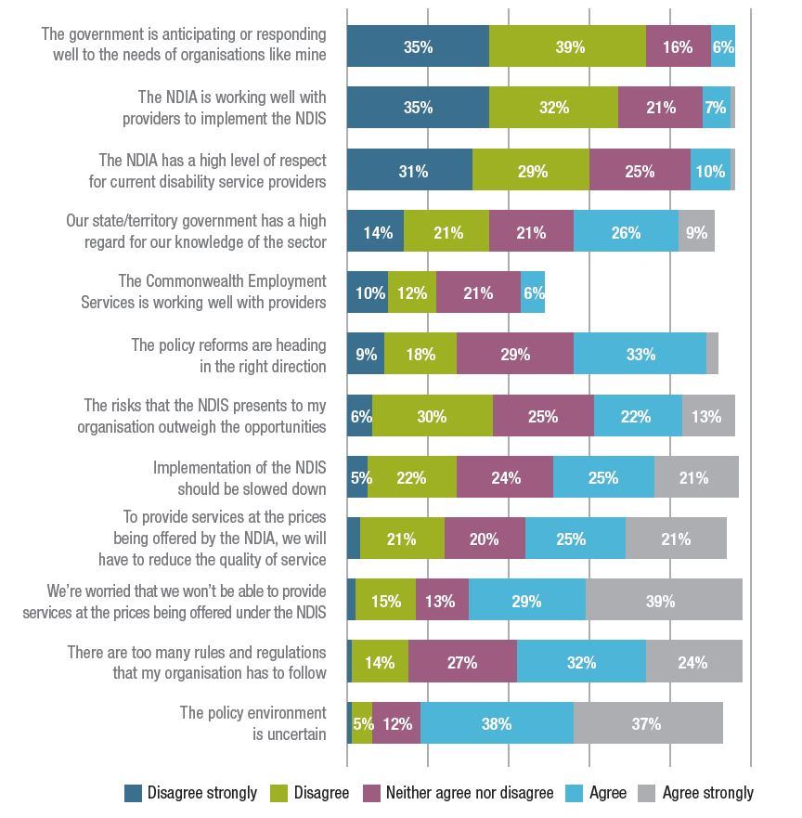

Fifty per cent of disability service providers agree or strongly agree they will have to reduce the quality of their services due to NDIS prices. This is an increase from 46 per cent last year.

Twenty-seven per cent of organisations disagreed or strongly disagreed the policy reforms were heading in the right direction. This is up only slightly from 2016.

The results to questions about what government should do to improve capacity are similar to last year. Sixty per cent want government to establish NDIS prices aligned with the actual cost of supply. All other improvements were markedly less important from the perspective of respondents.

Figure 19 Actions that would have the greatest impact on capacity to deliver services in the next 12 months

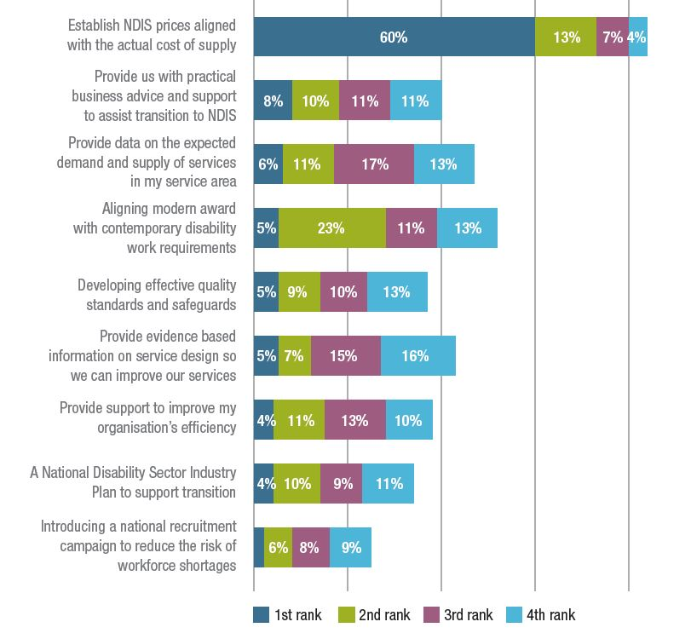

Case study

Jodie Collins

YellowBridge QLD

Tell us about your role at YellowBridge QLD.

I am the General Manager of the disability support team here, which is a large team of 80 staff. YellowBridge QLD also delivers a number of other services including an aged care
home service program that involves [helping elderly clients] complete minor or major home modifications around being safe at home.

How has the NDIS transition process affected your operations?

We had 93 clients transition over six months so it’s safe to say our lives have been eating, drinking and sleeping the NDIS for some time! It’s greatly changed the operations of our organisation. The most challenging thing has been understanding and preparing for how time intensive the process is. Like many other organisations, I think we underestimated the time it would take to assist individuals through the process. We decided early on that we would continue our client-centred approach throughout our clients’ progression through the NDIS and spent a lot of one-on-one time to help them understand what the process would
involve. Not only were we surprised by the time it took to work with our clients, but also how long it took for them to get through the system with a plan that can be implemented.

What’s the most valuable lesson you’ve learnt?

I did a quick calculation that pre-planning to plan implementation and delivery requires at least 14 hours of one-on-one time for every individual. You can see that if you apply this to large client numbers, you’d need a full-time position in your organisation to assist with the planning process through to actualisation.

Do you see the NDIS bringing opportunities to your organisation?

We saw that early on. We saw a lot clients access services they couldn’t previously. At YellowBridge we only do support delivery, so we work closely with other people in the community that offer complementary therapies. We’re already seeing excellent
outcomes for people who are now engaging with occupational therapists, speech therapists, exercise physiologists and physiotherapists who have never been able to afford to previously. Not only is that a great outcome for our clients, but this adds so much value to our support delivery. As we start to get more providers on board and look at other innovative service delivery models, I can see a lot more opportunity. It’s an exciting place to be in.

Can you tell me about one of your service user’s experiences of the NDIS transition process?

There are two young ladies at the moment living at home with mum and dad. Through the NDIS, they’ve been able to access speech therapy that they haven’t been able to for a long time. They also have new apps on their iPads which our staff have been able to use to communicate more effectively with them. It was also one of the goals in their plans to move out of home. One of the lady’s family was lucky enough to be able to purchase a new unit for them. They both have the Housing Options Package in their plans, so we’ve just completed all of the assessments including their application and we’re waiting for approval on their shared accommodation funds. They’re keenly already planning their housewarming party and planning their days in their own place. It’s a fantastic outcome not only for them, but their mums and dads too, who have not been able to do a lot of things since they were born over 24 years ago.

Qld
- 9,733 NDIS plans approved
- 53% of bilateral estimate
- 96,449 expected NDIS participants at full scheme
- 10% Aboriginal and Torres Strait Islander
- 3% Culturally and linguistically diverse

Key issues

Reliable market data:
Disability service providers made financial commitments to meet demand based on NDIS bilateral targets. Without reliable market data, providers may be unable to meet these targets and find themselves in precarious financial positions.

Pricing for rural, remote and very remote supports:
NDIS prices must respond to evidence regarding the delivery of supports in rural, remote and very remote areas to ease the financial strain on disability service providers in these regions.

Transport subsidy and travel:
The potential removal of the taxi subsidy scheme and other state-funded transport supports could create access barriers for people with disability. We need a solution that supports organisations to run vehicles and community transport systems.

Case study

Kathy Wonderley

ACES Incorporated

Tell us a bit about ACES Incorporated and your NDIS journey so far.

We’re a medium-sized service based in Port Macquarie. We’re what you might call a day program service, although we’ve branched out to accommodation support and short-term respite. We largely provide services for people from middle age to 65 years of age.

How has the transition to the NDIS affected the operation of ACES?

The NDIS has turned our organisation on its head. It’s essentially meant that we have to do business very differently. The prices are very lean. Essentially we’ve been asked to do the same work – probably more – for a million dollars less.

Have there been any lessons learnt so far?

I think you need to be honest and upfront with people all the way through. We’ve provided more staff training in the past couple of years than we ever have before, just to talk about the NDIS. We need to give staff a robust understanding of why we’re making changes. We had to cut spending dramatically and we still need to cut spending. Change will be the only normal, going forward. We have also changed to self-organised teams and we changed our software program so staff can be more self-organising. So I think the biggest thing for me is consultation – talking to people. As our old CEO John Faithfull used to say: “Tell people what you’re going to do; then tell them what you’re doing; then tell them what you’ve done.”

How have your service users responded to the NDIS transition experience?

What I’ve noticed is that it’s a lot more stressful for families. Some are really happy, but the vast majority have had this period of intense anxiety leading up to the NDIS. I guess there’s also a lack of understanding about exactly how much it costs. We have one person in particular, with quite complex needs, who we may not be able to support going forward; so we had to have that conversation with him. There are a lot of changes for the people we’re supporting.

Looking ahead, what opportunities can you see for ACES under the NDIS?

We’ve taken a deliberate consolidation approach: we’re choosing not to grow too much. I can’t see many opportunities unless the NDIS changes.

Have you seen the provider community come together under the NDIS?

A lot of services are still quite insular and I think some are concerned about competing against each other. I’m a member of a local human services organisation where there’s a few disability services involved and we’re working quite collaboratively. One of them is
Samaritans and we’ve joined together to create a training event. It’s about the NDIS and how we can look at things differently to keep people who come to your services engaged and happy; and that you’re delivering the services of their choice rather than what we think they need. That sort of stuff is happening locally, which is very positive. I think the only way
forward is to work collaboratively.

NSW

- 63,293 NDIS plans approved
- 87% of bilateral estimate
- 152,103 expected NDIS participants at full scheme
- 5% Aboriginal and Torres Strait Islander
- 7% Culturally and linguistically diverse

Key issues

Plan development and implementation:
The quality and consistency of NDIS plans is not good enough, causing unnecessary red tape for participants, disability service providers and government.

Pricing:
Many NDIS prices have remained too low. Prices must be based on evidence to allow for high-quality services and supports.

Communication and consultation:
Involving the sector to design a communication strategy is crucial. Communication from the government to both NDIS participants and disability service providers has been either too limited or too complex.

The state of the NDIS

Transition hurdles

The immense task of growing the NDIS from the 30,000 participants who entered during the three year trial to more than 100,000 a year has tested NDIS systems and processes and found many of them wanting.

Poor quality NDIS plans replaced the payment portal as the leading concern of disability service providers in early 2017. Planning was largely undertaken by contracted Local Area Coordinators under pressure to meet targets agreed to between the Commonwealth and state and territory governments. Planning was rushed, often conducted over the phone and existing services were frequently disregarded as a starting point for considering the supports needed. Essential supports were omitted from plans and rectifying these omissions was not easy.

A recent problem has seen participant plans expire without new plans in place. Disability service providers have carried the costs of continuing to provide supports without being able to claim for their provision. The NDIA assures NDS that payments will be made for these services but until then, payment delays result in cash flow difficulties.

The NDIA’s decision to require a quotation for every participant living in Supported Independent Living (SIL) has been burdensome for disability service providers. The process requires unnecessary duplication of information already held by the Agency and is based on a limited understanding of how shared supported living arrangements work in practice. The time to agree a quote can extend into months and some disability service providers have been without payment for extended periods of time.

A better system for determining SIL funding must be found. NDS continues to argue that disability service providers willing to accept benchmark prices should not have to submit a quotation and a new quotation should not be required for every plan review.

Another issue emerging with NDIS implementation is transport. NDIS funding for transport in participant plans is significantly less than disability service providers have been expending. As a result, a growing number of disability service providers are considering selling vehicles used to assist participants to travel. NDS has concerns this transport will be lost before other options emerge, severely disadvantaging NDIS participants.

NDIS funding for transport in participant plans is significantly less than disability service providers have been expending

In early May 2017 NDS published ‘How to get the NDIS on track’ which detailed many problems in implementing the NDIS and proposed practical solutions, making 24 recommendations in total. We continue to draw from this document in our negotiations with the NDIA.

At a similar time the NDIA began an in-depth review of provider and participant experience in the NDIS. They have identified many difficulties and are working on solutions. As details emerge NDS will work with the NDIA to ensure the solutions are right and practical. Wherever possible we will request they are tested with disability service providers before being implemented.

Pricing pain

For the second consecutive year the NDIA disregarded cost evidence from disability service providers when setting prices for the 2017-18 financial year.

The risk of this approach was highlighted when disability service providers announced closures of short-term accommodation (STA) facilities – a service which gives much needed support to families. After frequent discussions the Agency did respond to these closures by introducing significant price increases for STA in October
2017. Market failure cannot be the trigger for further price increases in other areas of support.

An Independent Pricing Review has been commissioned by the NDIA’s Board and will report by the end of the year. The Terms of Reference are broad allowing the review the potential to address many of the sector’s concerns by elucidating the real costs of service provision. We have worked constructively with the NDIA and consultant McKinsey & Company and hope the review will result in price adjustments for underfunded supports.

An Independent Pricing Review has been commissioned by the NDIA’s Board and will report by the end of 2017.

The future of quality and safeguards

The new NDIS Quality and Safeguards Commission will be established in Western Sydney beginning operation early in 2018. The Commission will assume responsibility for quality and safeguards in NSW and SA from July 2018 with other states and territories entering as the NDIS is fully transitioned in each jurisdiction.

The legislation and rules should be finalised early in 2018, along with associated elements such as the Code of Conduct for workers and organisations and the policy for worker screening. That process will be undertaken by states and territories.

NDS is providing input to governments to help shape the new quality and safeguards system and as core components are finalised we will work with disability service providers to ensure they are ready for its introduction.

NDS is giving practical support to disability service providers through its Zero Tolerance initiative. Zero Tolerance recognises the importance of organisational culture in safeguarding and empowering people with disability.

NDIS transition arrangements

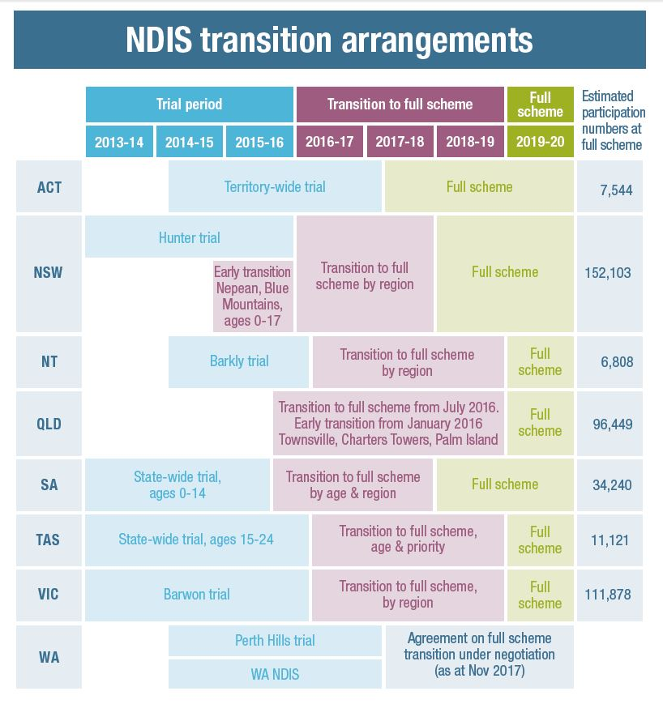

Case study

Melinda Kubisa

Community Living Options

Tell us a bit about Community Living Options and your NDIS journey so far.

Community Living Options is a family-centred, grassroots organisation, started in 1982 by a group of parents. The organisation grew by focusing on accommodation support from a human rights perspective, with an independent living skills model. We’re very outcomes-driven in our models. Over the past 10 years, a lot of our growth has been in complex, high-level forensic disability and dual disability. We work with people who are in and out of the prison system and hospital system.

How is the transition to the NDIS affecting the operation of CLO?

What we’ve been doing for the past three years is gearing up, but we haven’t transitioned
any of our 24-hour houses under the SIL [Supported Independent Living] model yet. We’ve had some growth in new services, so that’s testing our business processes and our set-up. We’ve implemented a Service Development Coordinator role to take on referrals and work with participants. The Coordinator holds information sessions for parents on all the steps of the NDIS and supports them through what’s going to happen next in the transition. We developed a goal- setting process to track progress.

How do you anticipate the transition to be? Any specific concerns?

We’ve done a lot of work in readiness around cash flow. I have concerns for smaller organisations and their financial sustainability if they haven’t got the operating cash flow to sustain the transition. I don’t want small providers to move out of this space, because that’s what choice and control is – having more organisations to choose from. I think there’s enough market share in the NDIS for us all to have a place. Even so, I worry. CLO has already noticed expense increases in getting ready for the NDIS – adding a role to support people through the process; increased training; IT. Other than those increased expenses, I believe the NDIS is going to affect the reliability of long-term business planning.

How do you think the NDIS transition experience will affect your service users?

What I’m hoping is that they do get a lot more choice and control and that we can help them navigate what is seemingly a scary world for them right now. What I hope is that people get at least what they’re getting now, to transition them smoothly and safely into the new world. It’s navigating all the complexities to have a truly person-centred delivery model. We’re trying to help their transition to be as smooth as possible so it doesn’t seem so fragmented and so they can get a whole package.

Looking ahead, what opportunities can you see for CLO under the NDIS?

I want to stay focused on what we do and what we do well, which is fill the gap in service delivery where mental health and disability services don’t quite meet for people with exceptional and complex needs. I want to watch how we can set up 24-hour environments in housing, because it’s a very complex space. And I want to continue to grow as a provider of choice for people with complex needs. The NDIS world is a new territory, so everyone’s a little bit confused about how it’ll look. But we’re certainly going to forge ahead!

SA

- 13,223 NDIS plans approved
- 95% of bilateral estimate
- 34,240 expected NDIS participants at full scheme
- 5% Aboriginal and Torres Strait Islander
- 3% Culturally and linguistically diverse

Key issues

Lost opportunities for employment:
School Leaver Employment Supports (SLES) have been assisting young people with workforce transition. SA is still in the dark about when and how SLES will be launched. This must be answered to ensure future employment opportunities.

Shortages in rural and remote areas:
The NDIS gives people with disability increased choice over their supports, but choice relies on having options. There is a real risk of inadequate supports in rural and remote communities. It is critical these areas have sufficient flexibility for local decision-making, without compromising the core principles of the NDIS.

Communication concerns:
There is a lack of communication and consistency in regions where a Local Area Coordinator has been appointed. This leads to confusion for NDIS participants and service providers. Prompt, consistent and transparent communication is needed.

Case study

Chris Oriel

Hopes

Tell us a bit about Hopes and your service users.

Hopes runs a cooperative living organisation for people with an Acquired Brain Injury (ABI) and neurological condition. Our organisation has 13 conjoined houses on the one site and we also have a community house. We have 12 residents – some who live by themselves and others in a relationship or with a family member. We have a great variety of abilities here, ranging from some people who do not receive any formal supports whatsoever to those who receive 24/7 care. Hopes and myself don’t provide personal support; we provide tenancy support, advocacy and low level case management.

How has your NDIS transition experience been so far?

Our first resident is set to transition at the start of next year. In my role I have consulted with the NDIS, NDIA and [government] departments and there has been a fair bit of information and opinion but very little definitive advice on how to proceed. I think this is partially because Hopes operates a Lead Tenant model and we receive a very small block funding grant from the state government. We have been advised that our residents, unlike in a group home,
will transition by age. We have not been given assurances that our residents, even though they are named in our funding agreement, will be eligible for the NDIS.

What have been the key challenges in the transition process?

Changing information, changing personnel and a disparity between what the NDIS is wanting to achieve in terms of choice, control and innovation and how a small organisation like Hopes that is already doing that, can [find] a roadmap for how to remain viable under the changing scheme.

Have you found any solutions to these issues?

It’s been put to me that one of the ways we can remain viable is if the role of coordinator, which is my current position, did service coordination because this is effectively what we already do. However, the difficulty is that if we do the wrong thing by the residents or they’re unhappy with our performance as service coordinator, their housing situation will be potentially under threat. We have moved away from this as it’s a potential conflict of interest and also deviates from our model which is for our residents to work with each other and their supports to get good outcomes. So I think an opportunity exists if enough people [support] our model where our residents do their own thing, participate in the cooperative and have certain responsibilities that they take on. We’ve had a lot of other people who do not have ABIs, such as parents of kids with learning or developmental disabilities, who like our democratic cooperative model. If enough people support us then there’s an opportunity to expand – but that would require private equity or partnering with another organisation.

Your first resident will transition in early 2018. How prepared do you feel for this process?
There’s two sides to this – organisational and individual readiness. As an organisation we are not quite ready in terms of our systems. However, the resident who is moving across is a motivated, articulate resident who passionately wants to go on living here. They have said
that they don’t want to live anywhere else and will do whatever they need [to stay]. We are now looking at doing some goal setting with them. Luckily, they are also supported by an organisation that provides their formal supports and we work well in partnership with them.

Can you see future opportunities for Hopes under the NDIS?

There certainly is opportunity as long as the NDIS can find a way to make small organisations – that are doing good and innovative work – viable. I think the fact that people with disability can vote with their feet is a good thing.

Tas

- 2,915 NDIS plans approved
- 102% of bilateral estimate
- 11,121 expected NDIS participants at full scheme
- 9% Aboriginal and Torres Strait Islander
- 2% Culturally and linguistically diverse

Key issues

Investment in workforce:
The narrow pricing margins under the NDIS mean there are insufficient funds to focus on workforce development and service quality. Without a resolution, the NDIS cannot deliver its goals of greater choice and control for people with disability.

The real price of supports:
Disability service providers are committed to not leaving any person with disability without supports. This has become financially difficult during NDIS transition as pricing does not account for the breadth of provider services, especially during non- client facing time. A nuanced understanding of the cost of service delivery is critical.

Inadequate transport funding leading to exclusion:
A key principle of the NDIS is fostering more inclusion for people with disability. The issue of transport funding needs urgent resolution as people living in regional and remote areas with no or unsatisfactory public transport are missing out.

The state of the broader policy environment

Numbers on DSP continue to fall

In March 2014 the number of people receiving the Disability Support Pension (DSP) peaked at 832,533. Since that time government policy has been driving a reduction in these numbers. In June 2017 the number of recipients was 758,911 representing a fall of more than three per cent since the previous year and almost nine per cent since March 2014.

NDS does not oppose policy to reduce the number of people receiving the DSP if it results in people with disability moving into employment. This requires increased effort to expand
employment opportunities. More stringent criteria for accessing DSP must be matched by more people with disability finding work.

In the past year the proportion of DSP recipients reporting wage income has been static at just over eight per cent.

In June 2017 the number of DSP recipients was 758,911 representing a fall of more than three per cent since the previous year and almost nine per cent since March 2014

National Disability Strategy needs boosting

The National Disability Strategy has six priorities, one of which the NDIS addresses. Progress on others – inclusive and accessible communities; rights protection; economic security; learning and skills; and health and wellbeing – has been slow.

NDS recently provided feedback to the Second Progress Report. We reported many children with disability are still receiving inadequate support from schools, sub-optimal hospitalisation experiences of people with significant disability and progress on improving transport accessibility is slow.

A positive we reported was the commitment by some governments to the implementation of Changing Places – fully accessible toilet venues. As this initiative will increase the participation of people with disability within their communities, all governments are being encouraged to invest in these facilities.

NDS has argued that annual reporting to Parliament on key measures would help drive greater commitment to investment in National Disability Strategy priorities by governments.

Case study

Nadia Lindop

MJD Foundation

Tell us a bit about the MJD Foundation and your NDIS journey so far.

The MJD Foundation was established in 2008 to provide supports to Aboriginal Australians living with Machado Joseph Disease. We provide person-centred and family-centred supports and work in partnership with communities to provide those supports.

How has the transition to the NDIS affected the operation of MJD Foundation?

With Machado Joseph Disease, people start well and their condition slowly worsens throughout their lives. They’re only really eligible to enter the NDIS at the moderate stage of the disease. We provide support to people throughout their entire journey of MJD. So that’s one of the complexities for us. Not only are we trying to get our clients the best possible NDIS plans, but also recognising that it’s not going to provide us with an income stream across all of our clients. It’s taken a really significant amount of time to get on top of the transition and work collaboratively with the NDIA to make sure our clients get really good plans.

What have been your greatest challenges?

The complexity of the scheme has been the most challenging and the fact that in the NDIA themselves, most staff are new. Most don’t have experience working with Aboriginal people or working in remote communities and they don’t have an understanding of what’s culturally important to people, at the centre of their lives.

There are a lot of teething issues that make things frustrating. We’re trying to disaggregate what those transition issues are, as opposed to what are the longer-term policy issues that are really going to impact people’s lives. In the NDIA price guide, the prices are not high enough to cover the cost of doing business in remote communities. So we also have to fill the gaps somewhere if we’re going to be sustainable.

What has been rewarding?

What has been rewarding is that despite the complexities, challenges and frustrations, we’ve been able to develop a really positive working relationship with the NDIA and the people on the ground. And we are starting to see some positive plans for our clients in remote communities.

What have been the biggest lessons?

A big lesson is just to try and be innovative. The NDIA has been receptive of suggestions and programs that are innovative. For us, we’re looking at how we can get smarter about pooling funds on Groote Eylandt and the NDIA is really happy to work with us on how that might look. We’re looking at doing something for our ‘on country’ days, where we can pool funds across clients to run a day a week where clients can get out on country, combining traditional therapy with what’s culturally important for people – to have access to their community.

I think that’s the big lesson: You don’t have to be constrained by exactly what you read in the price guide and on the website. You can try and come up with something innovative.

Do you have advice to pass on to other organisations who are transitioning?

Use your networks as much as possible. Everyone’s having the same issues, so it’s really important to try and find forums to share those and figure out ways to do things better.

NT

- 547 NDIS plans approved
- 61% of bilateral estimate
- 6,808 expected NDIS participants at full scheme
- 80% Aboriginal and Torres Strait Islander
- 1% Culturally and linguistically diverse

Key issues

Thin markets and service challenges:
The small and dispersed population of the NT makes it impossible to achieve an economy of scale in disability service provision, resulting in thin or non-existent markets. Investment in industry development is needed to support market growth.

Catering to remote communities:
The NT has one per cent of Australia’s population spread over 17 per cent of the nation’s land. Most of the Territory’s Aboriginal population live in remote and very remote areas. Providing services in these locations presents many challenges. So that remote communities are not marginalised further, we need a local response.

Transport shortages:
Transport in the NT is limited and very expensive. NDIS transport funding tiers are inconsistently applied and the need to return to country for Aboriginal participants isn’t recognised. A targeted approach to address these challenges is required.

Case study

Rosie Lawn

Avivo Live Life

Tell us a bit about Avivo Live Life and your NDIS journey so far.

Avivo Live Life supports people to live life across aged care, disability and mental health. We’ve been around about 50 years, we work in big geographical areas in WA and our infrastructure is a whole network of people providing support in the community. There is such a massive system change with the NDIS. We really welcome it, but it’s a big change in terms of how everything is organised.

How has the transition to the NDIS affected the operation of Avivo?

Avivo had the attitude that we needed to be in it to learn and I’m really pleased we did that, because we’ve learned an awful lot. Like everyone, we’ve experienced similar things around the relationship with the planners or the local coordinators. It was a shift to ‘How can we partner and work together to support people to get the best outcomes?’. There’s still a bit of a way to go. The other challenge is going into planning and putting supports into line items and that not always being easy or flexible enough to suit individual needs.

How has your experience in NDIS implementation been?

We are seeing people getting access to funding and supports that previously couldn’t. People with psychosocial disabilities are getting access.

It’s very much implementation issues that are the problem. We’ve worked hard at building our relationship with the planners and the local coordinators and that’s variable. There are issues of scale – the number of plans they had to do – and also a lot of problems with the phone planning – which might be improving. Because we’ve always worked with supporting people to live at home and in the community – personal care, assistance at home, help to get into the community – there’s also a perception of low-level payment for that. That’s an ongoing problem for how we remain viable and it’s really hard to influence.

One of the success stories has been that as the NDIS has rolled out, we’ve seen quite a few of the people we’ve worked with in partnership over the years going to self-management. We’re seeing a lot of people benefiting from our support coordination and plan management service.

Do you have advice for other transitioning organisations?

I think you’ve got to get in it to understand it. Try and develop a relationship with the planners. Look at how you build relationships externally and also how you reform yourself internally to be more effective. The price the NDIA pays at the moment is significantly lower than we used to get, so we’re thinking about how we transform the organisation to be viable in the long-term. We’re looking at how we streamline; working closely with the customers.

Looking ahead, what opportunities can you see for Avivo under the NDIS?

Ultimately, it’s fabulous that more people will get access to funding as part of the NDIS. And if we can make our changes successfully as an organisation, we can grow.

WA

- 3,982 NDIS plans approved
- 75% of bilateral estimate
- 3,356 WA NDIS participants
- 4% Aboriginal and Torres Strait Islander
- 5% Culturally and linguistically diverse

Key issues

Services in remote and Indigenous communities:
Both NDIS prices and engagement models need to be sufficiently flexible to reflect the cultural norms and costs of delivering services in isolated communities. Local knowledge and flexibility are critical to implementing the NDIS well in these regions.

Certainty required:
The state government is reviewing whether to keep a locally run NDIS or join the national scheme. We expect a decision by the end of 2017. To ensure successful transition, NDS’s WA Industry Plan provides clear strategies and actions for a co- ordinated and comprehensive approach.

Employment-first approach:
One of the best predictors of employment post school is a casual or part-time job while still at school. An employment-first approach in NDIS planning, where finding a job is the first and preferred option, should be implemented.

The state of disability employment

Open employment

2017 has been a year of planning for Disability Employment Services (DES) reform with new contract arrangements to begin from mid-2018. These changes are the result of an extensive consultation process with industry peaks and DES providers and include several gains for the sector.

The new arrangements improve choice and control for DES participants by relaxing Employment Service Area boundaries. DES providers will have greater flexibility through the removal of market share, funding indexation from mid-2019 and a simplified, extended contract.

A challenge for DES providers under the new contract will be the introduction of Risk Adjusted Funding. In theory this model will adjust service fees to reflect the difficulty of placing a person in employment. However, early analysis suggests an over-representation of some disability groups (autism and intellectual disability) at the lowest funding level. The actuarial model may not take sufficient account of the number of hours and specialist skills required to assist these groups into employment.

DSS has commenced a review of the current assessment process and star ratings. It is disappointing this didn’t happen in parallel with the development of the new DES funding arrangements. The star ratings will be modified to take into account additional milestones.

Government has indicated there are an additional 237,000 people with disability eligible to participate in DES. The majority of these individuals are over 35 and many have never participated in the labour market. Most would attract the highest level of funding, providing a significant opportunity for DES providers.

DES data for the period August 2011 to August 2017 shows a decline in participants with intellectual disability from 8,512 to 7,612

Supported employment

The legal and industrial matters regarding wage setting in supported employment are ongoing. The Supported Employment Services Award (SES Award) review reached a key stage in the second half of 2017 with proposed variations being examined by the Fair Work Commission. Included in the variations are the adoption of modifications to the Supported Wage System (SWS), changes to the definitions of Supported Employment Service and Supported Employee and the inclusion of a Work Value Classification Schedule. The advocates involved in the matter have sought the removal of all wage tools excluding the SWS.

The Federal Government has made strong commitments to supporting Disability Enterprises. We must ensure these commitments translate into practical support. This should include an industry adjustment package for NDIS transition and an ongoing subsidy to offset any increased wage costs.

The inclusion of the modifications to the SWS have received support from parties involved in the SES Award review. However, NDS and its members are adamant that additional wage assessment methods must remain available to Disability Enterprises. The impact of the modified SWS on wage costs remains unclear. Initial modelling suggests average wage increases could be in the vicinity of 30-60 per cent. Should the SWS emerge as the only wage assessment method identified in the SES Award, jobs will be lost unless government provides additional funding, preferably through an adequate NDIS price.

NDS advocates a wage model that bundles a supported employee’s wages and welfare benefits into a social wage. The social wage would result in supported employees receiving an income that approximates the National Minimum Wage.

NDS has launched BuyAbility to promote supported employment. It includes an impact measurement tool that calculates the net value of work in Disability Enterprises and encourages government agencies and private enterprises to make a purchasing choice that is commercially sound and socially responsible by buying from Disability Enterprises.

The modified SWS could increase wages by 30-60%

Disability employment in the NDIS

There is an unacceptably low rate of NDIS participants with employment supports in their plans. Only two and a half per cent of supports in NDIS plans are employment supports. This rate must increase to ensure more employment for people with disability and the ongoing financial viability of the NDIS.

Only 2.5% of supports in NDIS plans are employment support.

Ticket to Work

NDS initiative, Ticket to Work, demonstrates that young people with disability can thrive in open employment when well prepared and supported in a coordinated approach. Since its inception over 1,000 jobs have been created for young people with disability. The NDIS could learn from this approach to ensure all young people are prepared and supported to take an employment pathway.

Ticket to Work has extended its focus to assist students with disability to gain after school work – a rite of passage for many teenagers.

“I was sad about leaving school but now I feel positive about the future because
I am sure I will get a job after I leave school because I know what working means.”
Ticket to Work participant

“Ticket to Work has been great in ways I did not expect...It is changing cultures.”
School Principal

“Ticket to Work was the first time that a job had been presented as a possibility for my son. Previously the school kept telling me not to have too high expectations. Now he is working!” Parent of Ticket to Work participant

Customised Employment – Perth Hills

Customised Employment is an individualised approach to vocational supports and services consisting of two stages: Discovery – a process of support to identify the skills, interests and abilities of the individual; and Job Creation – information from the discovery process to determine the best work outcome for the individual.

Implementing a Customised Employment approach through the NDIS enables people with disability to access a continuum of supports. It links DES, Disability Enterprises and the NDIS and supports people with disability to engage in work at their own pace.

The Customised Employment approach has been trialled in the Perth Hills NDIS site. Eighteen per cent of NDIS plans in this site include employment supports, well above the national average. As a result, students in school years 10-13 received 150 hours of employment support and the approach has led to the development of more than 30 micro enterprises.

Students in school years 10-13 received 150 hours of employment support and more than 30 micro enterprises have been developed

Meet Kyal

Kyal is a 16 year old student with autism and ADHD. He lives with his parents, brother and family dog, Apollo. When Kyal began the discovery phase of the Customised Employment approach his team identified his love for cooking and his dog and his preference for hands-on work. After a lot of research, Kyal made his first batch of doggy treats – a huge success with Apollo!

Kyal was supported to find cafés that would be prepared to trial his Doggy Delights dog biscuits with their customers. Bolt Coffee in Hazelmere trialled the biscuits for a week and soon ordered another 60 – that has now grown to a regular weekly order. Demand continues to grow across the area with Kyal now making almost 500 treats each week.

Kyal’s mum, Amanda-Jane, says, “Our family is so proud of Kyal and this has finally made him feel worthwhile and shows he can achieve.”

Case study

Paul Carr

CatholicCare Canberra & Goulburn

Tell us about CatholicCare.

CatholicCare has around 50 programs and has been going for 60 years. We work
across disability, aged care, mental health, homelessness, counselling and allied health.

I first came on board to help with the roll out of the NDIS, particularly around change management to ensure we were ready for the scheme. This involved looking at changes needed to update our systems, aligning our people and helping them understand what the changes needed to be. I was also involved in working with the sector in giving feedback on how we found the process of implementation.

What were the biggest challenges in implementation?

Both the speed of the roll out and communication around what was coming and how we needed to prepare. A lot was put on organisations to prepare and while there was some help, much of it came down to making our best informed guess and putting whatever resources we had into making things work. [For us], everything was going well until the new portal came on board, at which point it really stretched our resources in terms of clients and invoicing. We learnt that you can’t quickly put new systems in place. With change management you need successes to celebrate, but they were too far and few between. The challenge was we couldn’t identify what was working and what wasn’t quickly enough.

What have you learnt from this process?

That the sector needed to change. We needed to reduce overheads and money wasted
in backend systems, while also improving customer service, efficiency and productivity. But we also need sufficient resources both in terms of people with the required skills and the money to invest in implementation. The challenge has been figuring out how to make our existing products work, which has required good systems and IT knowledge – especially challenging when you work across aged care and disability and need to ensure you have the same systems across both. We have learnt to roll out new things on a lean basis and test them.

How has the transition process with your service users gone?

They have all successfully transitioned. Our focus was on retention and quality rather than growth, which I think was the right decision. During tough periods, our focus on customer service became really important. Even when things are going wrong, you need to communicate with your clients proactively rather than retrospectively.

What advice do you have for other organisations also going through NDIS transition?

Stay focused on customer service and on quality. If you’ve found that you’re at a point when you can’t deliver, perhaps it’s time to consider not providing a particular service. Have a strategy for coping with that initial period of pain – you might lose some clients but once you get through it, you can have another strategy for finding new ones.

Looking ahead, what future opportunities can you see for the sector?

I think we will change the ways we do things and there will be new services. If we are to compete we have to change. I think we’ll become more efficient and there will be new ideas. What I hope is that we haven’t all been swallowed up by the big players and there’s enough diversity in the sector to ensure it is innovative, creative and responsive. I hope there’s enough energy and creativity in the sector to develop new products and ways of doing things. I think that has to happen.

ACT

- 6,301 NDIS plans approved
- 124% of bilateral estimate
- 7,544 expected NDIS participants at full scheme
- 4% Aboriginal and Torres Strait Islander
- 7% Culturally and linguistically diverse

Key issues

Quoting and plan review:
Delays in quote approvals and lack of information about new plans is leading to lagged payments affecting cash flow and efficiency. Resolving this requires working with the sector to fix system and process issues.

Communication and responsiveness:
Poor response rates on the NDIA’s 1800 information line continue to adversely impact disability service provider efficiency. In turn, this places stress on relationships with already overstretched local NDIA staff. Information needs to be more readily and consistently available.

Provider portal and service booking arrangements:
The functionality of the provider portal is limited and improvements have been slow. A public and accountable timetable for improved portal functionality designed in partnership with the sector is needed.

Case study

Anne-Maree Davis

Amicus

Tell us a bit about Amicus and your NDIS journey so far.

Amicus is a registered disability service provider based in the Loddon area of Victoria. We are currently transitioning to the NDIS – around 60 per cent of our current participants have transitioned so far. The people we support range from six to 65 in age and the majority (90 per cent) of our funding will be NDIS. We also deliver Targeted Care Packages which is a Victorian state initiative.

How has the transition to the NDIS affected how Amicus operates?

I’ve been here nine years and in that time we have been reorienting the way we work. When I started we ran a very traditional day service [where] most service delivery was segregated from the community. Now, 86 per cent of the people we support choose a one-person-at-a-time service which means they get a fully individualised service. A further seven per cent choose a mix of group and individual service and seven per cent opt for group-only service. All of this shows that even prior to the NDIS, we were well on the way to differentiating our service offering. Because of this, it was very easy to manage the transition as we were already helping people to actively participate in the wider community. We already had fantastic alignment with the NDIS and its principles.

How has your experience in NDIS implementation been?

Two implementation issues that don’t get much air time are the customer experience and service provider experience. In addition to providing NDIS direct services, Amicus is one of the approved providers to provide support coordination. There hasn’t been as much dialogue around support coordination as there has been in direct service delivery. Support coordinators don’t have direct communication with planners, which is just one of the issues significantly disadvantaging the most vulnerable in the scheme. Another shortcoming is that the NDIA is systemically not set up to respond to crisis. It expects the mainstream system will rise to the challenge – but they are not ready and they are not at the table. Addressing this systemic gap is a significant piece of work that needs to occur. Despite these issues,
I am extremely confident that some of the shortcomings in the implementation experience will be addressed by the pricing review and the new NDIS pathways.

How have your service users responded to the NDIS transition experience?

Each participant has had a different experience but the feedback we’ve heard from some is that they feel the NDIS has been more restrictive and bureaucratic and provided less choice
and control. As a provider, our experience has been that outcomes in plans have tended
to be limiting. For some participants, their plans direct them to more traditional service responses like group support. I don’t think that will fulfil the principles of the NDIS which are about economic participation and mainstream inclusion. It’s important to look at planning inputs if we want to see different outputs from people. Another issue is there is usually no relationship [between the participant and planner]. I believe a big part of getting the right outcome is about being in the right relationship with people.

Looking ahead, what opportunities can you see for Amicus under the NDIS?

As people become more familiar with the NDIS environment and have the capacity to be truly self-directing, I hope we will see the development of more innovative and bespoke arrangements. I definitely see opportunities for us in the future when the marketplace is ready.

VIC

- 19,506 NDIS plans approved
- 82% of bilateral estimate
- 111,878 expected NDIS participants at full scheme
- 2% Aboriginal and Torres Strait Islander
- 5% Culturally and linguistically diverse

Key issues

The NDIS payment portal:
The initial malfunction of the NDIS payment portal and subsequent glitches have led to delays to service bookings and large cash flow implications for disability service providers. Co-design must be introduced to avoid similar issues in future.

Lack of clear information:
NDIS participants and providers need clear, concise and timely information. A lack of certainty regarding interface supports, funding and responsibilities has caused unnecessary stress.

Quality and safeguards:
Ensuring a zero tolerance approach to abuse and neglect must be a focus under the NDIS. The Victorian Government’s desire to implement their own framework risks duplication, regulatory burden and red tape.

The state of the disability workforce

The data for the disability workforce paints a challenging picture. Average working hours remain low and working conditions are under pressure, making it tough to attract and retain staff – especially in some occupations and in rural and remote areas.

Around 60 per cent of disability service providers had moderate to extreme difficulty recruiting disability support workers. Recruiting troubles were also experienced for psychologists, speech and occupational therapists and physiotherapists. Nationally, these occupations are not in shortage pointing to a real issue connecting the allied health workforce to the disability sector.

Figure 20 Difficulty recruiting competent staff in the last 12 months

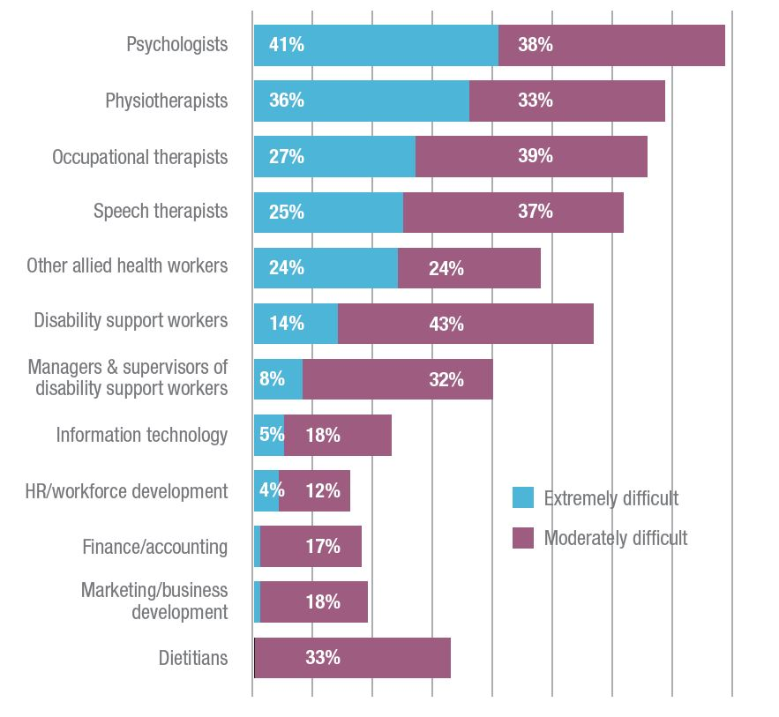

Underemployment in health care and social assistance is among the highest of any industry at nearly 11 per cent. Average hours worked for disability support workers is 21 hours per week and 24 hours per week for allied health professionals.

The average net workforce growth remains steady at three to four per cent each quarter with around three-fifths of disability service providers expecting their total headcount to be higher by the end of 2017-18.

These figures show the disability labour market is not responding as quickly as we might expect. The NDIS transition is capping the ability of disability service providers to offer competitive employment benefits and secure positions, while the changing structure of demand is also increasing constraints.

Casual part-time work is the biggest employment growth area with a three per cent increase in the last quarter. The growth rate for part-time and full-time permanent staff was just under one per cent.

Figure 21 Employment intentions this financial year

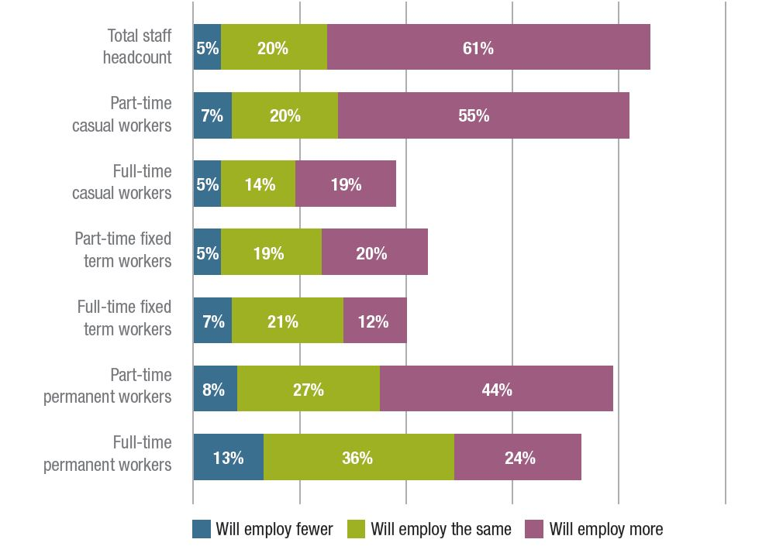
“We have made a strategic decision to put on more staff with limited hours and fixed contracts. We will continue to review utilisation of staff and demand for services to ensure the impact on our cash flow is positive.”

“Workforce is our most significant challenge. We now only work with self-managing and plan-managing participants and charge our own rate (not the NDIA rate), so we are able to offer employment arrangements and conditions that are more attractive to potential workers.”

“Demand for one-to-one support at peak times e.g. 3pm – 6pm is particularly challenging to meet and in great demand.”

The Productivity Commission’s report on NDIS costs identifies these issues but does not propose solutions commensurate with the scale of the problems.

Solutions will come from regulatory change – including additional workplace relations flexibilities – and disability service providers further embracing innovation and productivity improvements.

Workforce innovation in self-managed supports

The Disability Innovative Workforce Fund, funded by The Department of Social Services and administered by NDS, supports organisations to develop pragmatic responses to workforce issues.

There are many great projects in development. JFA Purple Orange is leading a collaboration with five disability advocacy bodies across Australia to build a body of knowledge on the workforce arrangements established by people with disability who self-manage their supports. The project is designed to represent the richness and range of tailored arrangements that exist.

Up to 40 people with disability who are self-managing supports and their support workers will be interviewed across six states and territories. Outcomes will include a report and several training resources including an interactive website and audio and video content from which others can learn.

Publisher
National Disability Services

Dr Ken Baker AM Chief Executive 02 6283 3200
ken.baker@nds.org.au

All rights reserved. No part of this publication may be reproduced, distributed or transmitted in any form without the prior written permission of the publisher. Except in the case of brief quotations embodied in critical reviews and certain other non-commercial uses permitted by copyright law.

Media
Katherine McLellan
Director of Communications 0408 175 564
katherine.mclellan@nds.org.au

About National Disability Services
National Disability Services is Australia’s peak body for non- government disability service organisations, representing about 1,000 service providers. Collectively, NDS members operate several thousand services for Australians with all types of disability.

Acknowledgements
The 2017 Annual Market Survey was undertaken by Professor David Gilchrist and Penny Knight from the University of Western Australia.

Thank you to our members who participated in our case studies. Thank you to the many people who have agreed to allow photographs of themselves to be used in various NDS publications.

This report was printed by a Disability Enterprise, a member of the BuyAbility network.

www.nds.org.au

