NDS Workforce Essentials eLibrary

Updated: June 2023

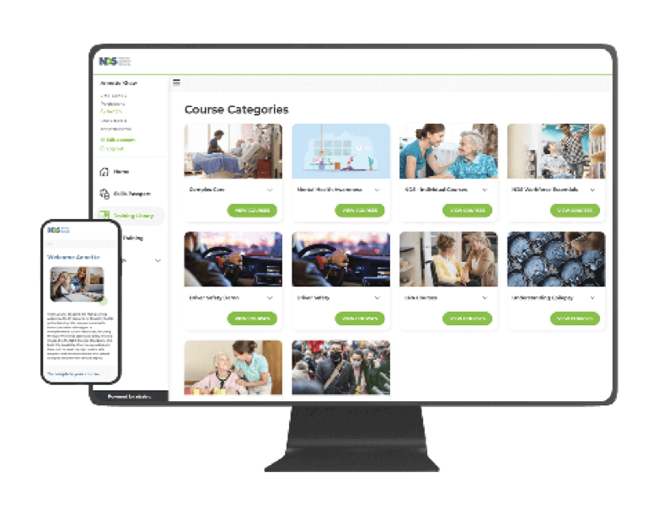

Overview

NDS and etrainu have partnered to bring together a comprehensive library
of eLearning assets focused on building the capability of disability services providers to meet the high quality, safe supports and service standards that people using disability services should expect.

Organisations and individuals are invited to access this content under a flexible and cost-effective licensing agreement, offering service providers an affordable solution to sourcing and deploying online training.

A sample of the over 100+ learning assets included in this eLibrary is provided below.

For a more comprehensive list please contact nds@etrainu.com

Aligned with NDIS Practice Standards

Standard 1: Rights and Responsibilities for Participants

​​Courses
- Bullying Awareness for Senior Managers
- Bullying Awareness for Workers
- Disability Induction
- Food Safety for Disability Support Workers
- Human Rights and You - Zero Tolerance
- Human Rights Resources
- Impairment in the Disability Sector
- Infection Control for Disability Support Workers
- Managing Stress and Building Resilience
- Manual Handling For Disability Support Workers
- Manual Handling Resources
- Orientation for External Support Workers in Tertiary Settings
- Professional Boundaries
- Risk Management
- Slips, Trips and Falls Awareness Training for the Disability Sector
- Understanding Abuse - Zero Tolerance
- Working with People with Disability

Standard 2: Provider Governance and Operational Management

Courses
- Adapting to the NDIS
- Business Writing Skills
- Coaching The Coach
- Communication Skills
- Dealing with Complaints and Difficult Customers
- Documenting Records
- Emergency and Disaster Management
- First-Response Evacuation Instruction
- Incident Reporting
- Managing Change and Communication
- Reliable Record-Keeping Webinars
- Resolving Conflict
- Safeguarding for Boards
- Sustainable Service under NDIS
- The Science and Art of Realising Human Potential

Standard 3: Provisions of Support

Courses
- Foundations of Positive Behaviour Support
- NDIS Financial Management: Cost Attribution
- NDIS Simple Financial Management
- Participation Project - Resources
- Person-Centred Practice Across Cultures - Resources
- Positive Behaviour Support
- Recognising Restrictive Practices
- Supported Decision-Making
- Supported Decision-Making (Resource)
- Understanding Care Plans

Standard 4: Provisions of Supports Environment

Courses
- Child Safe Standards (Victoria)
- Child Safe Standards (National)
- COVID-19: What It Is & How to Prevent Its Spread
- Hand Hygiene
- Leading Work Health & Safety in the Disability Sector
- Management of Waste
- Introduction to Mealtime Management
- Medication Management
- Personal Protective Equipment (PPE)
- Positive Cultures Films
- Trauma Informed Support Films

Key Benefits

- More than 100+ learning assets are available immediately, plus a committed content development schedule for new sector-specific training assets aligned to the NDIS Practice Standards.

- Discounted NDS Member pricing.

- Cost-effective and fixed annual licence fees with flexibility to sign up for a 2 or 4 year contract.

- Unlimited course access for a specified number of users in three different ways:
- Hosted on the NDS eLearning Academy (etrainu Learning Management System)

- Have this eLibrary on your own branded Academy via the etrainu Learning Management System

- Hosted on your own Learning Management System.

Pricing

Pricing is inclusive of access to NDS Workforce Essentials eLibrary and platform fees via the etrainu or NDS Learning Management System. Additional fees apply for custom Learning Management Systems and SCORM files.

 | NDS Member |  | Non NDS Member
No. of Users | 4 Year Licence | 2 Year Licence | 4 Year Licence | 2 Year Licence
251+ | P.O.A | P.O.A | P.O.A | P.O.A
201 - 250 | $6,700 per year | $8,900 per year | $9,250 per year | $11,300 per year
151 - 200 | $5,650 per year | $7,345 per year | $7,900 per year | $9,450 per year
101 - 150 | $4,840 per year | $6,290 per year | $6,775 per year | $7,865 per year
76 - 100 | $3,750 per year | $4,900 per year | $5,300 per year | $6,250 per year
51 - 75 | $3,200 per year | $4,150 per year | $4,500 per year | $5,200 per year
26 - 50 | $2,660 per year | $3,460 per year | $3,730 per year | $4,325 per year
Up to 25 | $1,920 per year | $2,650 per year | $2,890 per year | $3,435 per year
Individual Licence: $300/user/year
Price is per year and excludes GST. NDS Member discounts have been applied.
Price from 1st July 2023.

building exceptional communities through education

07 3114 2958 | sales@etrainu.com | etrainu.com

